Stereo Realist
This camera manual library is for reference
and historical purposes, all rights reserved.
This page is copyright© by , M. Butkus, NJ.
This page may not be sold or distributed without
the expressed permission of the producer.
I have no connection with any camera company.
On-line camera manual library
If you find this manual useful, how about a donation of $3 to:
M. Butkus, 29 Lake Ave., High Bridge, NJ 08829-1701
and send your e-mail address so I can thank you.
Most other places would charge you $7.50 for a electronic copy
or $18.00 for a hard to read Xerox copy.
This will help me to continue to host this site,
buy new manuals, and pay their shipping costs.
It'll make you feel better, won't it?
If you use Pay Pal, use the link below.
Use the above address for a check, M.O. or cash.
Venmo is @mike-butkus-camera

Back to main camera manual page

Updated 1980 film loading as Kodak
reduced the length of the film lead
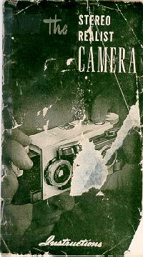

IMPORTANT NEW FEATURES IN YOUR Stereo-RealistCAMERA
(Separate booklet)
DOUBLE EXPOSURE CONTROL
A completely automatic device that now makes it impossible to accidentally double expose your film, yet enables you to make time exposures and also to make single exposures and double exposures for Hypo-Stereo, Hyper-Stereo and trick Stereo work.
INSTRUCTIONS FOR OPERATION OF NEW DOUBLE EXPOSURE CONTROL
To prevent Double Exposures
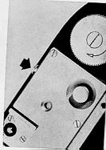 | Leave double exposure button (indicated by arrow) in this position. With button pushed in you cannot fire shutter again until film is advanced.

To take Single Exposures -
1. Cap left lens.
2. Wind the shutter.
3. Expose first picture.
4. Cap right lens.
5. Then without transporting film for next picture pull double exposure button out and release.
6. Wind the shutter.
7. Expose second picture.
For Time Exposures you must
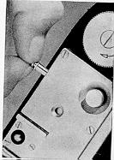 | 1. Pull double exposure button out and off center so button remains in extended position.  2. Take time exposure.  3. Be sure to release double exposure button when you are through taking your time exposure(s).
To take Intentional Double Exposure -
1. Wind the shutter.
2. Expose picture.
3. Then without transporting film for next picture pull double exposure button out and release.
4. Wind the shutter.
5. Expose picture.
You have now made an intentional double exposure. Camera will return to automatic double exposure prevention after each intentional double exposure.

DEPTH OF FIELD SCALE
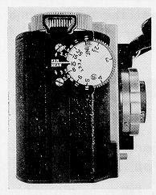 | An important feature of your Stereo-REALIST. The Depth of Field Scale indicates the maximum range of sharpness, from the nearest point to the farthest point, that may be obtained with your REALIST camera for each particular picture taking condition.  The Depth of Field Scale consists of two sets of numbers opposite the distance scale on your focusing knob. The lower set of numbers, below near on the scale, indicates the near distances at which your camera lenses are in sharp focus, depending upon the f stop number you have chosen. The upper set of numbers, above far on the scale, indicates the far distances, depending upon that same f stop number. The corresponding upper and rawer numbers on your Depth of Field Scale indicate the range of sharpness in your picture in their relation to the distance scale.
HOW TO USE YOUR DEPTH OF FIELD SCALE
A good stereo picture is sharp from the nearest to the farthest point. When you take a stereo picture, you are trying to exactly duplicate the scene as your eyes see it. The pictures you take should be just as sharp as the actual scene. The Depth of Field Scale helps you obtain this over-all sharpness.
The Depth of Field Scale indicates the maximum range of sharpness, from the nearest point to the farthest point, that may be obtained when taking a picture of a given subject.
The depth of field is dependent on two variables, the f stop you have chosen and your distance setting. The range of sharpness is found by using the same upper and lower number on your Depth of Field Scale as the one used for your f stop opening. in some instances, it may be necessary to estimate the depth of field numbers when they are between those marked on the scale.
EXAMPLES:
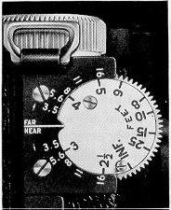 | If after using your rangefinder, the arrow indicates on the distance scale that you are 10 feet away from your point of focus, and the f stop you have chosen for the proper exposure is f:5.6, the range of sharpness for  that picture will be from 7 feet (between 5 and 8) indicated on the lower range of numbers, to 17 feet indicated on the upper range of numbers. if you choose f:l6 as your f stop for the same distance (10 ft.) your picture range of sharpness will be from 5 feet to infinity.  If you are 3 1/2 feet away from your subject, the maximum range of sharpness for that subject is from approximately 2 1/2 feet to 5 feet at f:l6.
It is important remember when taking close-ups with the subject extremely close, that the range of sharpness is greatly reduced. in these cases, small lens openings are recommended to yield the greatest possible depth of field.
You will sometimes be forced to use a certain lens opening because of light conditions. For instance, you are in the mountains, the light is very bright, you have chosen an exposure of 1/50th of a second with a lens opening of f:8. The Depth of Field Scale can now be used to bring your maximum range of sharpness to infinity by moving infinity on the distance scale opposite 8 on the upper range of numbers. if you will note on the lower range of numbers, 9 feet is opposite f:8— indicating the range of sharpness is from 9 feet to infinity in ail pictures. it is best to check the distance of a near object in your picture to be sure it is not closer than 9 feet.
Another way to use your Depth of Field Scale would be to find the distance of the nearest object and the farthest object with your rangefinder. Let us say, the normal exposure is 1 /50th at f:6.3 and the nearest object is at 5 feet and the farthest distance is infinity. Then the f stop you could use would be f:l6, which would require a shutter speed 1/5th of a second. in this particular instance, a tripod or similar support must be used.
Imagine you are taking a flash picture, there is a chair in the immediate foreground at 5 feet, a wall at 15 feet, and a group of people behind a Able at about 8 or 9 feet. Try f 8—this gives you a setting on the upper range of numbers on the Depth of Field Scale of about 11 or 1 2 feet, when setting 5 feet on the distance scale opposite number 8 on the lower range. if you go to f:11 on the scale, you have the correct lens opening or f stop for a near distance of 5 feet and a far distance of between 15 and 25 feet.
The Depth of Field and Hyper focal Table found on page 17 of your instruction book will give the complete range of sharpness for all distances.*
NOTE: There is not a sharp breaking off point between what is sharp and what is not sharp. Some leeway can be allowed before your pictures will become out of focus.
EXPOSURE TABLE
This convenient index, for basic exposures most open encountered when taking color pictures outdoors, is located under the lens cover.
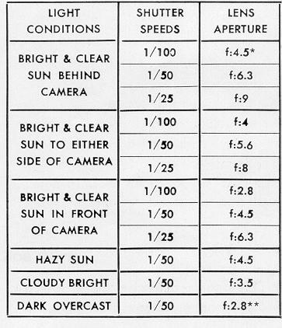

STEREO REALIST
The first American made, precision
built, true stereoscopic camera.
Foreword
if you are, as the owner of a new Stereo REALIST one who is about to use a stereoscopic camera for the first time, a rare thrill is in store for you. Your Stereo REALIST
- pictures will be so natural, so real, that you will almost expect them to come; to life.
On the other hand, if you are one of the many persons who have taken stereoscopic pictures in the past, it is probable that you have been limited to black and white film. Yours is now the new thrill of full color complemented by the third dimension—a technical achievement resulting in complete realism.
Stereoscopic (and let's not call it "stereopticon," which i s something else) photography is not new. it is, in fact, as old as photography itself, and the principles of stereoscopy were known long before that. As early as the sixteenth century, diagrams were drawn incorporating the elements of binocular vision and three dimensional seeing.
In the Stereo REALIST therefore, we claim nothing new i in principle. You will, however, find your REALIST to be a precise, well designed, high quality camera correctly incorporating the long known principles of stereoscopy, and at the same time taking full advantage of the latest developments in materials, lenses, mechanical design and color film.
We are proud of the Stereo REALIST. it is not the result I of casual or hurried designing. We are confident you
I will take pride in its ownership and experience much pleasure in using it.
DAVID WHITE COMPANY
Why we see stereoscopically
We see stereoscopically or with the "third dimension" because we have two eyes. Close one eye and the ability to judge distance or depth is lost. Each of our two eyes sees things from a different viewpoint and this difference in viewpoint, however slight, is one of the tools used by our brain to read the third dimension into things seen by the eyes. Also, the closer an object is to the eyes the more they have to converge or "toe-in" to see it. In exactly the same way as the range finder on a camera operates, this "human range finder" helps to tell us the distances to the objects we see.
The stereoscopic camera takes a pair of pictures, one picture corresponding to the viewpoint of each eye. When these pictures are viewed in the stereoscope, the left eye seeing the left picture and the right eye the right picture, the same factors of difference of viewpoint and convergence are present that were present when viewing the original scene, and we are able to interpret depth as well as though we were again actually seeing the original scene.
So we see that the two pictures of a stereo "pair" are not identical even though they are open thought to be. identical pictures, mounted as a pair and viewed in a stereoscope, exhibit no stereo relief whatever.
The stereoscopic camera is therefore actually two cameras so arranged that two pictures are taken at the same time and from the two viewpoints corresponding to the spacing of the eyes. When these two pictures are mounted as a Stereo REALIST slide and we see them in the Viewer, they blend together or merge to reproduce the original subject life size and in full color.

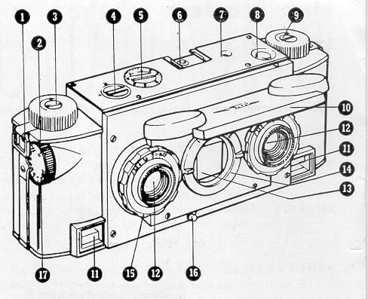 | 1. Neck strap lug  2. Focusing knob  3. Film winding knob  4. Rewind release  5. Automatic exposure counter  6. Flash attachment clip  7. Shutter-trip indicator  8. Shutter release button  9. Rewind knob  10. Plastic lens cover  11. Range finder aperture

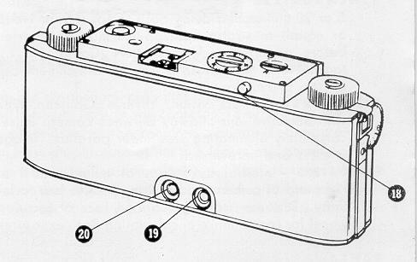 | 12. Matched objective lens  13. View-finder objective  14. Shutter speed setting ring  15. Diaphragm setting ring  - mechanically couple.  16. Shutter winding lever  17. Distance scale  18. Film wind release  19. Range-finder eye piece  20. View-finder eye piece
specifications of the STEREO-REALIST - MODEL ST41
BODY - Die cast aluminum, aluminize finish.
EXPOSED METAL PARTS - Satin chromium.
LENSES - Matched Cooke type coated anastigmat lenses of 35 mm. focal length, f:3.5, Iris diaphragms mechanically coupled.
SHUTTER - Gear retarded, ring set, winding, behind the lens type with speeds of 1, 1/2, 1/5, 1/10, 1/25, 1/50, 1/100 and 1/150 second, plus time and bulb.
SYNCHRONIZER—Built-in silver contacts—uses either 5 or 20 millisecond delay flash lamps (SM or No. 5 or equal) or strobe flash. Bulbs may be inserted before or after winding shutter. Contact to attachment for photoflash is through attachment clip on top of camera.
VIEWFINDER - Direct vision, reverse Galilean type with objective lens midway between camera lenses completely eliminating viewfinder parallax. image is erect and unreversed.
FOCUSING - Internal by means of milled wheel at right end of camera body. Range - 2 1/2 feet to infinity. Distance scale appears on face of focusing wheel for convenience in calculating flash exposures and in setting camera on the hyper focal distance.
RANGEFINDER—Coupled, split field military type. Magnification unity. Exceptionally wide base.
LENS COVER—Phenolic plastic - may be closed with filters in place. Caps viewfinder, automatically prevents exposures with lenses capped.
FILM TRANSPORT—Automatic spacing and positive locking of both winding knob and film sprocket.
FILM—20 or 36 exposures 35 mm. film in standard film magazines. Takes 16 pairs on the 20 exposure roll and 29 pairs on the 36 exposure roll. It is wise to familiarize yourself with any new piece of equipment before attempting to operate it. Therefore, before actually loading your new Stereo REALIST with film and taking pictures, we suggest that you study the following instructions carefully and learn the purpose and operation of the various controls with which the camera is equipped. Practice holding the camera before a mirror, watching particularly the position of your hands.
Lens cover
The plastic lens cover of your REALIST is designed to protect its lenses against damage and dust. To open— simply lift up from the bottom edge. A snap spring holds the cover in either the open or closed position. Since the cover in the closed position caps the viewfinder, there is no danger of forgetting to uncap the lenses.
Setting the diaphragm
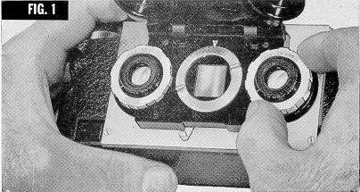 | The iris diaphragm regulates the size of the opening which admits light to the camera. To set, rotate the rim of either lens to the required setting. (See figure 1.) Since the diaphragms of the two lenses are mechanically coupled this will automatically set both of them alike. information regarding proper diaphragm openings for various conditions is provided further on in this manual.
Setting the shutter speed
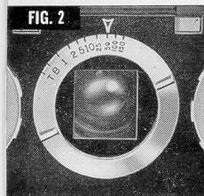 | The Stereo REALIST provides ten shutter speeds— 1, 1/2, 1/5, 1/10, 1/25, 1/50, 1/100, and 1/150 seconds, plus time (T) and bulb (B). When set on "bulb," the shutters remain open as long as the release button is depressed.  On "time," the shutters open when the release button is first pressed and close when it is pressed a second time. To set the shutter speed rotate-the ring around the viewfinder objective lens to the speed setting desired. (Figure 2.) Only the denominator of the fraction is shown: for example, 50=1/50 of a second.

Winding the shutter
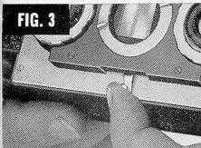 | The shutter should not be wound until after the proper speed setting has been made. To wind - move winding lever to left as far as it will go and then release. (See Figure 3.)
Shutter release
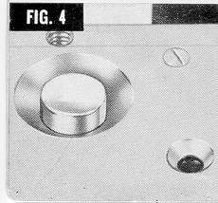 | The shutter release button is located on the left side of the too of the camera. (Figure 4.) This position makes  (Figure 4.) This position it easy to operate with the index finger of your left hand. Adjacent to the shutter release button is a socket for the cable release. Any American type with straight thread can be used.
Range finder
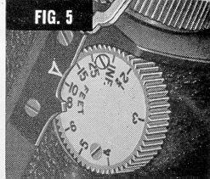 | The coupled rangefinder of the REALIST makes accurate focusing quick and easy. Looking through the rangefinder eyepiece (right hand aperture at the bottom of the camera back) select any vertical line in the view and rotate the focusing knob (Figure 5) with the second finger of the right hand until this line in the upper part of the split field matches the line in the lower part of the field. See diagrams below.  When taking pictures including considerable distance (over 100 feet) as well as foreground objects, it is advisable to set the focus on the hyperfocal distance. This setting gives the greatest possible depth of field. (See Table on page 17.) With the camera set on this distance everything will be sharp from one-half the hyperfocal distance to infinity. If no foreground objects are included, focus the camera on infinity.
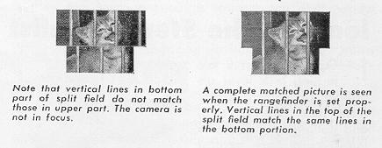
Holding the Stereo Realist
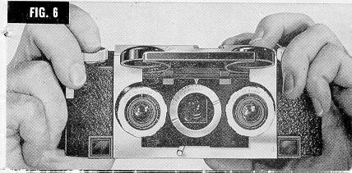 | Figure 6 shows the correct position of the hands when using the REALIST. The second finger of the right is used to rotate the focusing knob, and the shutter is operated by the second finger of the left hand. The left thumb is under the camera. Be careful that your other fingers do not obscure the two range objectives.  The location of viewfinder a n d rangefinder eye-pieces makes it easy to steady the camera against your forehead when taking pictures. (See figure 7.) Of course, the use of a tripod wherever possible will result in better pictures.

Loading the Stereo Realist
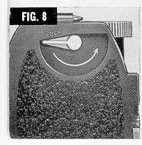 | 1. Open camera by . turning lock lever on bottom of camera away from "lock" (see Figure 8), and pulling up the end of the camera back nearest the lock lever. Remove the back completely from the camera. (See Fig. 9.) | 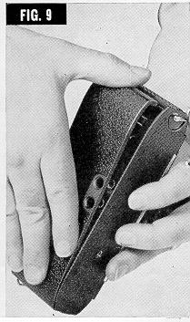

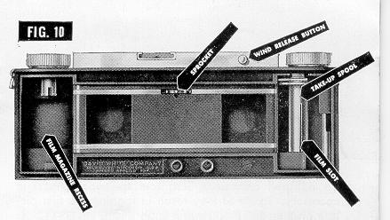 | 2. Return rewind release to normal position (2 dots together). Next, turn the sprocket (see Figure 10) in either direction with your fingers until it locks. Press film wind release button and turn winding knob until slot in film take-up spool is toward you. Pull rewind knob up as far as possible.

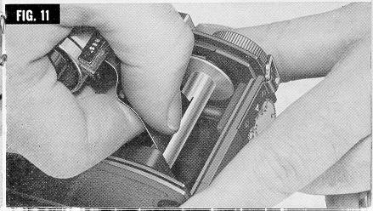 | 3. Holding film magazine in the left hand, insert 3. end of film firmly into slot in take-up spool. (See Figure 11.)

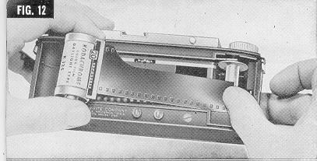 | 4. Holding right thumb on spool to prevent film pulling out, move film magazine to left end of camera and drop into its recess, allowing film to pay out from magazine as necessary.  (See Figure 12.)  CAUTION: Do not pull any more film from the magazine than necessary. To do so may result in fogging the first picture on the roll. Push rewind knob down.

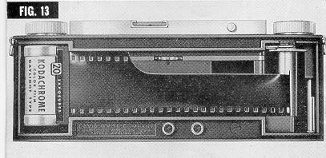 | Figure 13 Shows film in proper position ready for winding (after camera back is replaced.) Note that edge of film is even with lower end of take-up spool so that entire bottom edge of film is parallel with bottom of camera.

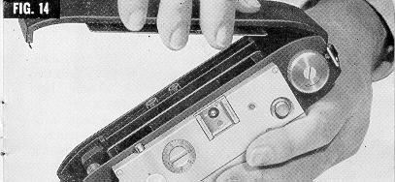 | 5. Replace camera back. in doing this, insert end with wide latch at left end of camera and swing closed as though it were hinged  (Figure 14). Turn lock on bottom of camera to lock position.
6. At this point it would be well to check the shutter . and make certain that it is closed. Then, holding thumb of left hand on rewind release button, turn winding knob in direction of arrow until exposure counter clicks. This indicates that the film perforations have engaged the sprocket and started rotating it. Now release button and continue to turn winding knob until it locks.
7. Press wind release button again and start to turn . film winding knob. Remove thumb from wind release button and continue winding until the winding knob locks. Film for the first exposure is now in place.
8. Set counter dial on number 1, turning it counter clockwise. You are now ready to make your first exposure.
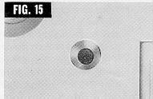 | 9. After each exposure, the shutter trip signal on top of camera (Figure 15) will show red. Repeat direction 7 to move unexposed film into position. After you have done this, the signal will show white indicating that the camera is ready for the next picture.
Caution: As with any camera using 35 mm. film magazines, the exposed film must be rewound back into the magazine before it can be removed from camera. It is important thereafter the exposure counter indicates you have made the 16 or 29 exposures (depending on which length of film you are using) not to continue winding film' since to do so would tear it from the magazine and necessitate darkroom unloading.
Unloading
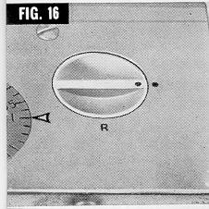 | 1. When you have finished taking exposure number 16 (or 29 in the case of the 36 exposure roll) turn rewind release so that the dot is on "R" (rewind). (See Figure 16)  2. Turn rewind knob in direction of arrow and continue turning until all the film is rewound back into the magazine. When the counter stops operating you will know that this has been accomplished.  3. Remove camera back.  4. Pull up rewind knob and remove film magazine. To reload, repeat loading instructions.

Care of your Stereo Realist
Keep your camera clean. Brush out the interior occasionally with a soft brush to remove dust. Remove any bits of film that may become lodged in the take-up spool slot or any other place.
It is necessary that the lenses be kept clean. Be careful not to touch them with your fingers. They may be dusted with a soft, clean, camel's hair brush or cleaned more thoroughly by breathing upon the surface and gently wiping with lens tissue. Do not attempt to remove any of the lenses.
Cameras in need of repair or adjustment should be returned to the manufacturer.
Mounting your pictures
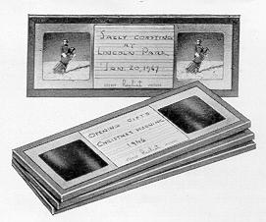 | For use in the Stereo REALIST Viewer, the pictures taken with the REALIST Camera must be mounted in the form of slides 1 5/8 x 4 inches in size with the individual frames on 2  1/2 inch centers. We recommend that you obtain the REALIST mounting kit and do this simple task yourself. This kit contains a device for cuffing the film strip into individual frames, a jig for mechanically ailgning the pictures and heat sealing them to the masks. These supplies are also available separately from your dealer.  If you prefer to have your pictures mounted for you, send them to the David White Company, using the printed forms supplied for that purpose (one such form is included with your camera) and carefully following the directions. Your pictures will be returned to you in cardboard mounts ready for viewing. For more permanent protection they may be easily removed from these mounts and bound in glass in the conventional way without special apparatus.  (I'm guessing they are out of business !)
Two types of masks are available for mounting Stereo REALIST slides. The "regular" mask is for general use and produces an apparent "window" at a distance of approximately ten feet while with the "close up" mask, which is used for portraits and other close-up pictures, the window appears about three feet distant.

General suggestions
When taking a picture, whether with a stereo camera or a single picture camera, there are only two things to determine and set distance (focus) and exposure (shutter speed and diaphragm).
The coupled rangefinder of your REALIST makes the setting of the focus easy and quick. Instructions for the operation of this control have been given on page 7 Be sure that you fully understand the matching of the split field and take a little extra time and care to be sure you have the exact focus each time. The result will be definitely better pictures. When the view being photographed includes distant objects of importance (over 100 feet) best results will be obtained by setting the focusing dial to the hyper focal distance for the diaphragm stop being used. (See table on page 17) All objects will then be in focus from one-half this distance to infinity.
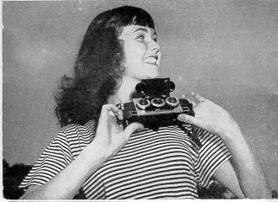 | 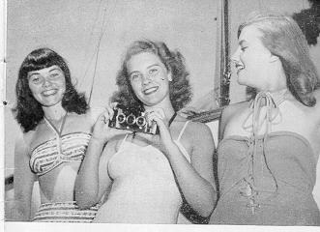
The other setting - exposure - is made up of two things: the size of the opening which admits the light (diaphragm stop) and the length of time the shutter stays open (shutter speed). The exposure required will depend upon the sensitivity or "speed" of the film being used and the amount of light falling upon the subject being photographed. The film speed may be found from the instruction sheet that comes with the film or from tables published by the film or exposure meter manufacturers. The amount of light is best determined with a photo electric exposure meter, although various calculating charts are available which work fairly well under ordinary conditions.
Having determined the film speed and the amount of light, you have the choice of any of the combinations of diaphragm stop and shutter speed settings which give the proper total exposure. In deciding which to use, consider the type of the subjects with little or no motion permit slower shutter speeds and smaller diaphragm openings, giving greater depth of field; that is, sharpness through a longer range of distances. (Table on page 17.) Moving objects require faster shutter speeds in order to "stop" the action.
Remember, the smaller the diaphragm opening (the smaller openings have the larger numbers), the greater the depth of field; the faster (or shorter) the shutter speed, the better motion will be stopped. You will soon gain enough experience and judgment to enable you to choose the proper combination of these two factors to suit any set of conditions.
The instructions up to this point apply equally well to either stereo or single picture cameras. In the matter of composition, camera angle and viewpoint, however, the stereoscopic camera offers much greater range and flexibility. Since the picture seen in the viewer will be so nearly like the original, anything that looks good to you in life will make a good picture. At will, you may hold the camera level, point it up to include tall buildings or point it down for close-ups of flowers. Aim it in any direction you would look with your own eyes and you capture what your eyes saw. Since you are now photographing things in their true spatial relationship you may let objects occupy their normal positions in space. Often your pictures will be more interesting if you purposely include foreground objects such as trees, flowers. or fences.
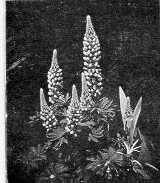 | In composing your pictures, take them from the viewpoints that look good to you at the time, with the assurance that they will look the same later when you view them in the stereoscope. You are no longer bound by rules of composition designed for flat pictures. Yours is now a new experience in photography with almost limitless possibilities. In the stereoscope you will see not a picture but the thing itself really created in all its original I beauty.  It has not been the purpose of this booklet to present a complete treatise on taking pictures, but instead to explain the operation of the Stereo REALIST Camera. For further information we suggest that you read one of the many available books on the general subject of photography.

