Ricoh Singlex
3-23-2021
This camera manual library is for reference
and historical purposes, all rights reserved.
This page is copyright© by , M. Butkus, NJ.
This page may not be sold or distributed without
the expressed permission of the producer.
I have no connection with any camera company.
On-line camera manual library
Back to main camera manual page
If you find this manual useful,
how about a donation of $3 to:
M. Butkus, 29 Lake Ave.,
High Bridge, NJ 08829-1701
and send your e-mail address
so I can thank you.
Most other places would charge
you $7.50 for a electronic copy
or $18.00 for a hard to read Xerox copy.
This will help me to continue to host this site,
buy new manuals, and pay their shipping costs.
It'll make you feel better, won't it ?
If you use Pay Pal, use the link below.
Use the above address for a check, M.O. or cash.

www.PayPal.me/butkus
Venmo @mike-butkus-camera Ph. 2083
www.butkus.us

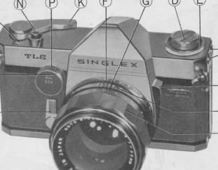

(Webmaster: This is a bayonet mount lens, manual does not state which make of bayonet.
Lens looks like a typical heavy Nikon lens. The camera has no built in light meter)

· CONTENTS
· Taking Your Picture ............... 2
OPERATING INSTRUCTIONS
· Operating Instructions ............ 2
Description of Parts ................. 3
· Loading ................................ 5
· Advancing Film and Winding Shutter .......7
· Setting Shutter Speeds ........................ 8
· Setting the Lens Aperture .................... 8
· Focusing ............................................. 9
· Releasing the Shutter to take Picture .... 10
· Unloading the Film ............................... 11
FURTHER INSTRUCTIONS AND THE USE OF OTHER FEATURES
· Ways to Hold Camera in taking Pictures .... 12
· " Depth of Field " of Photographic Lenses and their Utilization .... 13
· Depth of Field Scale on Lens Barrel ............ 14
· Lever for Previewing Depth of Field ............ 15
· Self-timer ................................................... 16
· Infra-red Marking ...................................... 17
· Changing the Lens ..................................... 17
· Removing the Lens ................................... 18
· Replacing the Lens .................................... 18
· Flash Synchronization ............................... 19
Film Speed (ASA and DIN) Reminder Dial ...... 22
· TAKING YOUR PICTURE
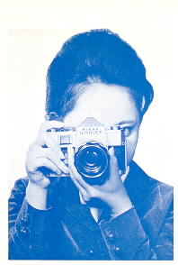 | 1. Load and advance film until counter registers "1"  (see page...5 ~ 7)  2. Set shutter speed (see page...8)  3. Set Iens Aperture (see page...8)  4. Focus and frame your picture (see page...9)  5. Depress shutter release button

· OPERATING INSTRUCTIONS
Familiarize yourself with your " Singlex ", before loading your first roll of film. Ex. amine your camera carefully and operate its controls as you would be doing when actually taking pictures. A patient study of these instructions will be rewarding.
1. Accessory Shoe for exposure meter  2. Neck strap eyelet  3. Combined preview self timer lever  4. Rewind lever (folded) | 5. Back cover sliding catch  6. Aperture scale ring  7. Focusing ring  8. Lens releasing lever
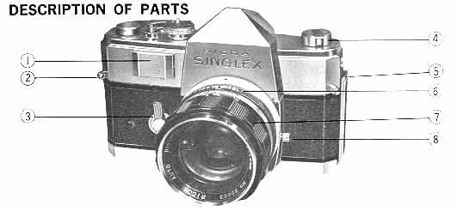
9. Cartridge chamber  10. Slotted rewind shaft  11. Tripod socket  12. Sprocket release pin  13. Sprocket teeth | 14. Take up spool  15. Eyepiece  16. Syncro sockets  17. Film type reminder
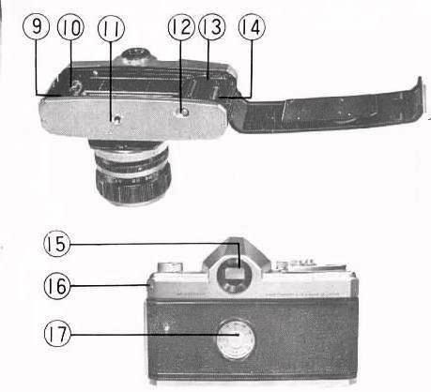

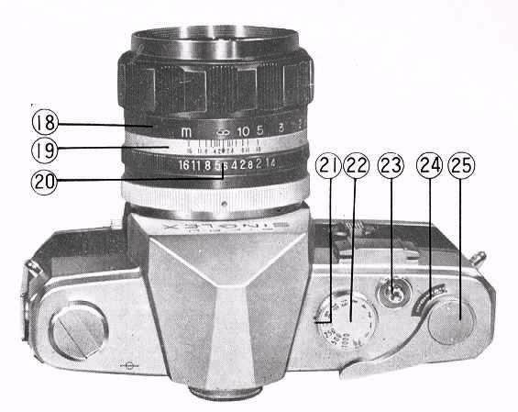
18. Distance scale ring  19. Depth of field scale  20. Aperture distance index diamond mark  21. Shutter speed index dot | 22. Shutter speed dial  23. Shutter release and cable release socket  24. Exposure counter  25. Rapid advance lever

· LOADING
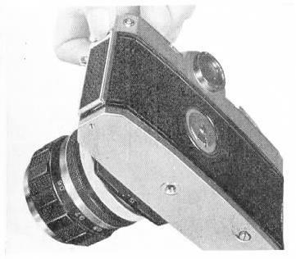 | Place camera face down on a table or other solid surface. Release the back cover by pulling up its sliding catch. The back cover will spring part-way open and may be opened fully by hand.  Push upward on the slotted rewind shaft situated inside of the chamber, towards the direction of arrow shown in the illustration.

Insert the film tongue into the groove of the " take-up " spool as far as it will go. Secure the film on the take-up spool by turning take-up spool once in the direction of the arrow on the spool.
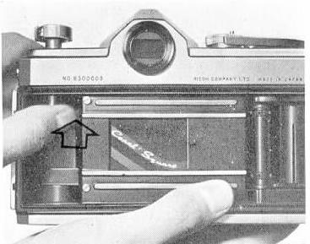 | 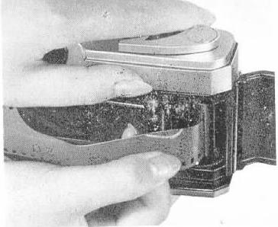
Place cartridge into the film chamber. Push back and turn the slotted rewind shaft until it engages the slot in the cartridge spool.
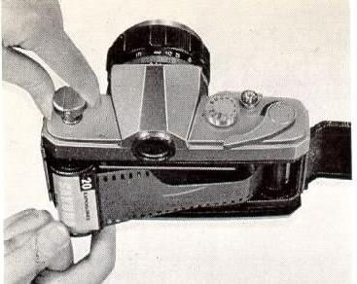 | 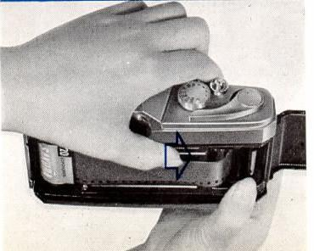
Make sure that the film is secure and that the film perforations are engaged with the sprocket teeth. Locking is automatic. Now, take up the slack of loaded film by rotating the rewind lever clockwise until tension is felt. Advance the "exposed" portion of film by winding the rapid advance lever and tripping the shutter until the counter registers " 1".
Your camera is now loaded and " ready".
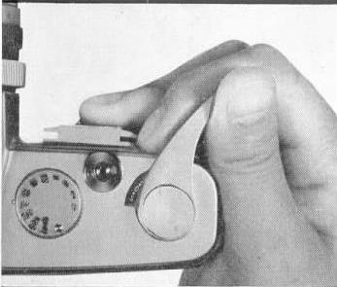 | A single, full stroke of the film advance lever, advances the film, counts the pictures taken and sets the shutter for the next picture. This operation is done as follows: 1. Put your thumb on the lever and turn it fully to the right until it stops. Do not advance the lever part way only.

· ADVANCING FILM AND WINDING SHUTTER
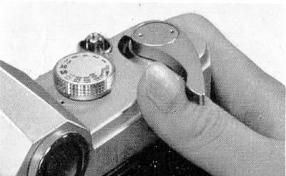 | 2. Place your thumb to original position to catch returning lever.
· SETTING SHUTTER SPEEDS
The desired shutter speed is set by rotating the shutter speed dial to the black dot on the camera top cover. This may be done before or after the shutter is wound. When set at " B " or bulb, the shutter will remain open for as long as the shutter release is held depressed. Speeds are: 1, 1/2, 1/4, 1/8, 1/15, 1/30, 1/60, 1/125, 1/500 and 1/1000 second
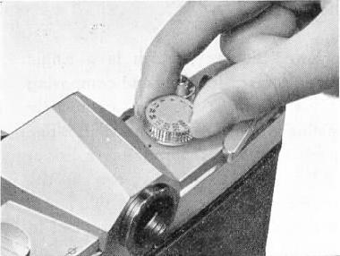

· SETTING THE LENS APERTURE
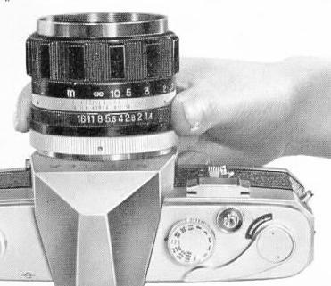 | The desired aperture opening of lens is set by rotating the aperture scale ring on the lens barrel to the red diamond mark on the "depth of field" ring. The diaphragm automatically reopens to full aperture after each shutter release. Consequently, the field of view visible before and after the shutter is released.

· FOCUSING
With your "Singlex", which is a single lens reflex camera, focusing and composing is achieved through the lens, completely eliminating the problem of parallax. The penta-prism system incorporates a bright fresnel lens for clear viewing even to the corners for perfect composition To focus, frame the subject to be photographed in the viewfinder and rotate the focusing ring either to the left or right until the split images merge into one clear image.
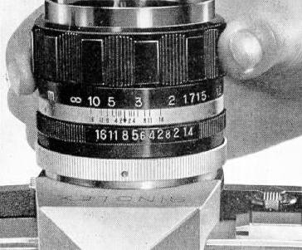
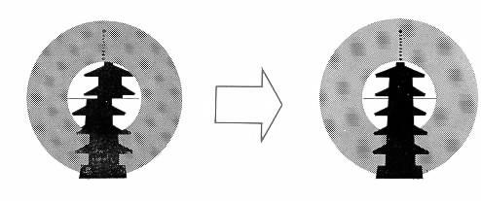
· RELEASING THE SHUTTER TO TAKE PICTURES
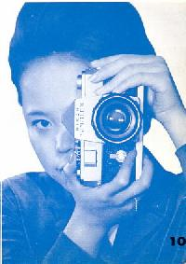 | With the subject in sharp focus and properly framed you are ready to take your picture. Press, gently, the shutter release on top right of camera. Press downward slowly until about half way and then at the precise moment of expression or Of action, press all the way. A harsh or jerky motion when used to trigger the shutter release will result in a blurred picture. Always press the shutter release button in a slow smooth manner.

· UNLOADING THE FILM
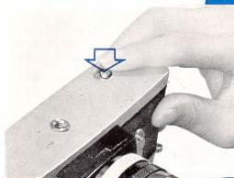 | As each picture is taken it is recorded in the film exposure counter window. When the counter reaches 20 or 36, depending upon the length of roll in the camera, proceed as follows:  Press release pin at the bottom of camera Fold out the rapid rewind lever

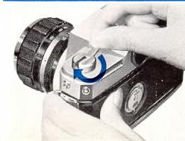 | Rewind the exposed film back into its film cartridge by rotating the rewind lever " clockwise" (in direction of arrow on knob) until no tension is felt. The film is now fully rewound. Unlock back cover and pull up the rewind lever.  With the back fully opened and the rewind shaft in the " up " position, turn the camera over and the film will drop out of its own accord.
· WAYS TO HOLD CAMERA IN TAKING PICTURES
 | 1. Hold the camera in both hands using right index finger to operate the shutter release and left thumb and index finger to adjust focusing. Use either the left or the right eye for viewing through the viewfinder eyepiece. Stabilize the camera by pressing left elbow against your side.

 | 2. Holding camera in upright or vertical position....There are two ways. One is with shutter release above your eyes and the other with the release below eyelevel. When held in former way, the film winding can be done without moving the camera from its shooting position.
However, since the camera is held high it is somewhat unstable, ' especially for slow shutter speeds. When taking still subjects, the latter manner is recommended as this position is more stable. The shutter release should be pressed with your thumb. Either way is satisfactory. Choose whichever method suits your picture taking needs.
· DEPTH OF PHOTOGRAPHIC LENSES AND THEIR UTILIZATION
Photographic lenses are capable of providing sharp focus in front of and behind the subject actually focused on. For instance, you are shooting at F2, if you focus on a subject 10 feet away from your lens objects closer than 7-5/8 inches and further than 8-3/4 inches from your main subject will be in acceptable sharp focus. The front limit to the rear limit in acceptable sharp focus is called the " Depth of Field " of a lens. This " Depth of. Field" range is shallow in the foreground and deep in the background and the limits vary with different lens openings and distances. In actual use the control of the " Depth of Field " serves as a tool to achieve desired effects and is utilized in the following two ways.
F2 F5.6
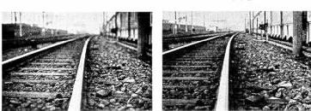
1. To obtain sharp image of subject located at different distances.
2. To limit sharpness and concentrate attention on a specific part of the scene by having only the specific " scene " sharp.
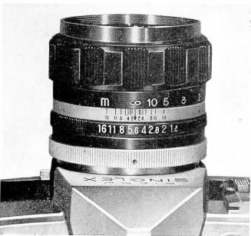 | Opposite to the distance scale on the lens barrel is a depth of field scale with lens openings 16, 11, 8, 4, 2 engraved. These, in conjunction with the distance scale give you the range of the depth for a selected lens aperture. The following method describes this feature. For instance, when taking a picture with your subject at 5 feet (1.5 meter) with lens opening at f/16, the range between the two 16s found on the scale is the distance of acceptable sharp focus. As you can see from the distance scale the front limit is 4feet (1.2 meter) and the rear limit 7 feet (2 meters).

· LEVER FOR PREVIEWING DEPTH OF FIELD
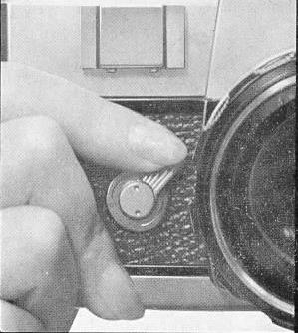 | Push combined preview-self-timer lever situated on the right front of camera in direction of "M" till it stops. The lens opening of the camera will correspond with that which you have set on the aperture scale. By looking through the viewfinder you will note the extent of the depth of field. At first it is somewhat difficult to see the depth, but practice will enable you to use this feature.

Self-timer
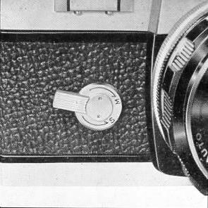 | The self-timer is built into the right of camera body. To set, push combined preview-self-timer lever in direction of "S" until it stops. To release it, depress shutter release. In 12 seconds it will trip the shutter This lapse of time is enough to permit you to get yourself into the pictured. The self-timer device is an excellent means of insuring smooth shutter releasing when very slow speeds are used. A tripod should also be used to insure steadiness when taking shots at slow speeds.
Infrared films
This infra-red marking on the depth of field scale ring is used for resetting the distance when using Black and White infra-red film.
After obtaining the correct focus, in the usual way, set the distance obtained on the scale to the red dot, instead of the red diamond. An infra-red filter is, of course, required.
· CHANGING THE LENS
This camera has a bayonet fitting mount on the front which permits removal and replacement of interchangeable lens with speed and ease.
(WEBMASTER: the manual does not state what bayonet type of lens mount. It could be the Nikon type which I have seen sold on E-bay stating that this particular model takes the Nikon lenses)
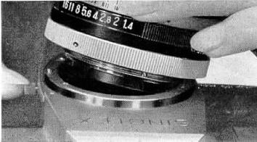

When changing the lens, do so carefully, especially, in replacing, be sure it is securely fitted to the bayonet mount. Care should be taken that the rear element of the lens does not strike against the bayonet mount of the camera body.
· REMOVING THE LENS
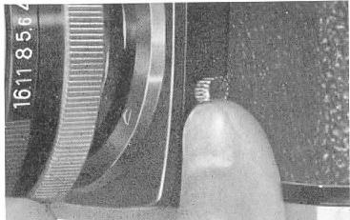 | Set the distance scale to infinity by rotating the lens barrel. Press towards the camera body the lever located at the left of the lens mount. This releases the catch which holds the lens to the camera. Now, turn lens in clockwise direction until the red dot on the camera body. Pull lens away from camera body.

· REPLACING THE LENS
Place lens, line up the red dot on:: the lens barrel with the red dot on the camera body. Turn lens counter clockwise until a click is heard. This will let you know your lens is properly seated.
· FLASH SYNCHRONIZATION
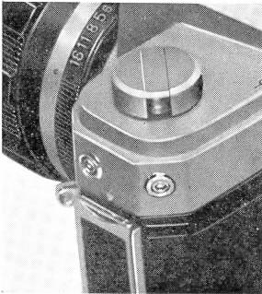 | Synchronization, here, means the coincidence of the flash with the shutter opening. The duration of the flash must be long enough to strike the film during the shutter travel. Now this duration of the flash depends on the kind of flash bulb you are using. The table on page 20 shows you what shutter speed a certain bulb or an electronic flash will synchronize when using the "Ricoh Singlex".

Two Standard sockets recessed into the left hand end wall of the camera and are color coded, M in black and X in red indicating the respective contacts, M in black and X in red. The plug from the flash unit is inserted into the socket M when using M class flash bulbs and X when using F class bulb or electronic flash unit. The red 125 on the shutter speed dial indicates the limit of speed when using an electronic flash unit having zero delay.
Class | G. E. Bulb | Permissible Shutter Speeds
M | ( 1 ) PH/5 | up to 1/1000 sec.
" | (2) PH/5B (for color film) | "
" | ( 3 ) PH/8 | " 1/125
" | (4) M 5 | 1/1000
" | (5) M 5B (for color film) | "
" | (.6 ) PH/M2 | 1/60
" | (7) PH/M2B (for color film) | "
" | (8) AG 1 | "
" | ( 9) AG 1B (for color film) | "
FP | (10) PH 6 | 1/125
" | (11) PH/6B (for color film) | *
F | (12) PH/SM | 1/60
X | Electronic flash unit, instantaneous firing | 1/125
X | Electronic flash unit, with firing delay | 1/60
FLASH SYNCHRONIZATION NOTE
1. Westinghouse PM/5, Sylvania Press 25, Dura No. 5, No. 5A, Amplex No. 5,
No. 5A, Philips PF 38 are also usable
2. Westinghouse PH/5B, Sylvania Press 25C and Press 25B, Dura No. 5B Amplex No. 5 B are also usable
3. Westinghouse PM/8, Sylvania Bantam 8, Dura No. 8, Amplex PF 4, PF 3 and PF 2 are also usable
4. Sylvania M 25 and M 5 are also usable
5. Sylvania M 25B and M 5B are also usable
6. Westinghouse PH/M2, Sylvania M2, Amplex PF 2 M are also usable
7. Sylvania M 2B is also usable
8. Sylvania AG 1 is also usable
9. Sylvania AG 1 B is also usable
10. Westinghouse PM/6, Sylvania FP 26, Dura No. 6, Philips PF 24, Osram S1, S0 are also usable
11. Westinghouse PH/6B, Sylvania FP26B, Dura No. 6B, Amplex No. 6B
Philips PF 24/97 and Osram S0 B are also usable
12 Westinghouse PH/SM, Sylvania SF, Dura SM, Amplex No. SM are also usable
· FILM SPEED (ASA and DIN) REMIND DIAL
The numbers 10, 25, 32, 50, 100, 200, 400, 800 and 1600 (11, 15, 16, 18, 21, 24, 27, 30 and 33) on the dial at the camera back are the " ASA " (" DIN ") film speed guide numbers. Setting the " ASA" (" DIN " number of your film to the black dot on the center piece serves as a reminder of the kind of film you have loaded into your " Ricoh Singlex ".
The dial is rotated by using the pin on the dial.

