PRIMO-JR
AKA Sawyer's Mark IV
POSTED 2-9-'04
This camera manual library is for reference and historical purposes, all rights reserved.
This page is copyright© by , M. Butkus, NJ.
This page may not be sold or distributed without the expressed permission of the producer
I have no connection with any camera company
On-line camera manual library
This is the full text and images from the manual.
If you find this manual useful, how about a donation of $3 to:
M. Butkus, 29 Lake Ave., High Bridge, NJ 08829-1701
and send your e-mail address so I can thank you.
Most other places would charge you $7.50 for a electronic copy
or $18.00 for a hard to read Xerox copy.
This will help me to continue to host this site, buy new manuals, and pay their shipping costs.
It'll make you feel better, won't it?
If you use Pay Pal, use the link below. Use the above address for a check, M.O. or cash.

Back to main camera manual page

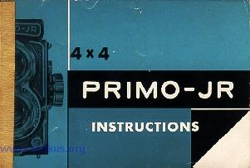

TABLE OF CONTENTS
Page
I. GENERAL DESCRIPTION AND MAJOR FEATURES 2- 3
II. SPECIAL NOTES ON OPERATION AND CARE 4--- 5
III. PRINCIPAL CAMERA PARTS 6- 7
IV. LOADING, ADVANCING AND UNLOADING FILM 8-14
V. EXPOSING THE FILM 14--20
VI. VIEWING AND FOCUSING 21-24
VII. DETERMINING THE DEPTH-OF-FIELD 24-28
VIII. FLASH SYNCHRONIZATION ... . 28-29
SHUTTER SPEED AND F-STOP COMBINATION
AT VARIOUS LIGHT VALUE INDEXES ¹⁹
DEPTH-OF-FIELD TABLE FOR PRIMO-JR
REFLEX CAMERA 26
CHART SHOWING RELATIONSHIP OF SYNCHRO SETTING,
FLASH BULB TYPE AND SHUTTER SPEED ²⁹
LIGHT VALUE INDEX EXPOSURE CHART .. 30

I. GENERAL DESCRIPTION AND MAJOR FEATURES
The PRIMO-JR is a twin lens reflex type camera taking 12 exposures of 4 cm x 4 cm size on No. 127 film. It has all the advantageous features of the twin reflex camera such as ease of handling and sharpness of focus, plus the added advantages of compact size and light weight of the 35 mm camera. The use of the 127 size film produces slides which give one and a half times larger film surface than 35 mm slides for use on projectors designed for 35 mm slides. Additionally, contact prints made from No. 127 films are large enough to permit satisfactory enjoyment even without enlarging.

The taking lens is a TOPCOR f/2.8 60 mm 4-element lens of high resolving power. The remarkable sharpness of this world-famous lens can be readily appreciated when slides taken with the PRIMO-JR are projected on the screen or when enlargement prints are closely inspected for sharpness of focus. A TOKO f/2.8 60 mm 3-element viewing lens assures bright reflection. The Fresnel lens installed beneath the ground glass screen increases the brightness of the reflected image by 2.5 times at the center and almost 10 times at the four corners. In addition, there is a 2.5 power magnifying glass to aid in critical "hair-line" focusing. Parallax compensating lines are etched on the ground glass and close-ups to about 24 inches can be made without the use of close-up adapters and parallax compensators.

The SEIKOSHA shutter is calibrated for Light Value System and has speeds of Bulb, 1, 1/2, 1/5, 1/10, 1/25, 1/50, 1/100, 1/250, 1/500 seconds. Flash synchronization settings are M, F, and X. The Light Value Scale intervals, except for 1/500, are in alignment so that the changes in shutter speeds and F-stops are coupled automatically.
The film is transported by an one-action pendulum swing of the crank which makes rapid sequence photography possible. The shutter is cocked simultaneously with the winding of the film. Except for the initial setting at "1", film exposure counting is also automatic and the exposure counter advances to ZERO mark after the last exposure is made and the film is completely wound on the Take-up Spool.

II. SPECIAL NOTES ON OPERATION AND CARE
This camera is a precision instrument. So please read the following notes carefully to insure long life and satisfactory operation of your camera.
1. Do not move the Exposure Counter Activating Button (15) when the camera is empty.
2. In case the Shutter Release Button (10) or the Film Winding Crank (13) becomes jammed on an empty camera, open the Back, remove the Film Take-up Spool and turn the gear with your finger tips until the Film Exposure Counter advances to ZERO mark .
3. To avoid damage to the shutter mechanism, do not re-set the shutter from the 1/500 speed AFTER it has been cocked.
4. Do not leave the camera with the shutter cocked for any period of time because this will weaken the delicate shutter springs.
5. To preserve the life of the shutter, leave the Synchro Setting Lever at "X" position when the camera is not used for flash photography.
6. Take extreme care in cleaning the lenses by using only very soft lens brush or clean soft chamois or soft bleached gauze daubed with a little alcohol or ether.

7. After using the camera at the seashore or in extremely damp weather, wipe it thoroughly with dry soft cloth.
8. When storing the camera for a long period of time, keep it in a plastic or vinyl bag with some moisture-absorbent, like silica gel.
9. If any part fails to work smoothly, do not force it but read carefully the relevant section of this operating instructions once more.

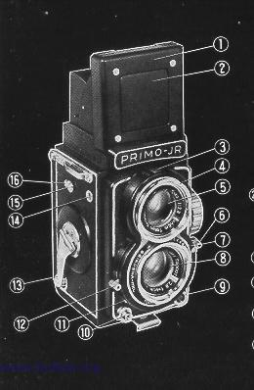 | 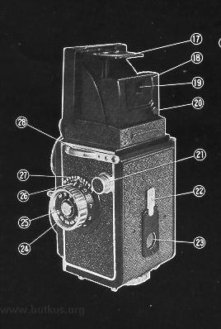
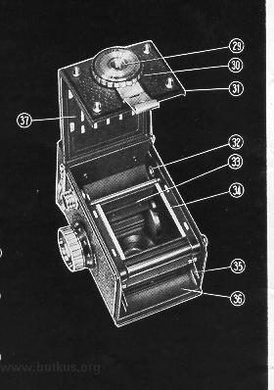

III. PRINCIPAL CAMERA PARTS
1. Focusing Hood | 20. Eye-level View-finder Release Button  21. Film Take-up Spool Pull-out Knob  22. Red Window Cover  23. Red Window
2. Eye-level View-finder Frame Plate
3. Shutter Speed and F-stop Indicator Window
4. Bayonet Mount for Accessory Attachment  5. Viewing Lens | 24. Focusing Knob
4. Bayonet Mount for Accessory Attachment  5. Viewing Lens | 25. Film Speed Indicator Disc  26. Distance Scale  27. Depth-of-Field Scale  28. Neck Strap Eyelet  29. Tripod Socket  30. Back Cover Locking Disc  31. Back Cover  32. Film Take-up Shaft Key  33. Anti-reflection Baffles  34. Film Guides  35. Film Spool Holder  36. Film Feed Trough Plate  37. Film Pressure Plate
6. Combined F-stop and Light Value Setting Lever
7. Light Value Scale
8. Taking Lens
9. Synchro-terminal
10. Shutter Release Button
11. M.F.X. Setting Lever
12. Shutter Speed Setting Lever 13. Film Winding Crank
14. Exposure Counter Window
15. Exposure Counter Activating Button
16. Exposure Counter Activating Button Safety Lock
17. Magnifying Glass
18. Eye-level View-finder Rear Plate 19. Eye-level View-finder Rear Sight

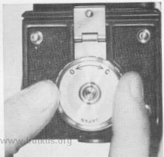 |  | IV. LOADING, ADVANCING AND UNLOADING FILM
 |  | A. To Open Camera
(1) Unlock Back Cover (31) by turning the Back Cover Locking Disc (30) as far as it will go towards "O" (Open).
(2) Lift up Locking Clip and swing Back Cover (31) to full open position.
 |  | B. To Insert Film
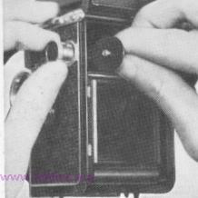 |  | B. To Insert Film
 | (1) Pull Film Take-up Spool Pull-out Knob (21 all the way out and give it a quarter turn to lock in position.
 | (2) Insert slotted end of the film Take-up Spool into Film Take-up Shaft Key (32). (Note : This operation can be facilitated by first turning the Film Winding Crank (13) until the Key is in horizontal position.)

(3) Release Film Take-up Pull-out Knob (21) back into place. | 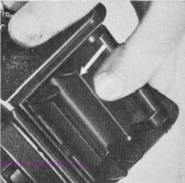
(4) Slowly turn Film Winding Crank (13) to make certain that the Take-up Spool is revolving properly. Stop when the longer slit on the spool faces up.
(5) Pull back Film Feed Trough Plate (36) against spring tension, then release and lock Spool Holder (35) into stationary position by catching lug in hole.
 | 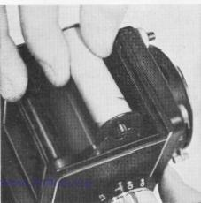
(6) Install new roll of No. 127 film into position on the Film Spool Holder (35) with the printed side of the backing paper facing out and the open end pointing directly towards the Take-up Spool.
(7) Break and remove seal.
(8) Pull out about 4 inches of the backing paper and insert the tapered end as far as it will go into the slot of the Take-up Spool.

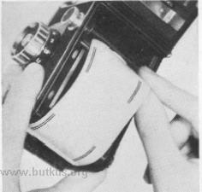 | (Note : Make sure that the film is centered evenly on the take-up spool; otherwise it may climb on the end of the spool after the camera is closed and cause tearing of the paper).  (9) Slowly turn the Film Winding Crank  (13) two or three full revolutions and make certain that the film is being correctly transported.  (10) Release the Film Spool Holder (35) to free position by pulling back on the Film Feed Trough Plate (36).
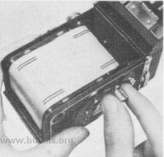
 | C. To Close Camera
 | 1) Close Back Cover (31) and snap Locking Clip back into position.
 | (Note : Make certain that the Locking Clip has engaged the short stud on the Camera Body.)
 | (2) Lock Back Cover (31) firmly by turning back Cover Locking Disc (30) all the way towards "C" (Close).

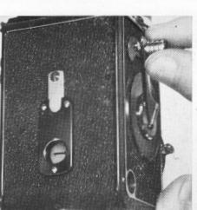
D. To Advance Film
(1) Open Red Window (23) on the back of the Camera.
(2) Slowly turn Film Winding Crank (13) until the No. 1 mark on the film backing paper appears in the center of Red Window (23).

(3) Press down on Exposure Counter Activating Button Safety Lock (16) and shift Exposure Counter Activating Button (15) to the left.
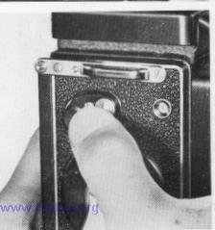
The shutter is now automatically cocked and the camera is ready for the first exposure. "Note : A click will be heard and numeral "1" will appear in Exposure Counter Window (14).)
(4) After making the first exposure, raise Film Winding Crank (13) into position and swing down 180`. Next swing up towards starting position until it comes to a stop ; fold back into inactive position. Numeral "2" will automatically appear in Exposure Counter Window (14). The shutter is automatically cocked for the second exposure.

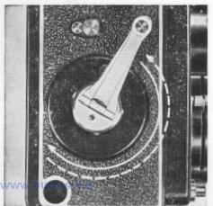

5) After the 12th exposure is completed, the !•: mark will automatically re-appear in Exposure Counter Window (14) and Film Winding Crank (13) will revolve freely.
Keep on revolving until there is no drag. This indicates that the film has been fully wound on the Take-up Spool.
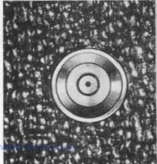 | Carefully open the Camera and unload film by pulling out Film Take-up Spool Pull-out Knob (21).  Fold back end of film backing paper and seal. Replace in original container.

FILM SPEED INDICATOR | 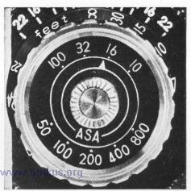
Since the faster the speed of the film used, the less the exposure required, it is convenient to remember the type of film loaded in the camera. The Film Speed Indicator (25) is provided for as a reminder and consists of a stationary dial and movable pointer which lines up with the appropriate ASA number for both Color and Black-and-White films. To operate the Indicator, press down and turn the milled button in the center of Focusing Knob (24).
SPECIAL PRECAUTION
1. The film take-up gear drive is designed to allow free full revolutions of Film Winding Crank (13) only when the camera is empty and the free position is indicated by the "0" mark in Exposure Counter Window (14). In case Exposure Counter Activating Button (15) is accidentally moved, the film winding mechanism may jam and it will not be possible to turn Film Winding Crank (13).
In case this happens, (1) Open the camera, (2) Remove the spool from the take-up chamber, (3) Revolve the geared wheel until the free position mark "O" re-appears and (4) Press Shutter Release Button (10).

2. The same operation as detailed above has to be followed in case the film is taken out of the camera before 12 exposures are completed.
3. After the camera has been loaded, operate Film Winding Crank (13) with one continuous "down-and-up" pendulum swing. In other words, avoid transporting the film with short jerky motions.
V. EXPOSING THE FILM
A photographic image is made by exposing the film to a controlled amount of light which enters the camera through the lens. The amount of light admitted into the camera is controlled by (1) the length of time the shutter remains open and (2) the size of lens opening or "F-stop" as it is sometimes called. Since the amount of light required to reproduce the image on the unexposed film is fixed, the shutter speed and F-stop are interdependent. Stating this in other words, a small lens opening (represented by a high F-stop number) will require longer light admission time, i.e. slow shutter speed. Conversely, a fast shutter speed will require a larger lens opening.

The shutter speed is indicated by red numerals appearing in Shutter Speed and F-stop Indicator Window (3) and except for "B" and "1" are fractions of a second; for example, "2" equals 1/2 of one second, "25" equals 1 /25th of one second and "500" equals 1/500th of one second. "B" stands for "bulb" which means that the shutter will remain in the open position as long as Shutter Release Button (10) is kept pressed in. The shutter speed is set by moving Shutter Speed Setting Lever (12) to the required position. The lens opening is indicated in black numerals and represents the following F-stop values 2.8, 4, 5.6, 8, 11, 16 and 22. |  | 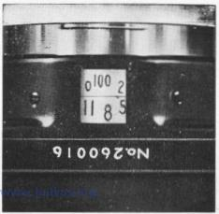
Most light is admitted on the lowest value of the scale, i. e. f/2.8 and there is approximately a 50 % decrease for each successive higher F-stop after f/2.8 with the least amount of light passing through the lens at f/22. |  | 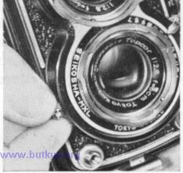
In photographing a picture-subject, there are three factors which must be taken into account; namely, the brightness of the object to be photographed, whether it is in motion, and the speed or sensitivity of the film used. To obtain a good photograph it is important to ascertain the proper combination of shutter speed and lens opening before exposing the film. This is done either by setting the shutter speed and lens opening separately or by setting the light value index only.

Determining Proper Exposure by the Light Value System:
It has been said in the foregoing that shutter speed and lens opening are interdependent. Since the lens opening determines, in part, the near and far limits of sharp focus and since the shutter speed must take into account the rate of speed of a moving object, the problem of obtaining the proper F-stop and shutter speed combination has heretofore been a source of perplexity to most beginners.
A light value index simplifies this by representing the correct relationship between the shutter speed and lens opening with one number or index. It is determined with an exposure meter with a light value scale or by following the exposure chart provided for in the final page of this operating instructions. To obtain the correct exposure, this index is transferred to the corresponding index on Light Value Scale (7) of the camera. Movement of Shutter Speed Setting Lever (12) will automatically change the lens opening within the limits of the same light value index and since the two are coupled, various combinations of proper shutter speed and lens opening are obtained for correct exposure under various conditions.

To illustrate this by a concrete example: Suppose we are using an ASA 100 film and photographing a street scene at mid-day in spring for which the Light Value Index is "13". This means that shutter speed lens opening combination should be 1/50-f/12.8  Move Combined F-stop and Light Value Setting Lever (6) to "13" on Light Value Scale (7). In case this Light Value Index should fall outside the range of travel of Combined F-stop and Light Value Setting Lever (6), move Shutter Speed Setting Lever (12) until the required Index "13" comes within the range of travel of Combined F-stop and Light Value Setting Lever (6).  If the picture-subject is in motion, the shutter speed can be changed to 1/100 sec. by moving Shutter Speed Setting Lever (12). Setting the shutter to this new speed will automatically set the lens opening to f/9.1 resulting in a new combination of 1/100 - f/9.1 to give the same exposure as the original 1/50 - f/12.8 combination.  On the other hand, let us suppose that a greater depth-of-field is desired and the lens opening of f/11 is called for. Move Shutter Speed Setting Lever (12) until the black numeral "11" appears in Shutter Speed and F-stop Indicator Window (3) indicating that the F-stop value is f/11. The shutter speed will automatically shift to the slower speed of 1/50 sec. to give us the same exposure as the two foregoing combinations. | 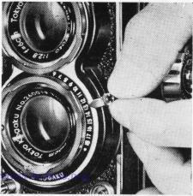

The table on page 19 shows in chart form the inter-relationship between shutter speeds and F-stops for the various light value indexes.
NOTE
1. From the Chart on page 19, it will be observed that for any given shutter speed the range within which it is coupled automatically with the F-stop is restricted; for example, for 1/50 sec. the shutter speed and the lens opening are automatically coupled for Light Value Indexes between "9" and "14" only. Therefore, if the light value reading on the exposure meter happens to be "5", it will be necessary to move Shutter Speed Setting Lever (12) to a slower speed in order to bring Combined F-stop and Light Value Setting Lever (6) within its free travel range.
2. Since the speeds on this shutter are not in multiple series, the lens opening numerals at shutter speeds of 1/10 sec. 1/25 sec. 1/100 sec. and 1/250 sec. will not appear in the exact middle of the Indicator Window. This, however, does not affect the correct exposure since, with the exception of 1;'500 sec., the scale intervals are in alignment and the shutter speed and lens opening are coupled automatically for correct exposure.
3. Because of the design of this shutter, the light value index should be ADVANCED to the next higher number when changing the shutter speed from 1/250 sec to 1,'500 sec. This, in effect, decreases the lens opening to the next higher F-stop value and compensates for over-exposure. Conversely, in changing from 1/500 sec. to1/250 sec., RETARD the light value index to the next lower number to compensate for under-exposure.

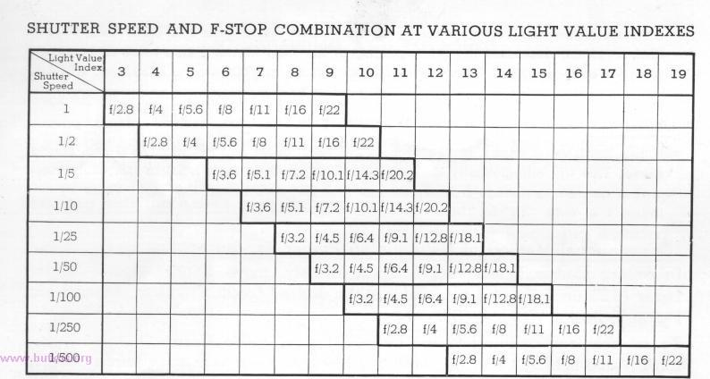
Example :
If the light value index is "14" for 1/250 sec., re-set to "15" for 1/500 sec, shutter speed. This will automatically decrease the lens opening from f/5.6 to f,'8. Conversely, if it is desired to change from 1,'500 sec. to 1/250 sec., retard the Light Value by one index, i. e. from "15" to "14".
Conventional Method of Determining Proper Exposure
In setting shutter speed and F-stop separately, move Shutter Speed Setting Lever (12) until the red numeral is at the desired position in Shutter Speed and
F-stop Indicator Window (3).
To set the lens opening to the desired F-stop, move Combined F-stop and Light Value Setting Lever (6) until the black numeral is at the desired position
in Shutter Speed and F-stop Indicator Window (3).

VI. VIEWING AND FOCUSING
One of the main advantages of a reflex camera is that it allows the operator to look directly at the image appearing on the Focusing Screen while turning Focusing Knob (24) to bring the picture-subject into critical focus. There are four basic positions of holding the camera for viewing and composing the picture; namely, waist level, eye level, above eye level and ground level.
Focusing with the Reflex View-finder
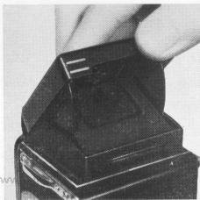 | Under most conditions the best method of focusing this camera is to look at the image on the Focusing Screen. The image appearing there is identical to what will be exposed on the film.
 | A. To Open the Focusing Hood
 | 1. Lift the rear edge of Focusing Hood (1) until it springs up into full open position.
 | B. To Use the Magnifying Glass

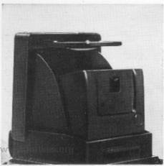 | 1. Magnifying Glass (17) is raised into position by pushing the upper edge of Eye-level View-finder Frame Plate (2) inwards. This will snap it into position. The eye should be brought as close as possible to Magnifying Glass (17) to obtain "hair-line" focusing. This glass has a magnification power of 2.5 times. It can be easily snapped back into lowered position by a light pressure on its outer edge.
Focusing with the Direct View-finder
In addition to the reflex view-finder method, it is also possible to focus this camera by using Distance Scale (26) and composing the picture through the Eye-level View-finder. Under this method, the distance from the picture-subject to Taking Lens (8) is measured, or estimated, and the resulting footage is read off on Distance Scale (26) directly below the "2.8" figure on Depth-of-Field Scale (27). This method is commonly used for fast-action photography.

To Use the Eye-level View-finder. | 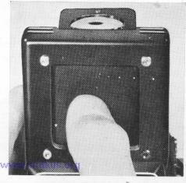
1. Raise Magnifying Glass (17) as directed above. 2. Press Eye-level View-finder Frame Plate (2) all the way down until it locks in the lowered position.
3. Sight through Eye-level View-finder Rear Sight
(19) and compose the picture.
4. To raise Eye-level View-finder Frame Plate (2) press Eye-level View-finder Release Button (20).
5. Be sure to lower Magnifying Glass (17) before folding Focusing Hood (l.)
 | 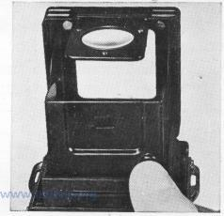
PARALLAX COMPENSATION LINE
When photographing picture-subjects at very close distances (under 24 inches or so) the image on the Focusing Screen covers an area much greater than that registered on the film. This error is due to the difference in the vertical positions of the Viewing Lens (5) and the Taking Lens (8) in relation to the picture-subject and is called "parallax". The two short lines etched horizontally on the upper edge of the Focusing Screen mark the upper limits of the picture composition and in taking close-up shots, care should be exercised to keep the reflected image below these lines.

VII. DETERMINING THE DEPTH-OF-FIELD
A. What is Depth-of-Field ?
When a camera is focused on a picture-subject, there is a zone in front of and to the rear of the picture-subject within which all photographed images are in acceptably sharp focus. Images falling outside this zone become progressively blurred and out-of-focus. This zone of acceptably sharp focus is called "depth-of-field", or sometimes "depth-of-focus" and is indicated in numbers of feet measured from the film surface.
B. Factors affecting "Depth-of-Field"
Generalizing broadly, it can be said that "depth-of-field" is primarily determined by (1) distance and (2) lens opening. Since it is axiomatic that the closer the picture-subject is to the camera, the narrower the zone of acceptable focus, it is very important for beginners to exercise great care when photographing at close distances.
As for the second factor, the larger the F-stop value (smaller lens opening), the greater the resulting "depth-of-field" and conversely, a small F-stop value (larger lens opening) will decrease the zone of sharp focus. To illustrate this relationship, it can be noted from the following Depth-of-Field Table that at "infinity" distance and f/22 lens opening, the zone of sharp focus for this camera is between 10.7 feet and - (infinity) while for f/2.8 this zone decreases to a range between 84.8 feet and - (infinity).
On the other hand, when the picture is taken at a relatively close distance of 5 feet from camera the "depth-of-field" with f/2.8 opening lies between 7.4 feet and 5.3 feet while for the camera distance of 30 feet, the "depth-of-field" covers a wider range; namely, between 22.2 feet and 46.4 feet.

C. How to Read the "Depth-of-Field" Scale
1. Read off the F-stop number on Shutter Speed and F-stop Indicator Window (3). (We will assume for the purpose of this illustration that this number is "8")
2. Observe that there are two figures "8" etched on Depth-of-Field Scale (27)
3. Now read the figure (or approximation thereof) on Distance Scale (26) immediately under the rear "8" (as seen by operator with camera in taking position). This is around "7.5" and indicates that the near limit of the zone of sharp focus is 7.5 feet.

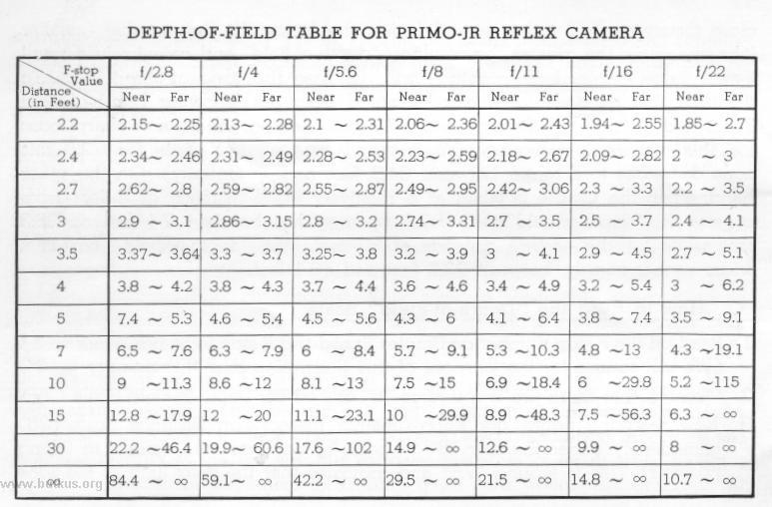

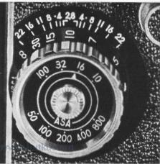
4. Next read the distance figure immediately under the forward "8" (again from operator's position)
This is "15" and means that the far limit of the zone of sharp focus is 15 feet.
5. Summarizing, the "depth-of-field" for this particular exposure (F-stop 8, focusing distance 10 feet lies between 7.5 feet and 15 feet and signifies that any image lying within these near and far limits is in acceptably sharp focus and images which are closer or farther away from the camera will appear progressively blurred on the finished print.

(Note: Because of restricted space, the figures for "5.6" are omitted on the scale and their positions are indicated by small white dots to the front and rear of the pair of figures "4".)
D. Practical Application of "Depth-of-Field"
The Distance Scale (26) and Depth-of-Field Scale (27) can be used in combination with each other for rapid sequence photography. Since we have found from the above illustration that any image falling within the zone between 7.5 feet and 15 feet will be in acceptable sharp focus, it is possible to take as many photographs as often as one wishes without re-setting or re-focusing the camera provided, of course, the light conditions have not changed appreciably in the meantime.

VIII. FLASH SYNCHRONIZATION
By using an appropriate flashbulb, photographs may be taken at night, indoors, in the shade or against the light in bright daylight. The flash synchronization mechanism on this camera has a 3-position selection which makes possible the use of M, F and X settings. Consequently, by selecting the proper type of flashbulb and matching it with the proper synchro setting, complete flash synchronization for Bulb and between 1 second to 1/500 th of a second is obtained. The synchro setting is changed by shifting M. F. X. Setting Lever (11) to the desired position.
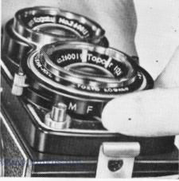
Note : The synchro-terminal is of the European type.
The exposure in flash photography is determined by the brightness of the light source and the distance of the flashbulb from the picture-subject. This relationship is worked out from the guide number supplied by the flashbulb manufacturer by applying the following formulas

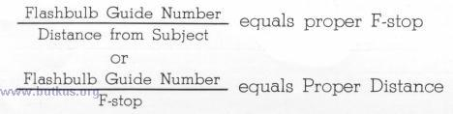
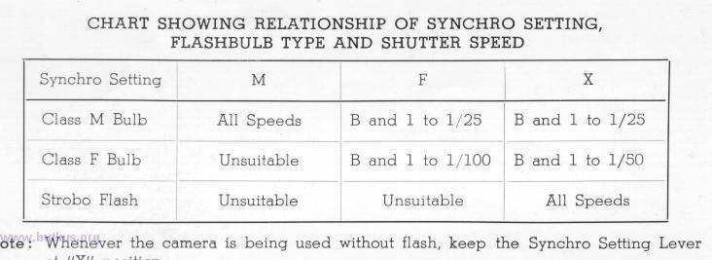

LIGHT VALUE INDEX EXPOSURE CHART
For Film: ASA 100 With Light: Shortly Before and After Mid-day At Latitudes: 25° to 50' North

Light Value Chart
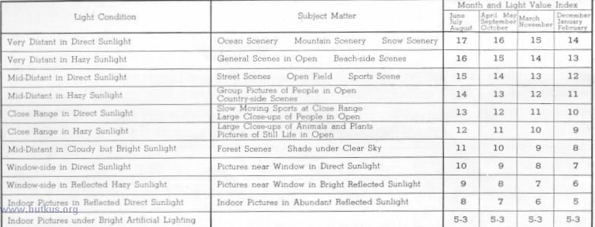
CORRECTION FACTORS (ADD TO OR DEDUCT FROM LIGHT VALUE INDEX IN ABOVE CHART)
Between 9 AM and 3 PM Deduct One Index
 | Between 8 AM and 4 PM Deduct Two Indexes | For Y 2 Filter Deduct One-Half Index For 02 Filter - Deduct One Index
 | Between 7 AM and 5 PM Deduct Three Indexes
 | Cloudy Day- Add One Index | For ASA 50 Film Deduct One Index
 | Rainy Day Deduct Two Indexes | For ASA 200 Film Add One Index

