Praktica BC 1
Posted 9-27-'03
This camera manual library is for reference
and historical purposes, all rights reserved.
This page is copyright© by M. Butkus, NJ.
This page may not be sold or distributed without
the expressed permission of the producer.
I have no connection with any camera company.
On-line camera manual library
If you find this manual useful, how about a donation of $3 to:
M. Butkus, 29 Lake Ave., High Bridge, NJ 08829-1701
and send your e-mail address so I can thank you.
Most other places would charge you $7.50 for a electronic copy
or $18.00 for a hard to read Xerox copy.
This will help me to continue to host this site,
buy new manuals, and pay their shipping costs.
It'll make you feel better, won't it?
If you use Pay Pal, use the link below.
Use the above address for a check, M.O. or cash.
Venmo @mike-butkus-camera


Click here to go to main Camera Manual site

Requires a PB bayonet lens called a Prakticar
Not a Pentax K-mount
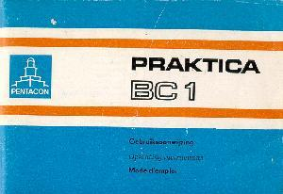

2 Introduction 4  3 Technical features 6  4 Guide to individual parts 10  5 Summary of instructions for  automatic operation 19  6 Preparing to take pictures 23  Inserting the battery 25  Checking the battery 27  Inserting the film 29  Preparing to shoot 31  Setting the film speed 33  7 Taking pictures 34 | Automatic shutter speed control 35  Semi-automatic mode 47  Flash photography 51  Changing the lens 55  Focusing 57  Depth-of-field indication 59  Stop down key 59  Shutter release 61  Locking the shutter release 61  Self-timer 63  Changing the film 65  8 Care of the camera 66
With the PRAKTICA BC 1 you have bought a quality miniature SLR camera with fully automatic shutter speed control in a range between 1/1000 s and 40 s. In addition, the camera's microelectronics make possible photography at fixed shutter speeds between 1/1000s and 1 s and unlimited shutter speeds with the B setting. The open-aperture TTL metering means a really bright viewfinder image as a result of the electronic transmission of aperture values from the lens to the camera.
There are 17 LEDs at the right-hand edge of the viewfinder image provide information on all important shot data and operations, such as the shutter speed to be expected, underexposure and overexposure, automatic and semi-automatic operating modes as well as flash readiness with dedicated computerized flash units. In addition, the preselected aperture setting is visible at the bottom of the viewfinder image. Manual corrections can be made for deliberate overexposures and underexposures. The PRAKTICA BC 1 is suitable for use with both normal electronic flash units and computerized flash units.
· SLR camera for 24 x 36 mm frame size open-aperture TTL metering system with electronic transmission of aperture values
· automatic step-less electronic shutter speed control between 1/1000 s and 40 s
· changeover from automatic to semi-automatic mode possible--fixed speed range from 1/000s to 1s
· indication of shutter speed in viewfinder by LEDs
· indication of overexposure or underexposure
· aperture setting displayed at bottom of viewfinder image
· manual exposure compensation of + 2 exposure factors
· memory locking
· self-timer (approx. 8 s) with starting button
· focusing system comprises Fresnel lens with novel diagonal triple wedge,microprism ring and ground glass ring
· flash synchronization (approx. 1/90 s) at **** or automatic formation of flash speed in automatic setting with dedicated computerized flash unit, indication of flash readiness in viewfinder
· viewfinder image shows approx. 95 per cent of picture sides
· PRAKTICA bayonet (flange focal length 44.4 mm, internal diameter 48.5 mm)
· connection for motor winder
· film information holder on rear of camera
· battery condition indication in viewfinder
· power source: 6 V primary battery
· silicon photoelement as light sensor
· metering and control range: O-17 EV at 21 DIN and aperture 1.4
· dimensions of body: 138 mm x87.5 mm x49 mm
· weight of body without battery: 530 g
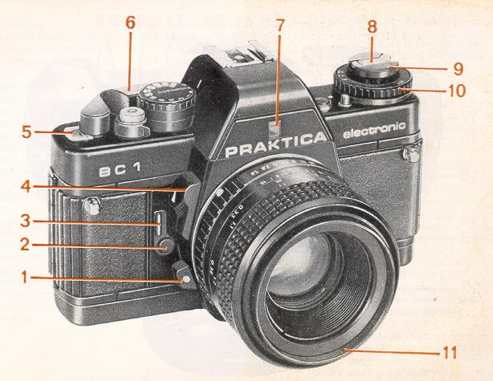

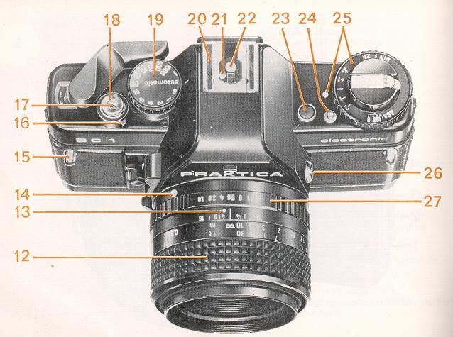

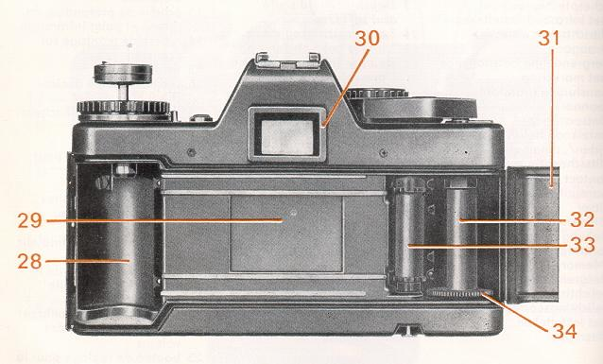

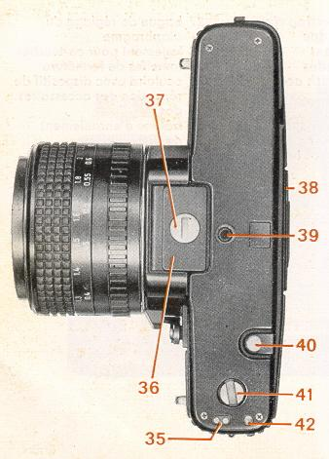

1 Unlocking key  2 Self-timer release  3 Self-timer winding lever  4 Stop down key  5 Frame counter  6 Winding lever  7 Aperture value indication  8 Rewind crank  9 Rewind button  10 Film speed setting ring  11 Filter thread  12 Focusing ring  13 Depth-of-field scale and infrared spot | 14 Lens positioning mark  15 Lug for carrying strap  16 Release lock with mark  17 Connection for cable release  18 Shutter release  19 Shutter speed/automatic setting knob  20 Hot shoe with center contact  21 Connection for computerized flash  22 Center contact  23 Memory lock and battery check button  24 Compensation unlocking button  25 Exposure compensation knob with marking  26 Flash connector

27 Aperture setting ring  28 Film cartridge compartment  29 Shutter blades  30 Eyepiece with accessory holder  31 Camera back  32 Film take-up-spool  33 Film sprocket  34 Knurled spool base | 35 Contacts for motor winder  36 Cover for battery compartment  37 Battery compartment locking screw  38 Film information holder  39 Thread for tripod  40 Rewind release  41 Coupling for motor winder  42 Catch for motor winder  43 Eyepiece cover (see page 41)

This summary is no substitute for a thorough knowledge of all the operating instructions contained in this booklet.
· Insert battery
Note + and -- pole markings in battery compartment cover (36).
· Open back
Pull rewind button (9) upwards and the back will open.
· Insert film
Adjust setting knob (19) to "automatic" or a fast fixed shutter speed. Insert film cartridge in cartridge compartment (28), press rewind button (9) back in, insert the start of the film into the slit in the take-up spool (32) and turn the spool by the knurled edge (34) towards the center of the camera until the teeth of the sprocket (33) engage in the perforations in the film. Swing winding lever (6) as far as it will go to check film travel.
· Close back
· Prepare to shoot
Carry on releasing and winding until the frame counter (5) indicates frame 1.
· Readjust setting knob (19) to automatic.
· Set film speed
Lift and turn setting ring (10) until the correct film speed is opposite the mark.
· Select aperture
Set the desired aperture using the aperture setting ring (27)
· Focus
Triple wedge: object is in focus when its contours and lines flow naturally Microprism ring: when focused correctly the object is clear and flicker-free Ground glass ring: used with poor lighting (eg for close-ups); image should appear clear and sharp.
· Release shutter
Depress shutter release (18) slightly; the camera's automatic system starts to work and an LED shows the shutter speed. If the speed suits the subject, release the shutter; if not, alter the aperture.
· Film change
Depress rewind release (40), fold out rewind crank (8) and turn in the direction of the arrow. When turning becomes easier the film has been completely rewound. Pull the rewind button (9) all the way up to unlock the back and then remove the film cartridge.
· Lens change
Press unlocking key (1), turn lens anticlockwise as far as it will go and remove. Insert the lens so that the red markings are opposite one another and turn clockwise till it locks.
Inserting the battery
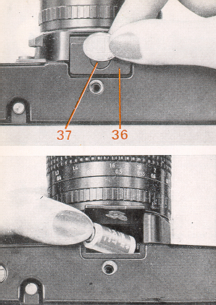 | A 6 V source is required to power the whole electronic system. It may be an alkali manganese, silver oxide or lithium battery.  Under normal conditions, a fresh battery lasts for about 2 years. To insert the battery, turn the locking screw (37) of the battery chamber cover (36) counterclockwise until the cover can be opened. Wipe the contacts in the battery chamber and those of the fresh battery with a dry cloth. Press the plus pole of the battery against the spring contact (polarity marks on battery chamber cover) and tip the battery in. Close and lock the cover.  Varta V28PXL Lithium should be the right one.
Checking the battery
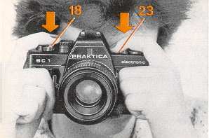 | The shutter must be wound. Press shutter release (18) and then memory button (23). If the LED indication is bright the battery still has a sufficient power reserve. When the battery is used up the LED goes out. In B and settings it is not possible to check the battery.
Special attention should be paid to the battery and contacts. Frequent checks are advisable, cleaning when necessary. The battery is sensitive to low temperatures and should be suitably protected. When the camera is not being used for lengthy periods the battery should be removed from the camera.
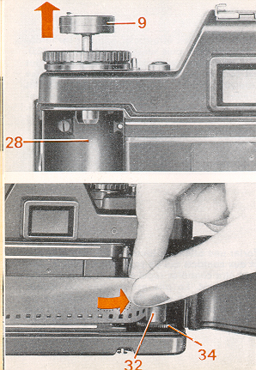 | Opening the back  Pull the rewind button (9) up as far as it will go to unlock the back. Open the back completely, the frame counter (5) will automatically return to the starting position. Insert the film cartridge into the cartridge compartment (28). Press the rewind button (9) back in all the way, turning it if necessary.  Inserting the film  Before the film is inserted the shutter speed setting knob (19) should be set to (approx. 1/90 s), as otherwise a slow shutter speed may be formed in the automatic setting. Do not use force. A slow shutter speed so formed can be cut short by changing from automatic to B. The winding lever can be operated only when the shutter cycle is completed.

Insert the start of the film at least 1 cm into the slit in the take-up spool (32). Then turn the spool by the knurled base (34) towards the middle of the camera through about one revolution. The teeth of the film sprocket (33) must engage in the perforation in the film. Check that the film is running properly by carefully operating the winding lever (6).
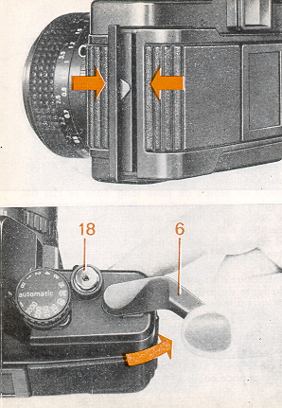 | Closing the back  Press the middle of the lock side of the back against the camera body until the lock is heard to engage.  Preparing to shoot  The winding lever (6) may be swung out a little way without starting the winding procedure. This readiness position increases handling reliability when taking rapid picture sequences.  Swing winding lever as far as it will go, return and press shutter release (18). Repeat procedure and continue to do so until the automatic frame counter (5) indicates frame 1.

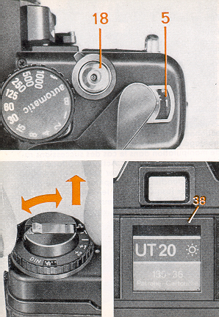 | Setting the film speed  Lift film speed setting ring (10) and turn until the film speed value used is opposite the mark.  The knurled ring locks when released. The flap from the film pack can be put into the film information holder (38) as an additional aid to the memory.
Automatic shutter speed control
In automatic mode the PRAKTICA BC1 operates automatically in a stepless shutter speed range from 1/1000 s to 40 s. The shutter speed is electronically controlled in line with the lighting conditions, the selected aperture and the film speed. LEDs at the edge of the viewfinder indicate the controlled shutter speed. Where the shutter speed range is exceeded this is indicated by OVER and UNDER. The TTL metering automatically takes into account all factors influencing the exposure such as focal length of the lens, filter and extensions. If lenses with the M 42 x 1 PRAKTICA thread are used with an adapter, light metering is automatic at working aperture.
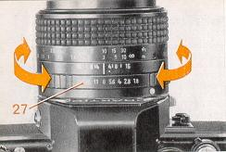 | Aperture selection  The desired aperture is set against the mark on the lens mount by turning the aperture setting ring (27). The set aperture is displayed at the bottom of the viewfinder image. As a guide, the selection of the following values can be recommended for a film speed of  20 DIN = 80 ASA:
  . | aperture
  sunshine | 8 - 11
  cloud cover | 4 - 5.6
  close-ups | not below 8
The choice of aperture can also be made according to the desired depth-of-field (foreground, mid-ground, background) and by taking into account the speed information in the viewfinder (danger of blurring). See also the section on depth-of-field indication. A small aperture means a large depth-of-field, a large aperture a correspondingly smaller depth-of-field.
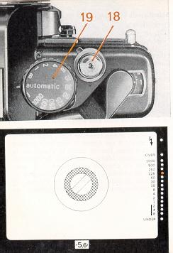 | Automatic exposure indication
Set shutter speed knob (19) to automatic. The electronics are switched on by slight pressure on the shutter release (18). In the viewfinder image the shutter speed calculated by the automatic system is shown by an LED display. If it appears unsuitable for the subject, it can be corrected by selecting another aperture. LEDs are allotted to selected speeds between 1/1000s and 8 s, with intermediate settings being indicated by the simultaneous lighting of two adjacent diodes.
Shutter speeds between 8 s and 40 s are indicated by the permanent lighting of the UNDER LED, while speeds outside the 1/1000s to 40 s range are indicated by the flashing of the LED at OVER or UNDER. In this case the shutter is set for 1/1000s or 40s. If shutter speeds of 1/15s and slower are formed, the use of a tripod or other steady surface is recommended.
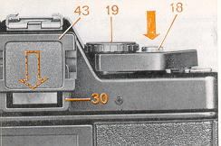' | Shutter release  After the shutter speed has been checked in the viewfinder, the shutter is operated by fully depressing the shutter release (18). When pressure is removed from the shutter release the electronics are automatically switched off. With slow shutter speeds the removal of pressure from the shutter release does not affect the exposure procedure. In this case the electronics are switched off only where the shutter cycle has been completed.
If the cycle needle to be broken off prematurely with a very long shutter speed (eg after an accidental shutter released), the shutter speed SE speed knob (19) should briefly be turned to B. If the camera is not held at eye level during automatic operation (eg with tripod shots), the eyepiece cover (43) which comes with the camera should be pushed into the holder (30). This keep light from coming in the viewing area and possibly not allowing correct exposure.
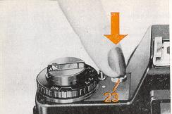 | Locking of metered values  If the subject features extreme contrasts such as  · people wearing dark clothes in sunlit snow or  · a light-colored object in front of a dark background, the exposure value can be calculated by individual metering of the most important element in the picture from close up.
The metered value calculated in the close-up measurement is stored, and the image section can be changed without another shutter speed being set.
To store the metered value first depress the shutter release (18) slightly to initiate the metering process and then briefly press the memory button (23) to lock in the metered value. The shutter must be wound. No new measurement is made before the shutter is released, and the shutter speed will correspond to the locked value.
The locked value is erased when pressure is removed from the shutter release and the electronics are switched off.
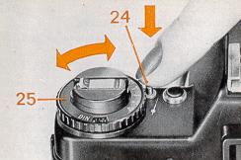 | Exposure compensation  Another way of influencing the exposure individually is by using the exposure compensation knob (25). Such compensation is necessary when the character of the object varies greatly from the norm, eg with dark objects in front of a light background (+1, +2) and with bright objects in front of a very dark background ( - 1, - 2).  Press the unlocking button (24) and turn the knob in the desired direction.

Starting from the initial position the shutter speed is reduced by 1 or 2 exposure factors when the knob is set to +1 or +2, respectively. The speed is correspondingly increased when the knob is set to--1 or--2. The knob can be set to half factors. At the borders of the film speed range--12 DIN and 36 DIN -- compensation by two factors is also possible (correspondingly to 6 DIN and 42 DIN).
The compensation cannot extend the shutter speed range beyond the speeds of 1/1000s and 40 s. Remember to return the button to the neutral initial position following exposure compensated shots.
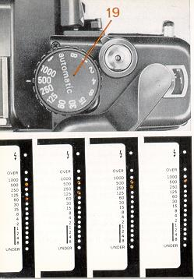 | Semi-automatic mode  If you want to shoot at a particular shutter speed, for reproductions or scientific work for example, set the PRAKTICA BC 1 to semi-automatic mode. Fixed shutter speeds from 1 s to 1/1000 are available. Select the speed you want using the shutter speed setting knob (19)--this automatically changes the camera operation to semi-automatic mode. As with automatic shutter speed control, the camera's electronics are switched on by gentle pressure on the shutter release. The shutter speed can again be checked using the LEDs in the viewfinder. While the LED corresponding to the set shutter speed flashes, the shutter speed required by the lighting conditions, the film speed and the selected aperture is shown at the same time by a steadily lit LED. (For intermediate speeds two adjacent LEDs light up.) To match the two, the aperture or shutter speed should be altered until the LEDs in the viewfinder are lit steadily. With and B settings there is no LED display. The flash speed of around 1/90 s is formed mechanically with and electronically when using a dedicated computerized flash unit in automatic position.
All other shutter speeds including B are electronically controlled. It is also possible to photograph with without a battery.
Holding the camera
The illustrations show the best positions in which to hold the camera for upright and horizontal format shots. Hold the camera steadily and tightly and support the elbows against the body. In this way you will achieve blur-free pictures.
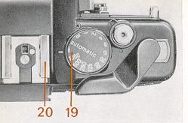 | Flash photography  If the available light is insufficient for hand-held shots (eg indoors) or if the subject has to be additionally "brightened up", flash should be used. All fitting electronic flash units can be used, whether computerized or not. Push the flash unit onto the hot shoe with center contact (20); the electrical connection is thus made. In the case of flash units without the center contact the electrical connection is made via the flash nipple. The simultaneous use of two flash units is possible with the two electrically separate connections.  For electronic flash without computer control set the shutter speed knob (19) to . The set shutter speed (around 1/90 s) is formed mechanically.
If a dedicated computerized flash unit is pushed onto the hot shoe in automatic setting, the electronic flash speed is automatically formed when flash readiness is achieved. Flash readiness is indicated by a green LED in the viewfinder when the flash unit is switched on and gentle pressure is applied to the shutter release.
All other information on automatic speeds on the display is extinguished. When fixed speeds are used, flash readiness is indicated in addition to the information on the relevant speed on the display and in and B settings.
To avoid incorrect exposures (overexposures) with flash when the surrounding light is bright, check by switching off the computerized flash unit that the shutter speed corresponding to the surrounding light is slower than 1/125s.
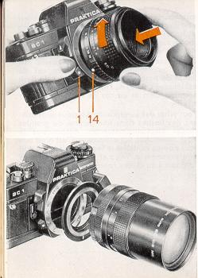 | Changing the lens  Press the unlocking key (1) and turn the lens anti-clockwise as far as it will go. Remove the lens from the camera.  Insert the lens in such a way that the red markings (1 and 14) on the camera and lens are opposite each other. Press the lens against the camera body and turn clockwise until the locking pin is heard to engage.  By using the PRAKTICA adapter all original PRAKTICA lenses with the M 42 x 1 thread can be connected, lenses of other makes with the M 42 x 1 thread must be suitable for PRAKTICA cameras and equipped for metering at working aperture. The PRAKTICA BC 1 also works automatically with screw-thread lenses, the only difference being that the light metering is made with working aperture.  Requires a PB bayonet lens called a Prakticar

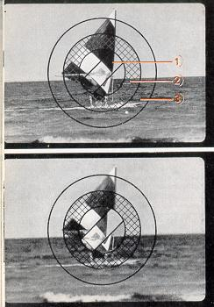 | Focusing  Focusing is possible using the triple wedge system, the microprism ring or the ground glass ring.  1) triple wedge  The wedge system allows highly accurate focusing Optimum sharpness is achieved when the contours and lines flow naturally. Incorrectly aligned edges indicate that the image is out of focus.  2) microprism ring  The image is correctly focusing when the image inside the grid is clear and flicker free.  3) ground glass ring  Especially useful in macro and micro photography and when using lenses with a small relative aperture (greater than 4). The image must appear clear and sharp in the ground glass ring.

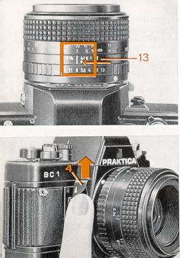 | Depth-of-field indication  The limits of the depth of field for the selected aperture can be read off from the depth-of-field scale (13) on the lens. Example: distance 3 m, aperture 8 -- depth of field ranges from around 2 m to 5 m.  Infrared photography  Infrared photography requires a slight correction to the focusing match the distance determined in focusing with the infrared mark (see arrow) on the lens.  Stop down key  The depth of field can also be judged by the ground glass ring in the viewfinder image. Push the stop down key (4) upwards. Do not meter or release when stopping down, as this will lead to an incorrect exposure.

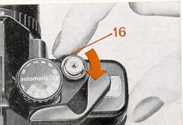 | Shutter release  For ease of operation several functions have been combined in the shutter release (18).  When the camera is wound, gentle depression of the shutter release until pressure is felt switches on the automatic system and the LEDs for shutter speeds or flash readiness (with special flash units). Further pressure will release the shutter.
Locking the shutter release
Accidental exposure and unnecessary use of power as a result of unintentional pressing of the shutter release when the camera is wound or not can be avoided by turning the release lock (16) clockwise to block the shutter release. To unlock turn in the opposite direction. Do not lock the shutter release when it is depressed.
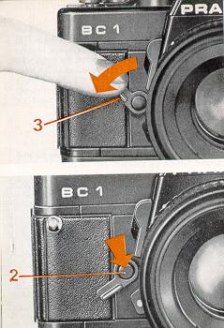 | Self-timer  Wind the shutter, swing self-timer winding lever (3) all the way down, release self-timer by pressing the starting button (2) at the pivot of the lever. The delay period is approximately 8 s.  Do not wind the shutter while the delay mechanism is running. If a motor winder is attached to the camera and switched on, 4 to 5 frames can be exposed during the delay period as in continuous operation with fast shutter speeds. If this is not desired the motor winder should be switched off.  To avoid incorrect metering in automatic operation the eyepiece should be covered with the eyepiece cover supplied.

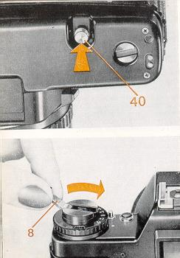 | Changing the film  The frame counter (5) indicates the number of frames which have already been exposed on a film when the shutter cycle is completed. If all the frames on a film have been exposed (red mark at 20 or 36), change the film.  Press in the rewind release (40) until it locks, fold out the rewind crank (8) and turn moderately quickly in the direction of the arrow (clockwise) until increased resistance followed by easy movement indicate that the film has been fully rewound. Pull rewind knob all the way up to unlock the back. The film cartridge can now be removed. Do not change the film in bright sunlight. If more frames are exposed than are indicated on the film pack, it is possible that the winding lever cannot be swung all the way. Do not use force. Wind back the film and swing the winding lever as far as it will go.
· Protect the camera from impact, dust and moisture.
· Clean the cartridge and spool compartments, the film track and the back from time to time with a soft brush.
· Do not use any organic solvents such as spirit or varnish thinner to clean the camera.
· Do not expose the camera or lens to aggressive vapors.
· Remove fingerprints from the lens and eyepiece surfaces with lens cleaning paper.
· Do not touch the mirror, field lens or shutter blades. Dirt on these should only be removed by a service workshop.
· Use an optical brush for dust removal or blow out.
· Do not expose the camera to very high or low temperatures for lengthy periods. Avoid, for example, placing the camera in a car window in direct sunlight. The camera should be suitably protected from extreme cold.
· When using the camera near the sea or on the beach, protect it from salt water spray and sand.
· Avoid sudden changes in temperature. These may lead to the formation of condensation and thus to corrosion damage.
· Never attempt to make your own repairs to the camera. Consult a service workshop where necessary.

