Petri MF-3
posted 3-16-'04
This camera manual library is for reference
and historical purposes, all rights reserved.
This page is copyright© by , M. Butkus, NJ.
This page may not be sold or distributed without
the expressed permission of the producer.
I have no connection with any camera company.
On-line camera manual library
If you find this manual useful, how about a donation of $3 to:
M. Butkus, 29 Lake Ave., High Bridge, NJ 08829-1701
and send your e-mail address so I can thank you.
Most other places would charge you $7.50 for a electronic copy
or $18.00 for a hard to read Xerox copy.
This will help me to continue to host this site,
buy new manuals, and pay their shipping costs.
It'll make you feel better, won't it?
If you use Pay Pal, use the link below.
Use the above address for a check, M.O. or cash.

www.PayPal.me/butkus
Venmo @mike-butkus-camera Ph 2083

Back to main camera manual page

PETRI MF-3
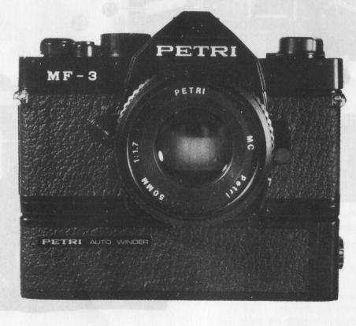 | Welcome to the exciting world of PETRI. You new camera is one of a family of professional quality cameras designed with the serious photographer in mind. And the name PETRI is your assurance of superbly crafted optics and outstanding mechanical performance and reliability.
Description of Controls
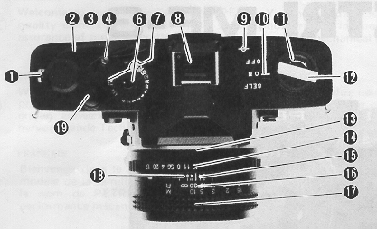 | 1. Exposure Counter Window  2. Film Advance Lever  3. Shutter Speed Index  4. Film Rewind Button  6. Shutter Speed Dial  7. Film Speed ASA Window  8. Hot Shoe  9. Film Plane Reference  10. Main Switch  11. Film Rewind Knob  12. Film Rewind Crank  13. Lens Flange  14. Aperture Ring

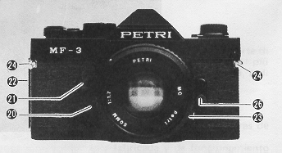 | 15. Aperture/Distance Scale Index Line  16. Depth of Field Scale  17. Focusing Ring/Distance Scale  18. Infrared Mark  19. Shutter Release Button  20. Lens Mount Release Button  21. Self timer LED  22. Removable Door Hinge

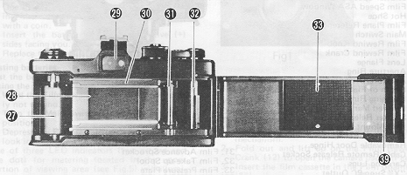 | 23. Cable/Remote Release Socket  24. Carrying Lugs  26. "X" Sync PC Outlet  27. Film Chamber  28. Film Aperture  29. Viewfinder  30. Film Guide Rails

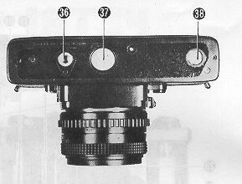 | 31. Film Advance Sprocket  32. Film Take-up Spool  33. Film Pressure Plate  36. Tripod Socket  37. Battery Compartment Cover  38. Auto-winder Coupler  39. Back Cove

POWER SUPPLY
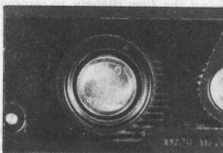 | Your MF-3 is powered by two, 1.5 volt silver oxide batteries (Eveready S-76, Mallory MS 76, G 13 or equivalent).  Battery installation  1. Open the battery compartment by unscrewing the battery compartment cover (37) with a coin.  2. Insert the batteries with the positive (+) sides facing you. (Fig.1)  3. Replace the cover and tighten it firmly.
Testing batteries
Test the batteries for sufficient power levels by taking the following procedure:
1. Wind the Film advance Lever (2) if previously not wound.
2. Turn the Main Switch Lever (10) to "ON" position.
3. Depress the Release Button (19) slightly and look into the viewfinder.
One of three LED indicators (two arrows and one dot) for metering located in the upper portion of viewing area (see Fig.5) will illuminate if there is sufficient power. If batteries are below the operational voltage of the camera system, replace them with a fresh set.
NOTE: Turn back the main switch lever to "OFF" position when you are not taking pictures.
FILM LOADING
Your MF-3 accepts 35mm, Black & White or Color film standard cassettes.
To load the camera:
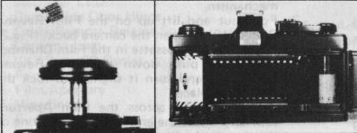 | 1. Press the release button to clear the camera mechanism.  2. Fold out and lift up on the Film Rewind Crank (12) to open the camera back. (Fig.2)  3. Insert the film cassette in the Film Chamber (27), then push down the Film Rewind Knob (11) and turn it slightly to lock the cassette in place.
4. Pull film leader across the Film Aperture (28) and insert the end of leader into one of the slots in the film take-up spool. (Fig.3)
5. With the film rewind crank in the folded out position, rewind the film slightly to remove any slack in the film cassette. Recheck to see that the film remains secured to the take-up spool and that it is properly aligned with the Sprocket (31). Fold down rewind crank.
6. Close the Back Cover (39) until you hear an audible click, which indicates that the cover is locked in the closed position. Advance the film by alternately winding the advance lever and pressing the shutter release button until the number "1" appears in the Film Counter Window (1). As the advance lever is wound, the film rewind knob should rotate, indicating that the film is advancing properly.
SETTING FILM SPEED
For properly exposed photographs, your MF-3's electronically controlled metering system must be set for the correct ASA (or DIN - for DIN equivalents,) rating of film you are using.
To set the film speed:
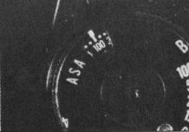 | 1. Lift the collar on the Shutter Speed Dial (6).  2. Turn the collar until the ASA rating for your film appears in the ASA Window. (Fig.4)  3. Release the collar to lock the setting in place.
SHUTTER SPEED SELECTION
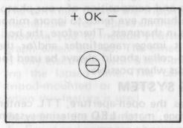 | The MF3 has a shutter speed range of 4 seconds to 1/1000 second, plus "B" (Bulb) for Time Exposures. To set the shutter speed, turn the shutter speed dial until the desired shutter speed is aligned with the Shutter Speed Index (3). When using shutter speeds below 1/30 of a second, it is advisable to use a tripod and a cable release or the exclusive remote controller to eliminate the possibility of vibration due to the camera movement. The MF-3 is equipped with a threaded Cable Release Socket (23) and Tripod Socket (36) for use with these accessories.
TIME EXPOSURES
When making time exposure photographs, your camera should always be tripod-mounted and used with a locking cable release. The MF-3's electronic shutter is capable of time exposures of up to 4 seconds.
For the time exposures of over 4 seconds in duration:
1. Align "B" setting on shutter speed dial with the shutter speed index.
2. Advance the film and press in on tip of cable release to open the shutter. Turn the cable release lock to hold shutter open.
3. After the desired exposure time in seconds has elapsed, release the cable release lock to close the shutter.
FOCUSING THE CAMERA
Your MF-3's focusing screen includes a central horizontal split-image rangefinder, which is surrounded by a microprism collar. (Fig.5)
To focus accurately:
1. Center the split-image rangefinder on your key subject and turn the Focusing Ring (17) until the upper and lower portions of your subject become one, clear vertical image.
2. The surrounding microprism collar will a) appear fragmented when the image is entirely out of focus, b) appear shimmering but viewable when image is nearly in focus and c) appears clear when your subject is in focus. It is especially useful when there are no pronounced vertical lines on your subject, making the use of the horizontal, split image rangefinder difficult.
3. The entire focusing screen may be used for both focus and composition of your photograph. The human eye tends to ignore minor differences in sharpness. Therefore, the horizontal split image rangefinder and/or the microprism collar should always be used for critical focus when possible.
METERING SYSTEM
Your MF-3 has the open-aperture, TTL centerweighted average, match LED metering system.
Setting the exposure:
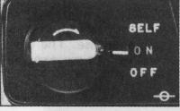 | 1. Advance the film.  2. Set the Main Switch (10) to "ON". (Fig. 6)  3. Select a desired shutter speed by rotating the shutter speed dial.
4. Depress the shutter release button quite slightly so that one of the LED indicators in viewfinder illuminates. (Fig. 7)
5. The LED indicators will tell you whether the present setting is over, under or correct exposure.
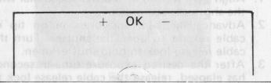 | 6. When the red warning light (+) lights it is meaning of Overexposure In this case the diaphragm ring of the taking lens should be turned to the I-) illumination or the shutter speed dial should be turned to a higher speed until the OK signal lamp lights.
7. When the red warning lamp I-) lights, it is meaning of Under-exposure. In this case the diaphragm ring of the taking lens should be turned to the direction the (+) illumination or the shutter speed dial should be turned to the opposite direction until the OK signal lamp lights.
8. The proper exposure of film is obtained whenever the OK signal lamp lights. The range that the OK signal lights is 0.3 EV. When a certain aperture size (F-stop number) is desired because of the depth of field effect (refer to the next paragraph, set the desired F-stop first and turn the shutter speed dial until the OK signal illuminates.
NOTE: When both red LEDs illuminate, you have gone beyond the cameras metering range and should, if possible alter the aperture so that a different speed can be used.

DEPTH OF FIELD
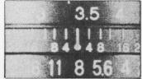 | The aperture setting determines the near and far areas in which items other than your key subject will remain acceptably sharp. This "zone of focus" is referred to as depth of field. Your lens features a depth of Field Scale (16), which allows you to select the zone of focus which will appear in the final photograph. (Fig. 9)

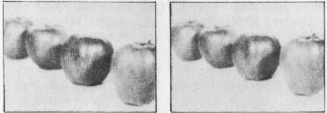 | Under normal lighting conditions, selecting a larger aperture opening (eg: F2.8 or F4( will allow you to keep your key subject in sharp focus while putting distracting elements in out of focus the foreground or background of your photograph. Under same conditions, selecting a smaller aperture opening (eg: F11 or F16) will bring both near and distant objects in focus. (Fig.10 & 11)
SELF TIMER
The self timer delays the tripping of the shutter mechanism for approximately 10 seconds, allowing you to include yourself in the photograph when desired. The timed delay function is fully electronic, with a self timer LED displaying the lapsed time. The camera should be tripod-mounted or placed on a firm support when this feature is used.
To activate the self timer:
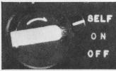 | 1. Focus and compose photograph.  2. Adjust controls for correct exposure display.  3. Turn the main switch lever to "SELF" position. (Fig.12)  4. Press the shutter release button.  5. Position yourself in photograph area within 10 seconds.
NOTE: If you decide not to use the self timer after setting it, turn back the lever to the original position. Also after photographing with self timer, turn back the lever to "ON" or "OFF" position unless you intend to take the next one with self timer. Mount the eyepiece cover (inserted in hot shoe) on the eyepiece whenever you photograph without looking through the viewfinder.
FLASH PHOTOGRAPHY
The MF-3 is synchronized for electronic flash photography by using either the hot shoe (8) or the "X" Sync PC Outlet (26). With either connection, the shutter should be set at the red 1/60 second marking on the shutter speed dial. When photographing under lighting conditions that require the use of supplementary flash illumination, use an electronic flash unit for consistency of results.
INTERCHANGING LENSES
Any wide-angle or telephoto, interchangeable lens with K type bayonet mount can be mounted on your MF-3 camera body.
To take off the lens:
1. Push the Lens Mount Release Button (20). 2. Hold the camera and lens body steadily, and rotate the lens body counter-clockwise.
3. Rotating approx. 65 degrees the lens will then become free.
To mount the lens:
1. Join the red index marks both on the camera and lens.
2. Rotate the lens body clockwise until it snaps
REMOVING FILM
When you have finished exposing the last frame in your film cassette (12, 20, 24 and 36 exposure settings are coded in red on your film counter dial), remove the cassette.
To rewind the film:
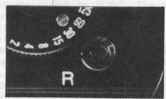 | 1. Push in the Film Rewind Button (4). (Fig.13)  2. Fold out the film rewind crank and turn in direction of arrow.  3. When the crank turns freely (without tension or "drag"), pull up on the crank to open the camera hack. The film counter will automatically reset to zero.  4. Remove the exposed cassette for processing. Insert a fresh roll of film while the camera back is still open, or close the back for storage.
NOTE: Do not load or unload your camera under direct sunlight.
CARING FOR YOUR CAMERA
1. Never force any camera operation. Consult this instruction manual if any questions occur.
2. Remove batteries when storing camera. Batteries can leak as they age, causing damage to your camera. Always inspect the batteries for signs of leakage before installing them in your camera.
3. Keep the lens cap on when not taking photographs. The cap protects your lens from dust or dirt particles.
4. Clean your camera's interior. Periodically remove any dust or film particles from the film chamber, rear lens element, take-up spool area or film pressure plate with an air blower. Inspect film pressure plate for accumulated deposits from film backing, and clean with lens cleaner and tissue if required.
5. Keep your camera and film away from direct sunlight or heat. Never store your camera or film on the rear window deck, glove compartment or other hot areas in your car.
6. Protect your camera from moisture. Do not store your camera in a moisture-retaining enclosure or environment. In areas of high humidity, extra care should be taken to insure that your camera is kept in a comparatively cool, dry location.
7. Do not touch shutter curtain.

SPECIFICATIONS
Camera Type: 35mm electronic single lens reflex camera with TTL, open-aperture, exposure balance system
Film Format: 24mm x 36mm
Lens Mount: K type bayonet mount
Flange back focus distance: 45.44mm
Shutter: Magnetically controlled cloth curtain focal plane shutter with shutter speed from 4 to 111000 sec. and B (Bulb) Flash (X) synchronisation at 1/60 sec. Electrically controlled self timer of 10-second duration with flickering lamp
Viewfinder: Fixed pentaprism type
Magnification: 1 X (with f=-55mm lens) Dioptre: -0.9
Field of view: 93% for both horizontal and vertical Focusing with horizontal split-image center with surrounding microprism collar on matt fresnel screen
Informations: Optimum, over and underexposures.
Metering System: TTL, open-aperture, match LED metering system. Average metering (center weighted) with two CdS cell metering range: EV2 - EV19 (ASA 100)
Film Speed range: ASA 25 - 3200
Film Advance: 135° rotation of wind lever with standoff angle of 30°
Shutter Release: Electrically controlled solenoid switch
Film Counter: Progressive type, Automatically resets when camera back is opened.
Power Source: 2 X S-76 (or MS 76 or G 13) 1.5-Volt silver oxide battery, Battery test with LEDs in viewfinder
Rear Cover: Removable hinge type
Dimensions: 136.5 x 83.2 x 51 mm
Weight: 530 gm.
Attachable accessories: PETRI auto-winder.
PETRI AUTO-WINDER
Specifications
Power source: 4 pcs. of AA size (alkaline) battery
Wind speed: approx. 2 frames per second at maximum shutter speed.
Photographing with the auto-winder
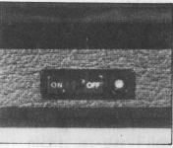 | 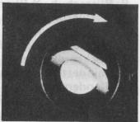 | 1. Couple the winder with the camera body. (Fig.18)  2. Tighten the screw. (Fig.19)  3. Set the switch to "ON". The winder advances the film, if the film has not been advanced.  4. Set the exposure and focus.
5. Depress the release button fully to activate the shutter. The winder will immediately start advancing the film. At this moment, if you release your finger from the release button, only a single shot is made. If you keep depressing it, continuous shots at a rate of 2 f/sec. can be made.
6. When you have finished exposing the last frame in your film cassette, take procedures as described in "REMOVING FILM". You need not remove the winder from camera body when removing film.
NOTE: Set the switch at "OFF" position when the winder is not in use.

