Honeywell Pentax
posted 4-21-03
This camera manual library is for reference
and historical purposes, all rights reserved.
This page is copyright© by , M. Butkus, NJ.
This page may not be sold or distributed without
the expressed permission of the producer
I have no connection with any camera company.
On-line camera manual library
If you find this manual useful, how about a donation of $3 to:
M. Butkus, 29 Lake Ave., High Bridge, NJ 08829-1701
and send your e-mail address so I can thank you.
Most other places would charge you $7.50 for a electronic copy
or $18.00 for a hard to read Xerox copy.
This will help me to continue to host this site,
buy new manuals, and pay their shipping costs.
It'll make you feel better, won't it?
If you use Pay Pal, use the link below.
Use the above address for a check, M.O. or cash.

www.PayPal.me/butkus
Venmo @mike-butkus-camera

Back to main camera manual page

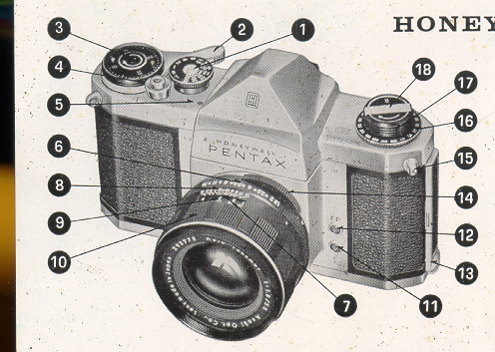 | 1. Shutter speed dial  2. Rapid wind lever  3. Film exposure count  4. Shutter release  5. "Wound" indicator  6. Diaphragm ring  7. Diaphragm and distance index  8. Depth of field guide

9. Distance scale  10. Distance scale ring  11. X flash terminal  12. FP flash terminal  13. Back lock | 14. Preview lever  15. D-ring book  16. Film type reminder dial  17. Rewind knob  18. Rewind crank

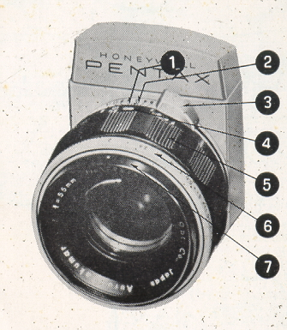 | 1. Distance index  2. Depth of field guide  3. Diaphragm winding lever  4. Distance scale  5. Distance scale ring  6. Diaphragm ring  7. Diaphragm index
IMPORTANT...read this First!
1. The "R" on the rewind knob (17) of recent Honeywell Honeywell camera bodies is green instead of red as on the previous models. Please note that the Auto-Takumar 55mm f/1.8 fully automatic lens with serial number smaller than 462500 can not be used correctly on such recent models due to modification of the Instant-Return Mirror and automatic diaphragm mechanism.
2. When advancing the film, be sure to stroke the rapid wind lever all the way until it stops.
3. Do not touch the surface of the mirror. If the mirror gets dusty, use a blower to dust it off, or dust lightly with a good camel's hair brush.
4. It your PENTAX should need repair, don t try to fix it yourself. Take it to the Honeywell PENTAX dealer from whom you purchased it. Further refer to the Warranty Policy described on the last page.
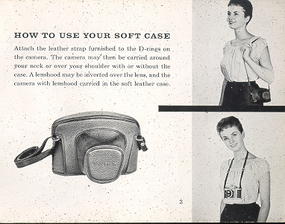

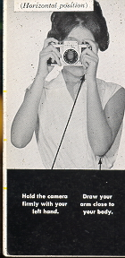 | HOW TO HOLD YOUR CAMERA  As a general rule, your camera should be held more firmly by the left hand which does not release the shutter. If you hold your camera with the right hand-- the hand which releases the shutter - it may cause movement. Very often, pictures which are not sharp are due to movement of the camera.
When you focus with the camera held horizontally, hold the lens barrel as illustrated in photograph. Put the camera on the root of your left hand thumb and little finger. Turn the distance scale ring with your thumb and index finger.
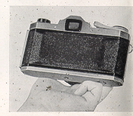
When holding the camera vertically, some people release the shutter. with the thumb (Photo A), while others release it with the index finger (Photo B). Position B is more desirable for fast focusing and shooting. With the PENTAX whether held vertically or horizontally, you can see your subject image through the taking lens, and this enables you to compose, focus and shoot faster than with any other type camera.
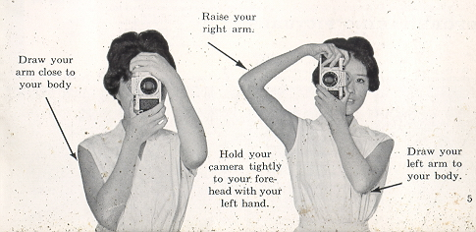
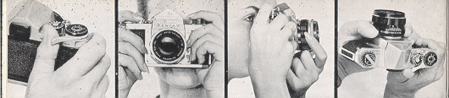
1. Wind the rapid wind lever. | 2. Compose your picture | 3. To view exact depth of field at-different apertures with the H.3, move the preview lever to "M" and view your subject while turning the diaphragm ring. On the h-1, simply turn the diaphragm ring. | 4. Select the F stop you want by setting the diaphragm ring

5. Set the proper shutter speed. | 6. Set the H-3's preview lever on "A," or wind the 6 H-1' s diaphragm lever for full-aperture viewing. | 7. Focus | 8. Trip the shutter.
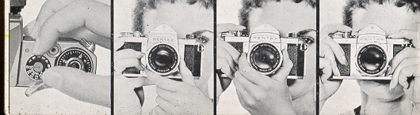

FILM LOADING
Avoid direct sunlight when loading your film
1. Open the back by pulling out the lock [13].
2. Pull out the film rewind knob [17] completely, place the film cassette into the cassette chamber [23] and push back the rewind knob. Draw out the film leader and insert it into the slit [20] of the take-up spool [21] If the slit is not in a proper position to insert the film leader, turn the take-up spool with your finger.
3. Turn the rapid wind lever [2] and make sure that both sprockets have properly engaged the film perforations. Close the back and fasten the lock E]
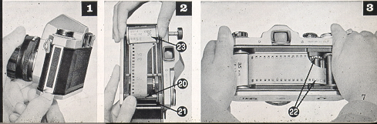

FILM WIND AND REWIND
To wind the film
4. Before turning the rapid wind lever, slowly turn the film rewind knob clockwise until a slight resistance is felt. This prevents loosening or warping of the film.
5. The first portions of the film cannot be used for picture taking as they have already been exposed to light. Generally, two blank exposures should be made before taking your first picture. Wind the rapid wind lever until it stops. Watch to see that the rewind knob is turning counter clockwise. This indicates that the film is moving from cassette to take-up spool. Trip the shutter and again wind the rapid wind lever. Set the exposure counter [3] to 0, and trip the shutter again. Your camera is now ready for the first picture. When winding the rapid wind lever for the first picture, the exposure counter automatically turns to '1', indicating that the first picture is ready to be taken.
ALWAYS WIND THE RAPID WIND LEVER COMPLETELY WITH A FULL STROKE.
6. Turn the exposure counter dial [3] in the direction indicated by the arrow. DON'T TURN IT IN THE OPPOSITE DIRECTION. After the final picture on the roll (20 or 36 exposures) has been taken, the rapid wind lever will not turn all the way as you stroke it. This indicates that the final picture has been taken on your film.  7. After the final picture has been taken, DON'T open the back or all exposed frames will be ruined. | 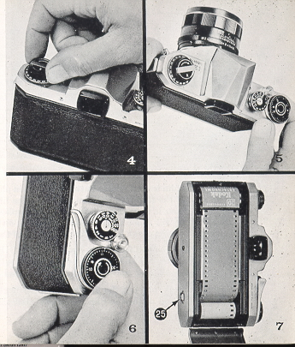

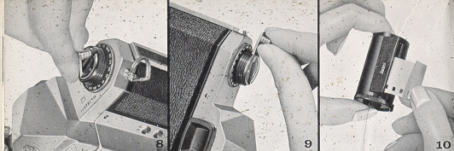
8. Unfold the film rewind crank [18]
9. Depress the film rewind release button [25] shown in photograph 7 Turn the rewind crank to rewind the film-into the film cassette. The film rewind crank permits rewinding at a smooth, even rate. Under some atmospheric conditions, erratic or too rapid 'rewinding will cause static electricity' marks on the film. You will feel the tension on the rewind crank lessen as the leader end of the film slips off take-up spool.
Stop rewinding when you feel this happen. AVOID DIRECT SUNLIGHT WHEN UNLOADING YOUR FILM. (The rewind release button [25] will return to normal positions you load your next film and turn the rapid wind lever.)
10. Open the back, pull-out (he film rewind knob [17] and remove the film cassette. Bend the leader end of the film to indicate that the film is exposed and ready ' for development.

BRIGHT FIELD FOCUSING  11. With the recent Honeywell Pentax camera with the green "R" marking on the rewind knob, you can start viewing and focusing before and after winding the rapid wind lever. When the preview lever [14] on the H-3 is set on "A", the diaphragm is fully open except for the moment- of exposure.' On the H-l, turn the diaphragm operating lever to fully open the diaphragm for bright viewing and focusing.  12. Turn the distance scale ring (Ed on the H-3; ~ on the H-l) until your subject image is clearly in focus. It is not always necessary for you to view and focus with the diaphragm fully open. In bright sunlight, you can easily focus with the diaphragm closed to fl5.6 or fl8, and still observe the depth of field. It is easier, however; to focus with the diaphragm fully open as your subject image is much brighter. | 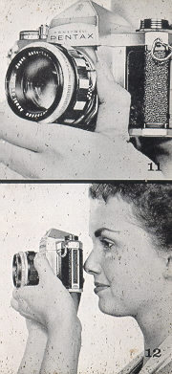

AUTOMATIC DIAPHRAGM
When the H-3's preview lever is set on "A" (Automatic), the fully automatic diaphragm is at its largest aperture (f/1.8) at all times, except for the instant of exposure, no matter what aperture is set on the diaphragm ring. When you release the shutter, the diaphragm automatically stops down to the predetermined aperture-and the shutter curtains start traveling instantly. When the exposure is completed, the diaphragm reopens to maximum 'aperture completely-automatically, and you are ready to compose, focus, and shoot your next picture. If you wish to visually check exact depth of field before making the exposure, move the preview lever to "M" (Manual).
This stops the diaphragm to the aperture selected and shows you exactly how much depth of field will appear in your picture. The preview lever may be moved back to "A" before- or after making your exposure, or, if you are making pictures in bright sunlight, it may be left on "M", which permits a constant check of depth of field.
The diaphragm of the Pentax H-1 is semi-automatic and is opened to its maximum aperture by means of the diaphragm winding lever. When the shutter is released, the diaphragm automatically stops down to the preselected aperture. To fully open the diaphragm again, turn the diaphragm lever each time before you trip the shutter. You may turn the H-l's diaphragm lever any time - before or after winding the rapid wind lever, setting the shutter speed, or focusing. After the diaphragm winding lever of the recent H-1 with the green "R" marking has been wound to fully open the diaphragm for bright viewing and focusing, the diaphragm will not be closed down manually to check the depth of field. Check the depth of field before winding the diaphragm lever.
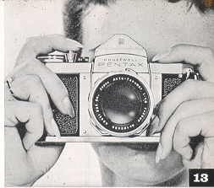 | You may turn the H-1's diaphragm ring and change the preselected aperture after winding the diaphragm lever. For example, you may change the diaphragm ring setting from f/11 to f,/5.6 after winding the diaphragm lever; the diaphragm will automatically stop down to f/5.6 when you trip the shutter.  NOTE: When you do not intend to use your Honeywell Pentax H-l for a lengthy period of time, turn the diaphragm ring to its smallest aperture (f /22) to protect its spring mechanism. Don't keep the diaphragm winding lever open. If it is opened, turn the rapid: wind lever and release the shutter button to release the spring tension.

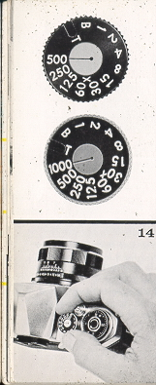 | SHUTTER  The Pentax H-3 is equipped with the following shutter speeds: T. B. 1,1/2,1/4,1/8,1/15,1/30,1/60,1/125, 1/250, 1/500, and 1/1000 sec. The H-1 has identical speeds with the exception of 1/1000 sec. On both cameras, only the figures 1, 2, 4, 8, 15, etc. appear on the shutter speed dial.  Adjustment of shutter speeds  Turn the shutter dial [E clockwise or counter-clockwise as you like, to the desired shutter speed. The shutter speed may be set either before or after winding the rapid wind lever. As you wind the shutter by turning the rapid wind lever, the "Wound" indicator [3] becomes red showing the shutter is wound. The indicator window blacks out as you trip the shutter button. For use of the X setting on the shutter dial, refer to page 24.

With the shutter speed dial set on B (bulb) the shutter will stay open as long as you depress the shutter button. As you release your finger from the shutter button, the shutter closes. When a long exposure is desired while using the B setting, attach a shutter release cable with a locking device to the shutter button. This will permit "Time Exposure." With the shutter speed dial set on T (time), the shutter stays open after the shutter button is released. To close the shutter, turn the shutter speed dial in either direction. Unless you turn the shutter speed dial? the shutter will not close.  CAUTIONS  1. At slow speeds - slower than 1/30 - support your camera rigidly or use a tripod to prevent movement of your camera.  2. To protect the shutter mechanism, trip the shutter release before putting the camera out of use for any extended period. | 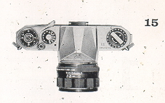

MAINTENANCE OF YOUR CAMERA
1. Protect your camera from humidity, salty air and dust. Hot temperatures above -120°f and low temperatures below - 55°f will affect the shutter performance. In extremely hot weather, try to keep your camera cool. Never put it in the glove compartment or on the rear window sill of your car. When extremely cold, try to keep the camera warm.
2. To remove grit or dirt from the camera body, use a soft brush or a dry soft piece of cloth. For the lens, use only a spray of air, soft lens tissue, or a camel hair brush. For the reflex mirror, use a spray of air or a soft camel hair brush only. Never wipe the mirror or lens surface with cloth.
3. Never use oil in your camera and do not touch the shutter curtains.
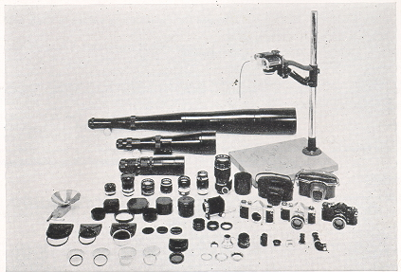
COMPETE SYSTEM OF PHOTOGRAPHY... from -photomicrography to macro photo . . .
from macro photo to close-up . . .
from close-up to infinity . . .
with a complete range of accessories and lenses.
MAJOR FEATURES OF THE PENTAXH-1 AND H-3
Here's why Honeywell Pentax cameras are the outstanding values in their field:
Type: Single lens reflex.
Film size: 35mm; 20 or 36 exposures.
Picture size: 24mm x 36mm.
Standard lenses: ~ H-1: Auto-Takomar 55mm f/2.2 with semi-automatic diaphragm. H-3: Auto-Takomar 55mm f/1.8 with fully-automatic diaphragm.

Shutter: Focal plane shutter; single, non-rotating shutter speed dial.
Speeds--H-1: T (Time), B (Bulb), 1, 1/2,1/4,1/8,1./15, 1/30, 1/60, 1/125, 1/250 and 1/500 of a second.
H-3: Same as H-1 with the addition of 1/1000 of a second.
Finder and Focusing: Pentaprism finder with microprism Fresnel lens brightened ground glass. Life size image viewing and focusing with standard 55mm lenses.
Reflex mirror: Instant return type.
Rapid film advance: Single-stroke rapid wind lever transports film and winds shutter.
"Wound" indicator: When shutter is wound, a red disc appears-in a small window along side the shutter speed dial.
Film rewind: Rapid rewind crank speeds film take-up.
Double exposure: Coupled film "wind set" prevents double exposure.
Lens moue: - Threaded lens mount for interchangeable lenses Adaptor rings are available for the use of Leica-type and Asahiflex lenses.
Flash Synchronization: FP and X flash terminals.
Film type: Color coded film type dial with ASA ratings for color, black and white, and special films.
Accessory Clip: Grooves located on both sides of the viewfinder window frame accept accessory clip and 90° finder, available as accessories.
As shown on page 2, Honeywell Pentax cameras have a Fresnel lens with a-microprism center underneath the ground glass. As you look through the finder, you will see that the Fresnel lens consists -of many concentric rings which provide the brightest possible image on the ground glass.  The microprism is the portion pointed out in this diagram. When your subject is in focus, the image in the microprism will be sharp and perfectly clear. If your subject is not in focus, the H-3's microprism will break the image. up into many small dots, much like an engraver's screen, while a number of parallel diagonal lines will appear in the microprism of the H-l. You can focus on your subject at any portion of the ground glass of either Pentax model. | 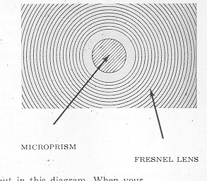

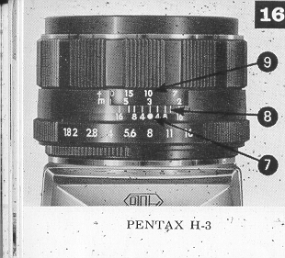 | DEPTH OF FIELD  Depth of field is the range the nearest and farthest distances which are in focus at different lens apertures. With the Pentax, you can determine the depth of field in advance by looking through the camera's taking lens with the diaphragm stopped down to the desired opening.  DEPTH OF FIELD GUIDE  If you want to know how great the depth of field is at a certain aperture, look at the depth of field guide (8,2). In figures 16 and 17 both the H-3 and H-1 have their distance scales (9,4).set at 10 feet . . . the lens is focused on a subject 10 feet away. The figures on each side of the distance index (7,1) correspond to the diaphragm setting and indicate the range of in-focus distance for different lens apertures. For example, if the lens opening of f/8 is to be. used, the range on the distance scale ring covered within the figure 8 indicates the area in focus at that lens opening. You will note from the depth of field guide that the range from 8 to 14 feet is; in focus. Note that as the lens apertures change, the effective depth of field also changes. For the depth of field when using extension tubes, refer to pages 22, 23.
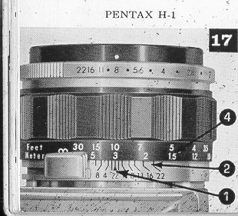

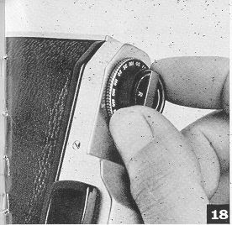 | FILM TYPE REMINDER DIAL  The ASA film speed rating of all 35 mm films is given in the data sheet packed with each roll of film. As the ASA number increases, the sensitivity of the film also increases. For example, for two films of ASA 50 and ASA 200, the ASA 50 film requires 4 times more exposure than the ASA 200 film.  Use the film type dial (located beneath the rewind knock) to show what type of film is in your camera. Simply set the ASA number of the' film you Are using opposite the -pointer. Use white figures or black and white film; red figures for color film; and green figures for special film, such as positive film, copying film, etc. To check whether the camera is loaded, turn thy film rewind. knob clockwise. If it turns freely, the camera is not- loaded.

Depth of Field Table for Auto-Takumar 55mm F/1.8 Lens - F/1.8 F/16
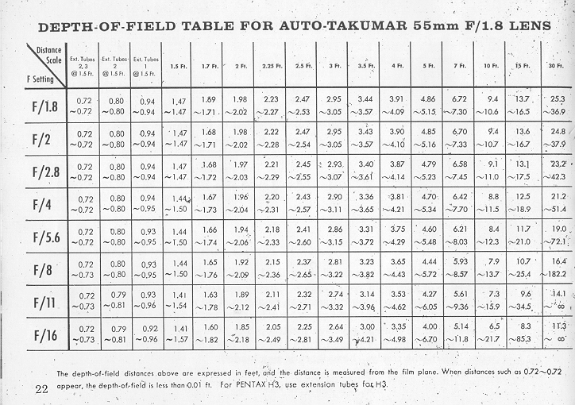

Depth of Field Table for Auto-Takumar 55mm F/2.2 Lens - F/1.8 F/22
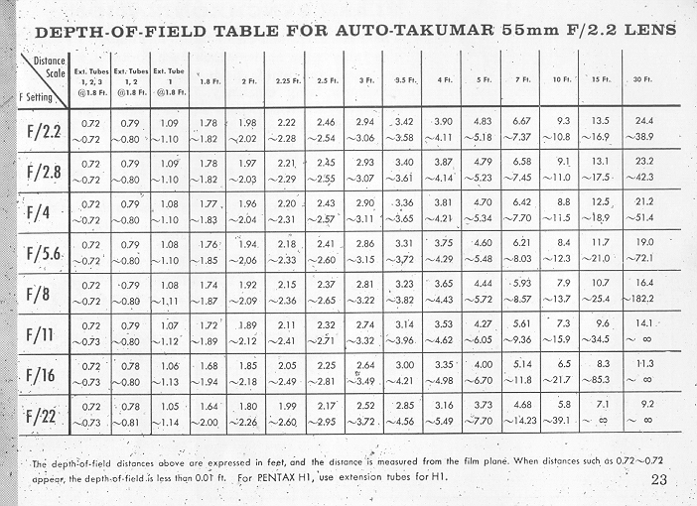

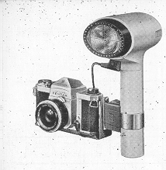 | FLASH SYNCHRONIZATION  The PENTAX has two sets of terminals--FP and X. The table below shows which flash contacts, which shutter speed and which flash bulb maybe combined for maximum lamp efficiency.. Unless these combinations are rigidly followed, there will be a failure in flash synchronization. Note the "X" setting between 61) and 30 on the shutter speed dial.  The speed of this X setting is 1/50 of a second, and this indicates the highest shutter speed at which Honeywell Strobonars or other electronic flash units may be used.

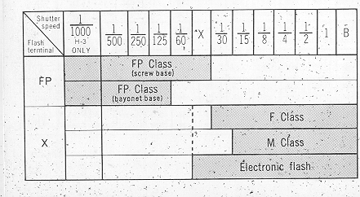 | 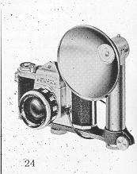

INTERCHANGEABLE LENSES  The PENTAX offers many interchangeable lenses, all of which are widely respected by professional and amateur photographers for their fine resolution. The photographic coverage of the various Takamar lenses is illustrated on the next page. With focal. lengths longer than 55mm, the subject image is seer' through the viewfinder larger than its life size. Regardless of the lens selected for the PENTAX,. there is never need for an accessory viewfinder, ordinarily required for rangefinder type cameras.  When interchanging lenses, hold the lens by the distance scale ring (A) as shown in photograph 20. When attaching a lens; filter, or lens hood, do not screw it too tightly, as you may find it difficult to unscrew. | 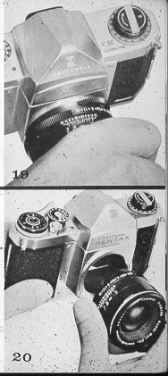

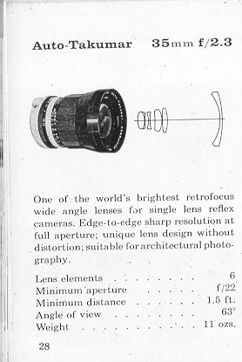 | 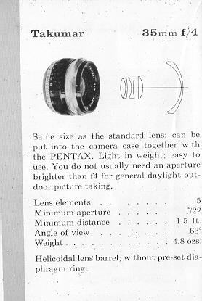
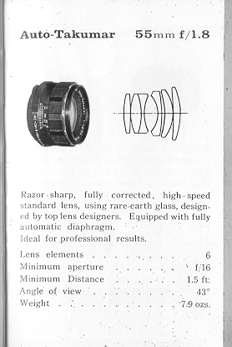 | 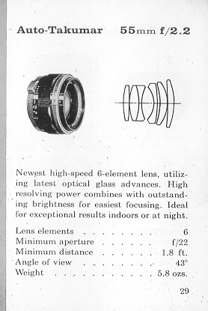
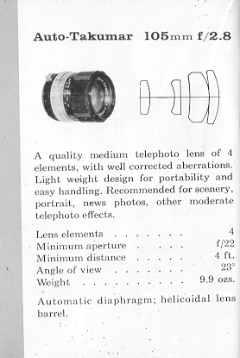 | 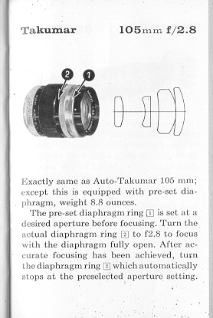
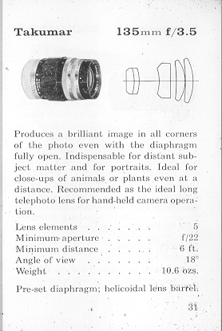 | 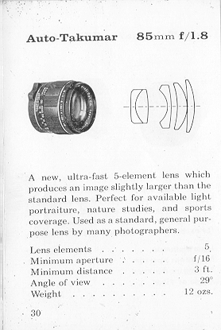
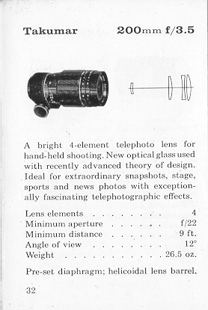 | 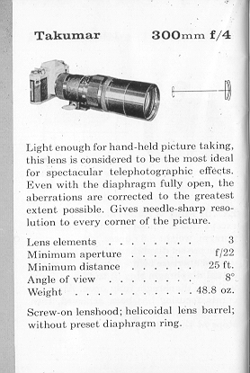
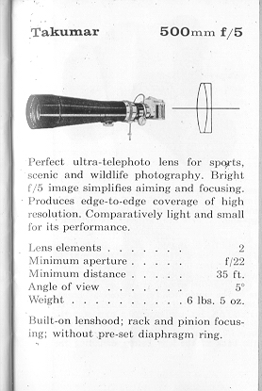 | 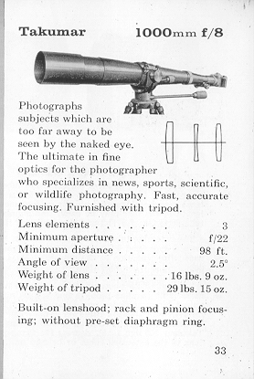

HONEYWELL CLIP-ON METER
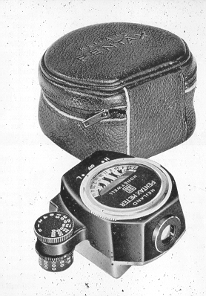 | Easily attached to the pentaprism housing of Honeywell Pentax H-1and H-3 cameras, this meter couples directly to slotted shutter speed dial and is extremely. convenient to use. Cadmium sulfite, cell offers high sensitivity; measures an angle of only 9°, which results in complete exposure control. Operates on one 1.3v Mallory 640-R battery. Complete with battery and leather carrying case.  See this link on a Wein Air replacement battery.
RESOLVING POWER OF TAKUMAR LENSES
Resolving power of all Takumar lenses is factory-tested by skilled engineers. There are three types of . tests: microscopic aerial test, projection test and photographed film test. Resolving power of a lens shown by LPM (lines per mm ) varies depending upon the method of resolution test. Takumar lenses have been-tested for resolving power to conform to Asahi standards, which are higher than those set by J - Japan Industrial Stand-: arcs). All Takumar lenses bear the seal of the Japan Camera Inspection Institute Which insures the performance, standards. :
When testing' your lens performance .... Use a slow-speed fine grain film.
Generally, high speed films are grainy and are not suitable for resolution test. Support your camera on a good tripod. Use a shutter release cable to prevent movement of the "camera. The definition of the picture on the negative film may decrease if exposure and developing time are not proper. Time your exposure and development correctly.
If you do your own developing and enlarging, see that your enlarger uses a fine quality enlarger lens.: If it is not of a fine quality, your-pictures can never be sharp no matter what superb lenses are mounted on your camera. Usually, the diaphragm of tine' enlarger should be closed down to f/8 or f/11.

