Paxette - Braun/Nornberg
posted 2-19-'04
This camera manual library is for reference and historical purposes, all rights reserved.
This page is copyright© by , M. Butkus, NJ.
This page may not be sold or distributed without the expressed permission of the producer
I have no connection with any camera company
On-line camera manual library
This is the full text and images from the manual. This may take 3 full minutes for all images to appear.
If they do not all appear. Try clicking the browser "refresh" or "reload button" or right click on the image, choose "view image" then go back. It should now appear.
To print, try printing only 3 or 4 pages at a time.
If you find this manual useful, how about a donation of $3 to:
M. Butkus, 29 Lake Ave., High Bridge, NJ 08829-1701
and send your e-mail address so I can thank you.
Most other places would charge you $7.50 for a electronic copy
or $18.00 for a hard to read Xerox copy.
This will help me to continue to host this site, buy new manuals, and pay their shipping costs.
It'll make you feel better, won't it?
If you use Pay Pal, use the link below. Use the above address for a check, M.O. or cash.
send a PayPal donation to lynn@butkus.org
Top of Form
Bottom of Form
Back to main camera manual page



It is first of all necessary to become thoroughly familiar with the various parts of the camera. Before inserting a film go over the necessary operations several times. Good snapshots can only be achieved if your Paxette is ready for instant action.
Key to numbers on opposite page.
1. Film locking stud  2. Film Counter  3. Knob for winding on film and cocking shutter  4. Optical exposure meter  5. Shutter setting  6. Socket for cable release  7. Shutter release lever  8. Lens aperture control  9. Locking ring  10. Tripod hush (1/4' Whitworth)  11. Film rewinding knob  12. Optical eye level view finder 13. Depth of field ring  14. Focusing ring  15. Flash socket  16. Delayed action release | 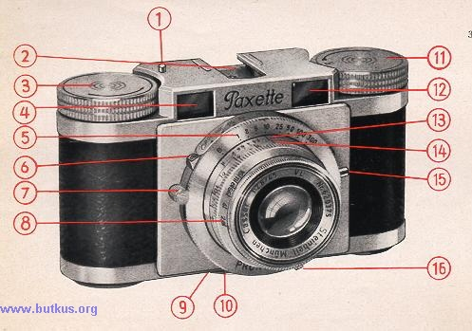
The Paxette camera is made by Carl Braun K. G. of Nuremberg under the most modern conditions.
The beautiful finish of the Paxette is the first evidence of the quality of the plant and the skill and care of the operatives which lie behind its production. Actual use of the camera very quickly confirms the first impression. It will be found delightful to handle, thoroughly reliable and an instrument capable of producing the most perfect pictures.
Careful study of this booklet is necessary to get the best out of this camera. Once the mechanical details are mastered every photographic problem can be faced with confidence and the Paxette will become a constant friend and companion of leisure hours.
How to Open the Camera
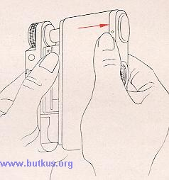 | The milled locking ring on the bottom of the camera is released by turning anti-clockwise. The back and bottom of the camera can then be slid out.
How to insert the film cassette
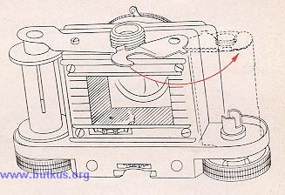 | The arm which retains the cassette is swung outwards by about 90° and the cassette is engaged in the REWIND dog. The lever holding the cassette is then swung back again so that it fits over the protruding spool knob.
Attention!
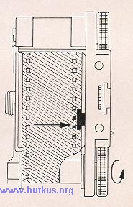 | When film is inserted, it is imperative that the margin of the film is sliding underneath the guide spring at the right side of the cog-wheel.
How to insert the film
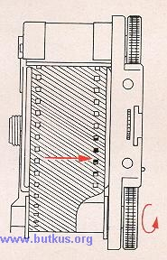 | Pull out the film from the cassette sufficiently far for the trimmed end to be inserted into the slot of the empty spool and then bent back on itself so that it cannot slip. Turn the film winding knob in the direction of the arrow until the sprocket of the film transport engages with the perforations of the film. As the turning of the film winding knob causes the shutter to be cocked, the shutter release ]ever should be operated every so often whilst winding is in progress. This will enable the film to be wound on. Once the perforations have engaged the sprock, the back of the camera should be replaced and locked.
Warning: Direct sunlight should be avoided when loading with film. If there is no shade, the operator's own shadow in better than direct sunlight.
How to close the camera.
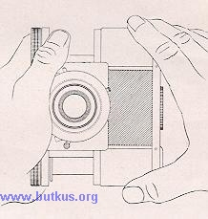 | To close the camera the back should be inserted between the camera housing and front plate and the locking ring tightened.
The film Counter
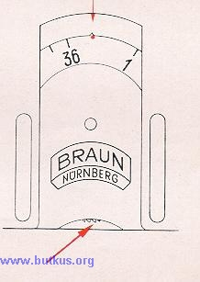 | The film counter reads backwards from 36 to 1. It thus indicates the number of unexposed frames still available. After the film has been loaded and the camera has been closed, the counter should be set at the red dot near the figure 36, by means of the projecting teeth. The film winding knob is then turned until the reading is 36. It is necessary to release the shutter to allow the film to wind on.
Film Winding and Film Transport
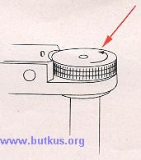 | The shutter winding mechanism, film transport and film counter are coupled so that they are operated when the winding knob is wound in the direction of the arrow. After the shutter has been released and until the camera has been re-wound, the safety device which prevents double exposure is in operation.
How to unload the Camera
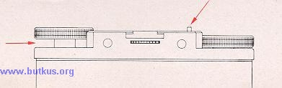 | The whole length of the film has been exposed when the counter reads figure 1 and the shutter has been released.  To wind back the film, press the locking stud; pull out the rewind knob as far as it will go and turn it in the direction of the arrow. Towards the end of the film a somewhat stronger resistance is felt which indicates that the film is being held by the take up spool.
A few further turns will then wind the film completely into the cassette, and the camera can be opened for insertion of a new film.
Note: The locking stud must remain depressed throughout the whole rewinding operation. It throws the sprocket out of gear.
Loading and Unloading Drill
1. Open the camera  2. Insert film cassette  3. Attach the film to the take-up spool  4. Close the camera  5. Set the film counter on the red dot near 36  6. Wind on until 36 is against the index mark | 1. Press down locking stud throughout the winding operation  2. Raise rewind knob as far as it will go  3. Turn rewind knob in the direction of the arrow  4. Wind the whole of the film into the cassette  5. Open the camera  6. Remove the cassette
Checking the film transport
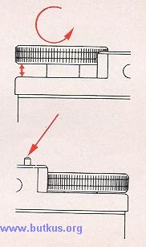 | To make sure that the film transport is functioning properly and the film really being wound on, lift the rewind knob as far as it will go. If the film transport is functioning properly the rewind knob will turn in the opposite direction during winding operations.  Checking the Re-winding  To check the rewinding, release the locking stud during rewind operations. It will then stand proud and there should be a strong resistance if the mechanism is working correctly.  Warning. If force is used against this resistance the perforation of the film will tear. When continuing to rewind, press home the locking stud.
The Lens Diaphragm
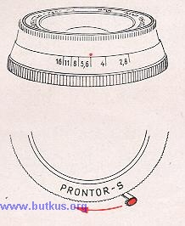 | The lens aperture or diaphragm is set by means of the front ring on the lens. Bring the red dot into register with the black line at whatever setting is required.  Note: The smaller the aperture number the more light is admitted, but the more limited is the depth of field. The larger the aperture number, the less light passes, but the greater the depth of field. For example. f/2.8 passes more light than f/16 but the depth of field is much less.

Delayed Action Release for Self Portraitures
The delayed action release is fitted to the bottom of the shutter and is set by moving the lever as far as it will go.
Warning: The delayed action release cannot be used with "B" setting (time). It would damage the shutter.
The Optical Exposure Meter
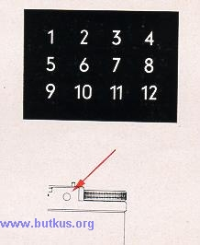 | There are three rows of figures of different density inside the exposure meter (right hand eye piece). With the eye piece held close to the eye, aim the camera at the subject to be taken. The highest figure which is discernible after looking through the eye piece for about 20 seconds will be the light value and is the basis for reading off the exposure time from the exposure tables on the camera case.

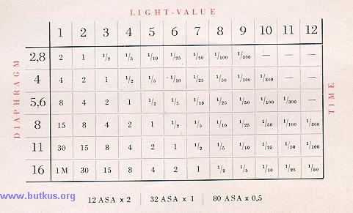
How to Read the Exposure Time from the Exposure Table
Example. Assuming that the figure 10 is the highest discernible figure in the exposure meter, refer to the table which is attached to the back of the camera case and look for figure 10 in the top horizontal row. The left-hand vertical row, in front of the thick black line gives the apertures from the 2.8 to 16. It is then possible to read off the exposure times for each aperture from the vertical row running down from the figure 10. Assuming that aperture 16 has been chosen (smallest aperture), the reading in the vertical line under the figure 10 for aperture 16 will be 1/10 second. For aperture 11 an exposure time of 1/25 second would be required, for aperture 8, 1/5n second, for aperture 5.6, 1/100 second and for aperture 4, 1/300 second. No exposure time for aperture 2.8 is given because for this light value (10) so large an aperture would be unsuitable. The same procedure should be adopted for all other light values.
Note: The table is compiled for film with a sensitivity of 17/10 DIN. For 21/10 DIN the exposure times should be halved and for 13/10 DIN they should be doubled.
The corresponding values for other sensitivity scales may be taken to be as follows:
DIN | SCHEINER | WESTON | ASA/BS
21/10  17/10  13/10 | 31  27  23 | 64  25  10 | 12  32  80
How to Focus
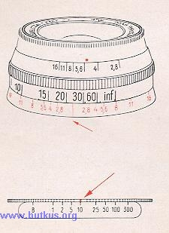 | After estimating the distance between the camera and the subject to be taken or after ascertaining it by means of a range finder (which can be mounted on the camera), the second milled ring situated on the lens is turned to register with the line which will be found in the middle of the fixed ring engraved in red. The scale of the distance setting ranges from 3'/2 ft. to infinity.  Exposure Time  The shutter is set by bringing the red line on the milled ring of the shutter into register with the desired speed which is engraved on the collar on top of the shutter housing.
The Depth of Field
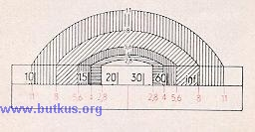 | The depth of field comprises the area which is sharply defined by the lens, from the foreground to the background. This area or depth varies according to the aperture chosen, that is to say, a large aperture (f/2.8) gives less depth of field and a small aperture (f/16) gives a greater depth of field. The depth of field for every aperture setting can be read off the red scale on the middle ring of your Paxette.
This repeats on the left and on the right on the centre LINE, the range of lens apertures.
Examples . If the focus is set between 20 and 30 ft., everything will be sharp from down 60 ft. to about 15 ft. when working with an aperture of f/4. If working at f/8 however, everything will be sharp from infinity down to 12.5ft.
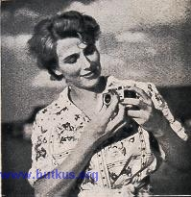 | The Palette should be held firmly in both hands so that the rounded bottom edge is resting on the palms of the hands. When the shutter is released, the left hand will then be keeping the camera steady.  The camera and the hand should be pressed against the head and a broad stance adopted to ensure steadiness. Another point to observe is that the ball of the right hand should exert slight counter pressure whilst the second finger of the right hand presses the trigger.

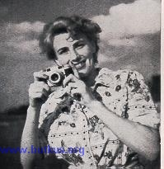 | This should be done gently and without jerking. Move the finger only and not the whole hand. Allow the finger to rest on the release lever until the release has run off. Remain calm whilst taking a picture especially when taking snapshots with  the Paxette.  Good results amply repay the trouble taken.
If the Paxette should happen to go wrong, the temptation to get a screwdriver and open it up should be resisted. The correct assembly of, say, the shutter or the relationship of the lens to the focal plane are most delicate matters, and even a skilled mechanic not accustomed to cameras should hesitate. A faulty camera should not be touched but should be handed to a good photographic dealer who has a specialist repairer with special tools at his disposal.

Camera | Format | Lens | Shutter
Paxette | 24 x 36 mm | f/2.8 | Pronter S 9 - speeds delayed action : flash
Paxian I | 6 x 6 cm | f/7.7 | 3 - speed (B - 1/25 - 1/100)
Pacian II | 6 x 6 cm | f/3,5 | Vario 4 - speed : flash
Inperial Box | cameras for 2 1/2" x 2 1/2" | and 2 1/4" x 3 1/4" with and without flash

