Mamiya ZE-2 Quartz
AKA - REVUE AM QUARTZ
This camera manual library is for reference
and historical purposes, all rights reserved.
This page is copyright by , M. Butkus, NJ.
This page may not be sold or distributed without the
expressed permission of the producer
I have no connection with any camera company
On-line camera manual library
If you find this manual useful, how about a donation of $3 to:
M. Butkus, 29 Lake Ave., High Bridge, NJ 08829-1701
and send your e-mail address so I can thank you.
Most other places would charge you $7.50 for a electronic copy
or $18.00 for a hard to read Xerox copy.
This will help me to continue to host this site,
buy new manuals, and pay their shipping costs.
It'll make you feel better, won't it?
If you use Pay Pal, use the link below.
Use the above address for a check, M.O. or cash.

www.PayPal.me/lynnbutkus
Venmo is @mike-butkus-camera
Back to main camera manual page

MAMIYA ZE LENSES


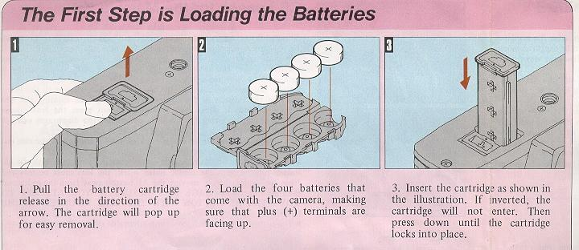
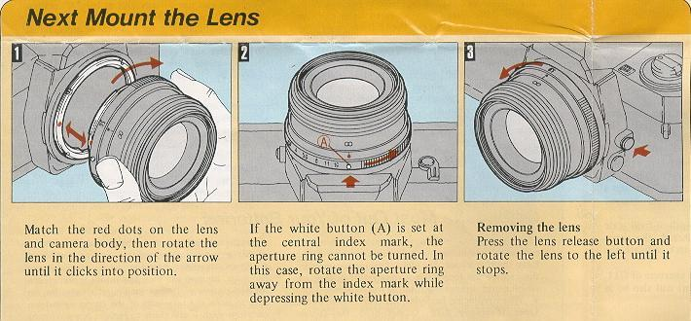
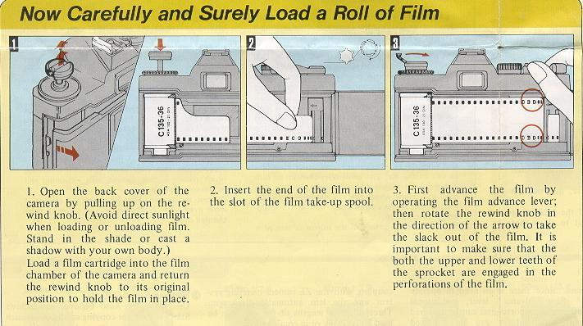
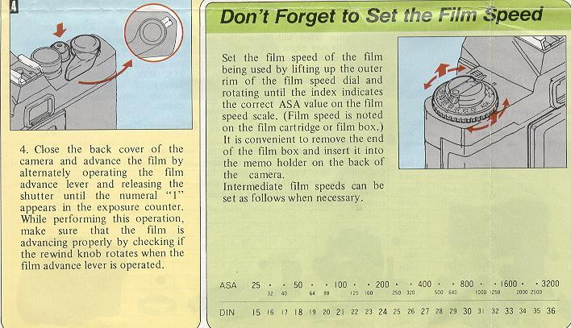

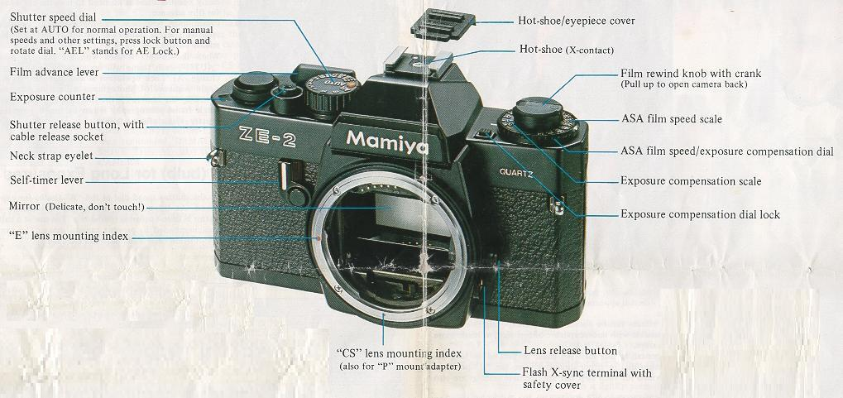
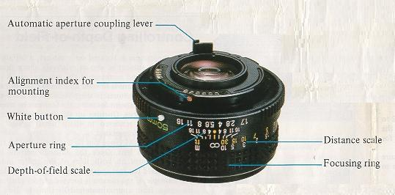

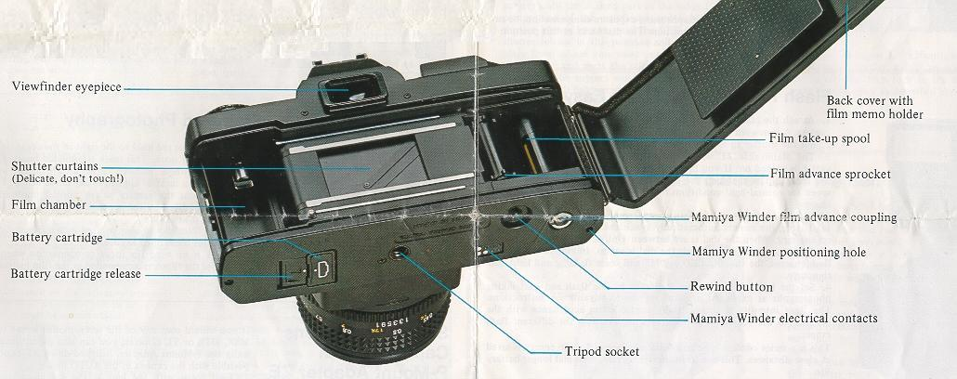
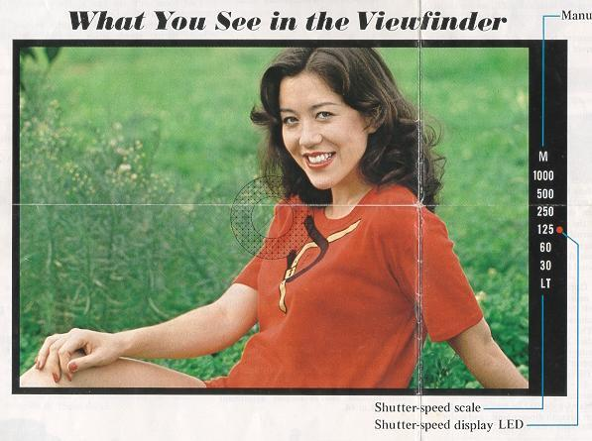

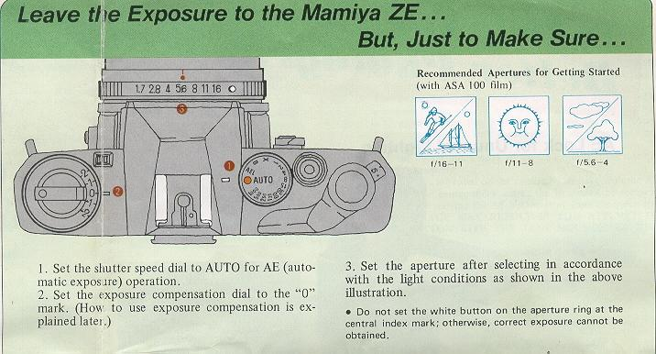
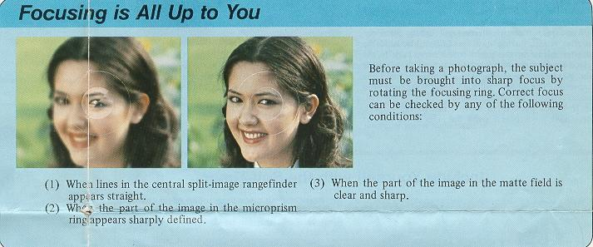

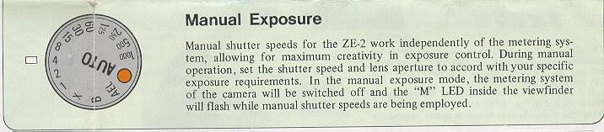
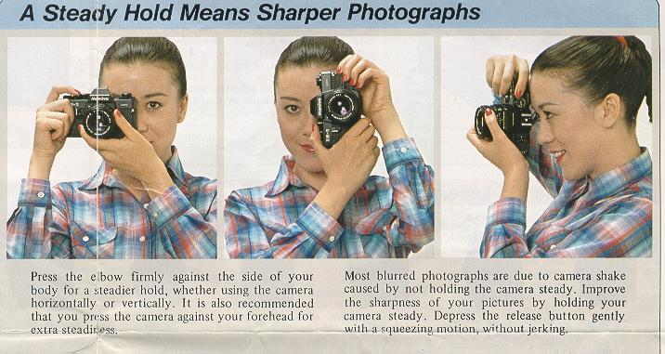

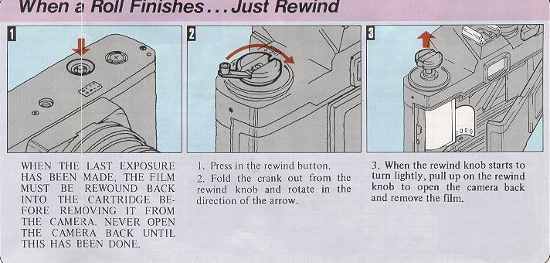
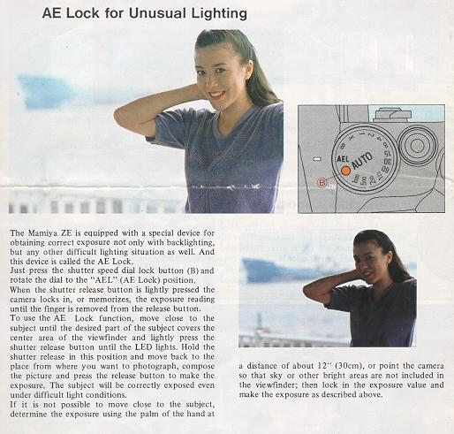
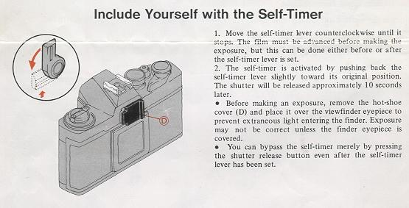
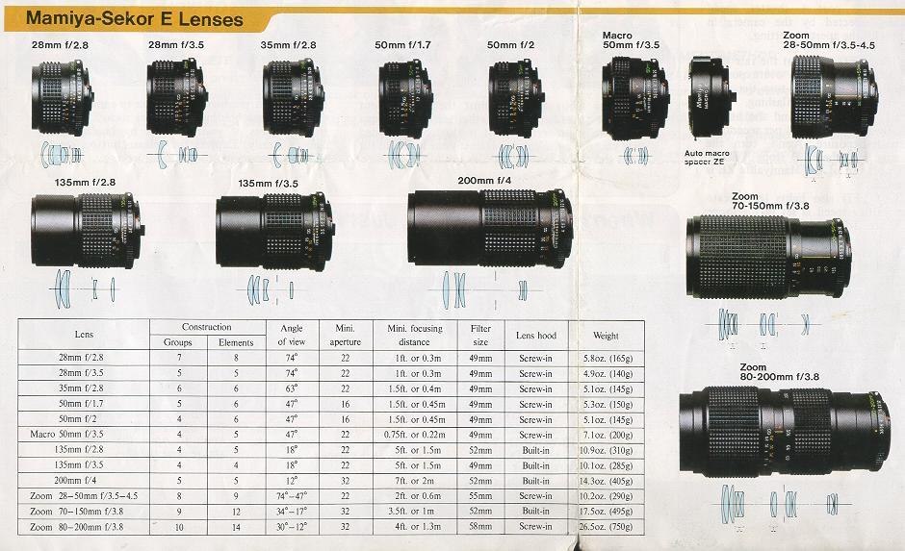

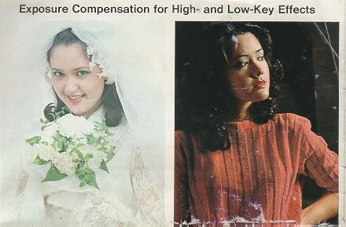
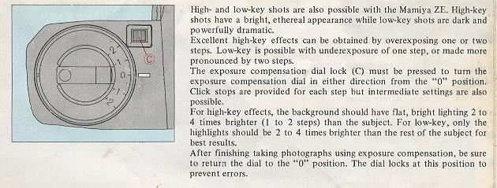
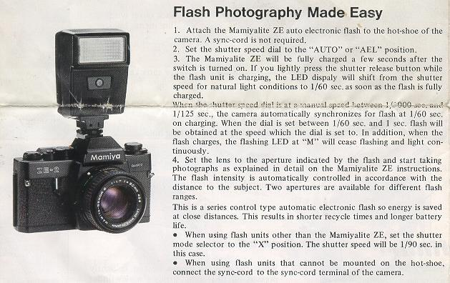
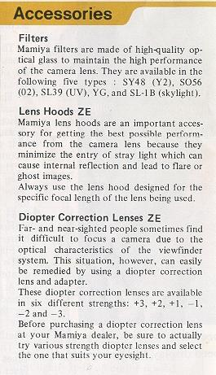

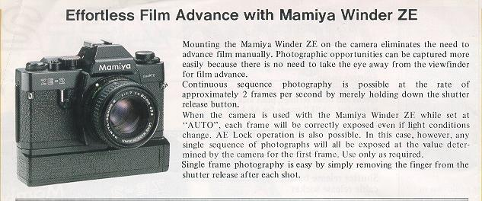
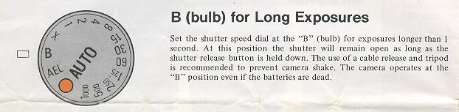

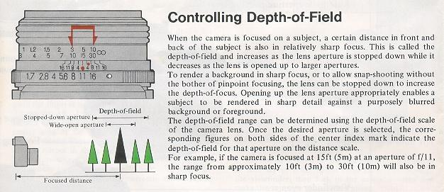

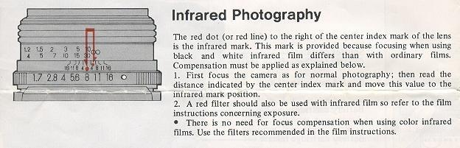

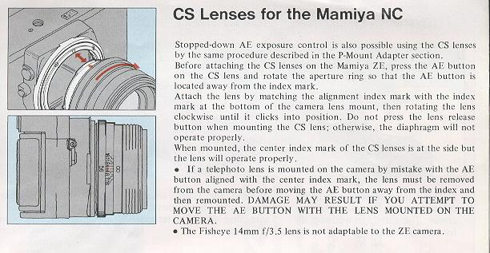
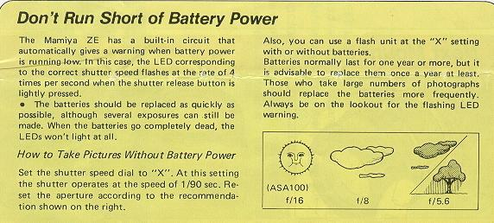
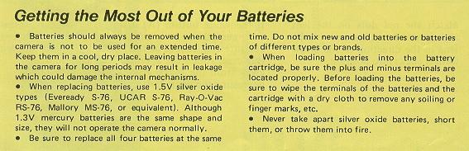
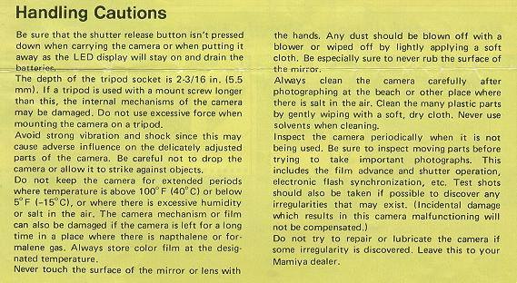

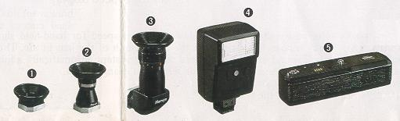
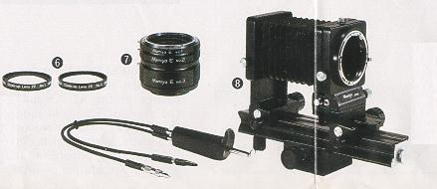
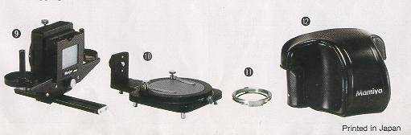
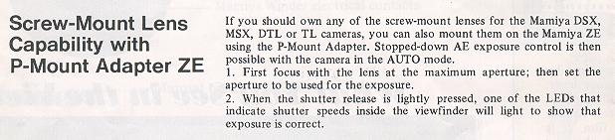

SPECIFICATIONS
Type of camera:
35mm single-lens reflex (SLR), aperture priority "Quartz Timed" automatic exposure camera, manual override.

Picture format: 24mm x 36mm.
Usable lenses: Mamiya-Sekor E series lenses with fully automatic diaphragm operation and open-aperture metering. CS lenses for the NC cameras and thread mount lenses for other Mamiya 35mm cameras also usable on AUTO with stopped-down metering.
Shutter:
Electronically controlled metal focal plane. Speed range from 1 sec. to 1/1000 sec. at AUTO position; Manual speed from 1 sec. to 1/1000 sec. in one stop increment with click stop at each nominal position, plus mechanical speeds of X (1/90 sec.) and B.
Slow shutter speed warning:
Buzzer sounds when shutter speed drops below the slowest safe speed for hand-held shooting with the lens in use.
Self-timer:
Approx. 10-second delay.
Sync contact:
X-sync terminal and hot-shoe.
Metering system:
TTL center-weighted, open-aperture metering using SPD (silicon photo diode).
Metering range:
EV1.5—EV18 (ASA100, f/1.7 lens) EV2 - EV18 (ASA100, f/2 lens).
Exposure compensation:
+2 f-stops.
Film speed range:
ASA12-3200.
Viewfinder information display:
LED dot displays shutter speeds of 1/30 - 1/1000 sec., plus LT. Flashing LEDs warn of over- and under-exposure and battery condition. LED dot flashes at "M" with dial set at manual shutter speeds.
Viewfinder magnification ratio:
0.85X with 94% coverage of field of view (with 50mm lens at infinity).
Focusing screen:
Fixed-type with 45° split-image rangefinder spot, microprism and matte field.
Film advance:
Using film advance lever with 130° winding angle and 30° stand-off angle.
Exposure counter:
Additive type. Automatic reset to "S" mark when camera back is opened.
Film rewind:
Manual rewind with rewind lever.
Power source:
Four 1.5V silver oxide batteries SR44 (Eveready S-76, UCAR S-76, Ray O Vac RS-76 Mallory MS-76, or equivalent). Four 1.5V alkaline manganese LR44 (same size as S-76, RS-76 or MS76).
Power switch:
Shutter release button.
Flash synchronization:
Shutter speed automatically set to 1/60 sec. when the Mamiyalite ZE is fully charged. Other electronic flash units usable at "X" position ( 1/90 sec.).
Winder coupling:
Electrical contact and coupler built-in for operation with the Mamiya Winder ZE.
Dimensions:
139.5mm(W) x 88.5mm(H) x 50.5mm(D)
Weight:
460g (body only)
Specifications and design are subject to change without notice.

ACCESSORIES FOR YOUR ZE-2
Filters
Mamiya filters are made of high quality optical glass to maintain the high performance of the camera lens. They are available in the following five types: SY48 (Y2), S056 (02), SL39 (UV), YG, and SL-I B (skylight).
Lens Hoods ZE
Mamiya lens hoods are an important accessory for getting the best possible performance from the camera lens because they minimize the entry of stray light which can cause internal reflection and lead to flare or ghost images. Always use the lens hood designed for the specific focal length of the lens being used.
Diopter Correction Lenses ZE
Far- and near-sighted people sometimes find it difficult to focus a camera due to the optical characteristics of the viewfinder system. This situation, however, can easily be remedied by using a diopter correction lens and adapter.
These diopter correction lenses are available in six different strengths: +3, +2, +1, -1, --2 and -3.
Before purchasing a diopter correction lens at your Mamiya dealer, be sure to actually try various strength diopter lenses and select the one that suits your eyesight.
1. Rubber Eye-cup ZE with Adapter
This adapter is required for attaching the diopter correction lenses to the camera. The rubber eye-cup helps to prevent stray light entering the viewfinder while taking photographs.
To attach the diopter correction lens, first remove the mounting ring located inside the eye-cup by turning it counter-clockwise; then put the lens in place and replace the ring.
2. Magnifier ZE
The magnifier is a useful aid for critical focusing as required in copy work, close-up photography, and similar applications. The size of the image is doubled and only the center part is visible for more accurate work. The magnifier also features diopter adjustment from -5 to +5.
3. Angle Finder ZE
The angle finder is useful when shooting at low angles and for copy work. Click stops are provided every 90°, but full 360° rotation is possible for viewing even from the side or from below. The angle finder also features built-in diopter adjustment from -4 to +4.
4. Mamiyalite ZE
The Mamiyalite ZE is a compact auto electronic flash with a Guide Number of 17 (ASA100, meters) and contact for hot-shoe synchronization. Two auto ranges and manual operation are available using the selector switch.
When used with the Mamiya ZE, the LED at the 60 position inside the viewfinder lights when the flash unit is fully charged and the shutter speed is automatically set to 1/60 sec.
Angle of coverage: 45° vertical, 60° horizontal. Attaching the wide-angle diffuser provides coverage for a 28mm wide-angle lens.
Batteries used: Four alkaline or Ni-Cad penlight batteries.
5. Mamiya Winder ZE
The Mamiya Winder ZE provides continuous sequence photography capability at speeds of up to approximately two frames per second. Since there is no need to operate the film advance lever, additional photographic opportunities can be captured because the subject can be followed continuously without taking the eye away from the viewfinder.
Batteries used Four alkaline or Ni-Cad penlight batteries.
6. Close-up lens ZE
The close-up lenses ZE are convenient attachment lenses which screw directly to the filter threads of the master camera lens enabling swift and easy conversion to close-up photography.
Two models are available: Close-up lens No. 1 having +2 diopters, and Close-up lens No. 2 having +4 diopters.
7. Auto Extension Rings ZE
A set of three extension rings are intended for close-up photography and mount between the camera body and lens, directly coupling with the ZE camera metering system and the lens automatic diaphragm. Three different lengths of the rings can be used individually or in combination.
8. Auto Bellows ZE
This is an easy to operate, precision bellows type close-up attachment. Automatic aperture stop-down coupling is possible using a double cable release. And the front standard can be swiveled 360°, permitting simple reversing of the lens for large magnification ratios with images that are sharp to the very edges. Shift control also enables control of perspective. And the camera can also be rotated at the back for a choice of vertical or horizontal format with easy operation. The focusing rail allows the entire bellows unit to be shifted back and forth for sensitive adjustment of distance . and focusing.
9. Slide Copier ZE
This device is mounted on the front of the Auto Bellows for making copies of slides. Convenient film trays are provided for copying film strips The slide stage also moves vertically and horizontally for easier cropping of 35mm slides.
10. Bellows Stand ZE
Used with the Auto Bellows, the Bellows Stand is used for copying small objects such as stamps, coins, insects, etc.. Clips are provided for holding subjects on the platform. And the platform rotates for precise positioning. The platform is also. finished to provide 18% reflectance, convenient for measuring exposures. A clear glass platform is also included for backlighting of subjects.
11. P-Mount Adapter ZE for Mamiya TL/SX Lenses:
This adapter is used for mounting Mamiya DSX, MSX, DTL and TL lenses on the Mamiya ZE camera. Stopped-down AE exposure control is possible using this adapter.
<<<< Additional information not in the manual:
I just wanted to point out that not all Mamiya M42 lenses are safe to use with the P adapter for the Auto-XTL. If you attempt to use the SX type lenses with the Auto-XTL P adapter, the aperture sensing pin will dig into the P adapter face since it is not perfectly flush with the outer surface edge of the SX lense. Furthermore, since the entire moving surface of the aperture ring of the SX lense comes to rest against the P adapter face, it will lock down the aperture control of the lense and make it impossible to turn, therefore preventing SX lens f-stop manipulation.
Mamiya M42 AUTO lenses seem to be safe choices as are M42 Yashica-Yashinon, M42 Meyer-Optik and M42 Zeiss MC Sonnar (S) lenses. Any aperture ring that rotates at the extremity of a lens should be avoided. Of course the SX lens works perfectly well with the "ZE" P adapter for Mamiya ZE series lenses which it was designed for. Lenses with Auto and Manual switches like Zeiss MC Sonnar work well with the Auto-XTL P adapter in conjunction with its Auto Aperture pin. Lenses that have no Auto Aperture and only manual control of aperture appear to work equally well like Meyer-Optik Orestor M42.
Robert A. Genna, Connecticut teacher and photographer, 10-23-04 >>>>>>
This info was provided by a reader:
<< In an added note, I have found that the "ZE" P adapter designed for use with the ZE and ZE-2 Mamiya cameras will not work on the Mamiya ZE-X camera. Most references for the "ZE" P adapter give the perception that it can be used on all ZE series cameras. This is not the case for the ZE-X. If you attempt to use the "ZE" P adapter on the ZE-X camera the adapter will stop cold at the gold dedicated EF camera/lens contacts of the ZE-X and if you force the installation of the "ZE" P adapter onto the ZE-X it will damage those gold contact pins.
I have not seen a reference to this effect in any description of the ZE-X. Furthermore, I have seen no references for the Mamiya ZM camera allowing adapters that permit the use of lenses from the DSX, MSX, DTL and TL series of cameras. The ZM does allow 645 series lenses to be used on "ZE" and "ZE-2" cameras utilizing their "645 adapter ZE". I have however installed the Mamiya "ZE" P adapter to an Auto Mamiya-Sekor 1:1.8 f=55mm M42 mount lens with it's f-stop aperture switch set in manual mode on the Mamiya ZM in auto shutter mode with good operational results. >>
12. Eveready Case ZE
DON'T RUN SHORT ON BATTERIES
The Mamiya ZE has a built-in circuit that automatically gives a warning when battery power is low this case, the LED corresponding to the correct shutter speed flashes at the rate of 4 times per second when the shatter release button is lightly pressed.
· The batteries should be replaced as quickly as possible, although several exposures can still be made. When the batteries go completely dead, the LEDs won't light at all.
How to Take Pictures Without Battery Power
Set the shutter speed dial to "X". At this setting the shutter operates at the speed of 1/90 sec. Reset the aperture according to the recommendation shown on the right.
Also, you can use a flash unit at the "X" settings, with or without batteries.
Batteries normally last for one year or more, but it is advisable to replace them once a year at least. Those who take large numbers of photographs should replace the batteries more frequently. Always be on the lookout for the flashing LED warning,
GETTING THE MOST FROM YOUR BATTERIES
· Batteries should always be removed when the camera is not to be used for an extended time. Keep them in a cool, dry place. Leaving batteries in the camera for long periods may result in leakage which could damage the internal mechanisms.
· When replacing batteries, use 1.5V silver oxide types (Eveready S-76, UCAR S-76, Ray-O-Vac RS-76, Mallory MS-76, or equivalent. Although 1.3V mercury batteries are the same shape and size, they will not operate the camera normally.
· Be sure to replace all four batteries at the same time. Do not mix new and old batteries or batteries of different types or brands.
· When loading batteries into the battery cartridge, be sure the plus and minus terminals are located properly. Before loading the batteries, be sure to wipe the terminals of the batteries and the cartridge with a dry cloth to remove any soiling or finger marks, etc.
· Never take apart silver oxide batteries, short them, or throw them into fire.
HANDLING CAUTIONS
* Be sure that the shutter release button isn't pressed down when carrying the camera or when putting it away as the LED display will stay on and drain the batteries.
* The depth of the tripod socket is 2-3/16 in. (5.5 mml. If a tripod is used with a mount screw longer than this, the internal mechanisms of the camera may be damaged. Do not use excessive force when mounting the camera on a tripod.
* Avoid strong vibration and shock since this may cause adverse influence on the delicately adjusted parts of the camera. Be careful not to drop the camera or allow it to strike against objects.
* Do not keep the camera for extended periods where temperature is above 100°F (40°C) or below 5°F (-15°C), or where there is excessive humidity or salt in the air. The camera mechanism or film can also be damaged if the camera is left for a long time in a place where there is napthalene or formalene gas. Always store color film at the designated temperature.
* Never touch the surface of the mirror or lens with the hands. Any dust should be blown off with a blower or wiped off by lightly applying a soft cloth. Be especially sure to never rob the surface of c mtrror.
* Always clean the camera carefully after photographing at the beach or other place where there is salt in the air. Clean the many plastic parts by gently wiping with a soft, dry cloth. Never use solvents when cleaning.
* Inspect the camera periodically when it is not being used. Be sure to inspect moving parts before trying to take important photographs. This includes the film advance and shatter operation, electronic flash synchronization, etc. Test shots should also be taken if possible to discover any irregularities that may exist. (Incidental damage which results in this camera malfunctioning will not be compensated)
* Do not try to repair or lubricate the camera if some irregularity is discovered. Leave this to your Mamiya dealer.
When the shutter release button is lightly pressed, an LED lights inside the viewfinder to indicate the correct shutter speed automatically selected by the camera in accordance with the aperture setting.
* The 1/1000 LED flashes at the rate of 8 times per second to indicate overexposure. To obtain correct exposure, turn the aperture ring until the LED stops flashing.
* The "LT" LED flashes and the buzzer sounds at the rate of 8 times per second to indicate underexposure. Again, turn the aperture ring until the LED stops flashing. If it does not, use of the Mamiyalite ZE is recommended.
* The "LT" LED also lights to indicate when the shutter speed is set in the range below 1/30 sec. down to I sec. To shoot at the slow shutter speeds indicated by the "LT" LED, it is recommended to use either a tripod or the Mamiyalite ZE to prevent blurring.
* Flashing of any of the shutter-speed LEDs at the rate of 4 times per second indicates that the batteries should be replaced.
* As long as the shutter release button is pressed, the LED display continues indicating the same shutter speed after the exposure is completed for easy checking of whether or not exposure was correct.
* The "M" LED flashes at the rate of 8 times per second to indicate the shutter dial is set at a manual speed.
Slow Shutter Speed Warning
When the shutter speed automatically selected by the camera in the AUTO and AEL (AE Lock) modes is too slow for hand-held shooting, a buzzer will sound at the rate of I time per second warning you to set the lens to a wider aperture (giving you a faster shutter speed), or to mount the camera on a sturdy tripod to avoid the possibility of blurred pictures.
The safe slowest shutter speed for hand-held shooting varies with the focal length of the lens in use. The slow shutter speed warning stem automatically adjust for this variation when you change lenses.

