Mamiya Winder ZE
Posted 4- 26-'03
This camera manual library is for reference
and historical purposes, all rights reserved.
This page is copyright© by , M. Butkus, NJ.
This page may not be sold or distributed without the
expressed permission of the producer
I have no connection with any camera company
On-line camera manual library
If you find this manual useful,
how about a donation of $3 to:
M. Butkus, 29 Lake Ave.,
High Bridge, NJ 08829-1701
and send your e-mail address
so I can thank you.
Most other places would charge
you $7.50 for a electronic copy
or $18.00 for a hard to read Xerox copy.
This will help me to continue to host this site,
buy new manuals, and pay their shipping costs.
It'll make you feel better, won't it ?
If you use Pay Pal, use the link below.
Use the above address for a check, M.O. or cash.

www.PayPal.me/lynnbutkus
Venmo is @mike-butkus-camera Ph 2083
www.butkus.us
Back to main camera manual page



Mamiya Winder ZE
The figure numbers throughout the instructions refer to pictures on the foldout pages at the back.
Names of Parts (Fig. 1)
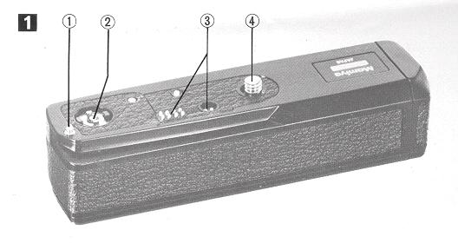 | 1. Positioning pin  2. Drive coupler  3. Electric contacts  4. Attachment screw
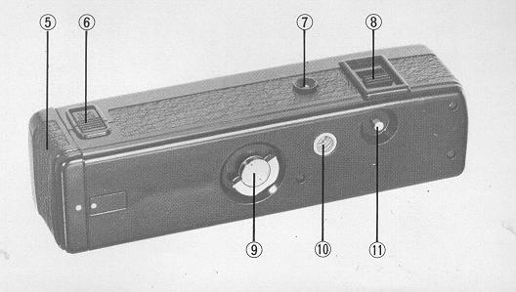
5. Battery chamber cap  6. Battery chamber lock slide  7. Pilot LED  8. Power switch | 9. Attachment screw key  10. Tripod socket  11. Rewind button

Loading the Batteries
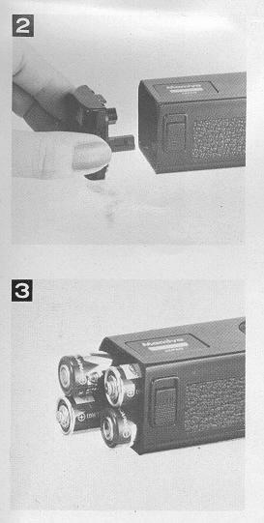 | Push up on the Battery Chamber Lock Slide and remove the Battery Chamber Cap by pulling out (Fig.2)  Load the batteries, making sure the plus and minus poles are located as indicated; then replace the cap  (Fig. 3).  The batteries may also be first loaded into the cap and then inserted into the Battery Chamber as the  Cap is replaced (Fig.4).
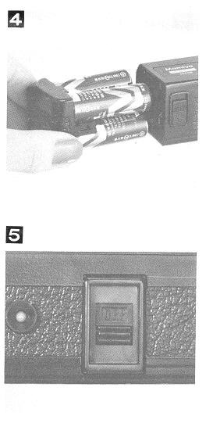 | Attaching the Mamiya Winder ZE to the Camera  1. Make sure the Power Switch is turned off (Fig. 5).  2. Put the Mamiya Winder ZE in place on the ba# of the camera, using the Positioning Pin for correct alignment (Fig. 6)
 | 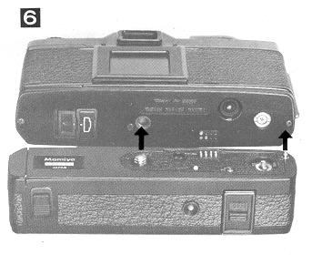

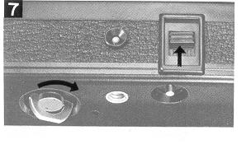 | 3. Turn the Attachment Screw Key to fasten the Winder to the camera. After turning on the Power Switch, the Mamiya Winder ZE is ready for use (Fig. 7).

When the camera is set at "AUTO" when used with the Mamiya Winder ZE, each frame will be correctly exposed even if light conditions change while shooting a sequence. AE Lock operation is also possible. in this case, however, all frames will be exposed at the value determined for the first frame. U# only as required.
Releasing the Shutter
The operation of the Mamiya Winder ZE is controlled by the shutter release of the camera. After the shutter operates, the Winder automatically advances the film and winds the shutter for the next shot.
For single frame operation, remove the finger from the shutter release as soon as the shutter is released. The Winder will advance the film one frame and stop automatically. If the shutter release button is held down, the camera and Winder will continue operating for sequence photography at the rate of approximately 2 frames per second.
Operation Indicator
Each time an exposure is made, the LED on the back of the Winder lights to indicate that operate is normal. This indicator will flash each time an exposure is made.
At the End of the Roll
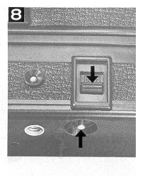 | Rewinding the Film  1. Turn off the Power Switch and press the Rewind Button (Fig. 8).  2. Rewind the film by turning the rewind crank of the camera clockwise until you feel the crank begin to turn lightly (Fig. 9).

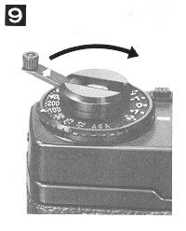 | When the end of a roll of film is reached, both the camera and Winder will automatically stop operating. And the pilot LED will light constantly to indicate that the end of the film has been reached.  3. Remove the exposed roll of film by opening the back of the camera and reload if desired.
Manual Operation
To operate the camera manually with the Winder attached, just turn off the Power Switch and use the film advance lever of the camera as you would normally. There is no need to detach the Winder for manual operation.
Detaching the Winder
1. Turn off the Power Switch.
2. Turn the Attachment Screw Key counter clockwise until the Winder is detached from the camera.

Notes:
1. Be sure to turn off the Power Switch when using the #If-timer with the Winder ZE attached to the camera; otherwise, the camera will continue to shoot several frames once the shutter is tripped by the self-timer.
2. Be sure to turn the Power Switch off when detaching the Winder from the camera. And do not try to operate the Winder by shorting the contacts directly when the Winder is detached from the camera. This will damage the Winder, making it inoperable, because the internal fuse will be blown.
Specifications:
Applicable camera: Mamiya ZE
Operating speed: Up to approx. 2 frames per second, continuous or single frame.
Operational shutter speed range: 1/1000 to 1 sec. and B (Automatically switches to single frame operation at B.)
Shooting control: Using camera shutter release.
Operation indicator: Flashing pilot LED.
Film end indicator: Continuously lit pilot LED.
Power source: Four 1.5V AA-type alkaline manganese or Ni-Cad batteries.
Number of rolls: Using 36-exposure film at normal temperature
AA-type alkaline-manganese batteries: approx. 60 rolls or more.
AA-type Ni-Cad batteries: approx. 120 rolls or more
Dimensions: 139.5{W) x 36.5tD) x 32.51H) mm. - {5-1/2 x 1-7/16 x 1~9/32 in.)
Weight: 210 9. (7.4 oz.), without batteries.
· All specifications are subject to change without notice.

Notes on Batteries:
1. Remove the batteries when the Mamiya Winder ZE is not to be used for an extended period in order to prevent possible damage due to leakage.
2. Manganese batteries con also be used, but the number of rolls of film that can be exposed per set is less.
3. Battery performance is less under low temperature conditions, so Ni-Cad batteries should always be used fully charged. Alkaline-manganese batteries should be kept warm during use.
4. All four batteries should be replaced at the same time. Never mix new and old batteries, or batteries of different brands, as leakage may result. 5. Battery fife varies depending on the type of battery, the storage after manufacture, the amount of time that has elapsed since manufacture, on whether usage is continuous or intermittent, the type of film used and the ambient temperature.

