Mamiya TL
Camera Manual
posted 12-8-02
This camera manual library is for reference
and historical purposes, all rights reserved.
This page is copyright by , M. Butkus, N.J.
This page may not be sold or distributed without
the expressed permission of the producer
I have no connection with any camera company
If you find this manual useful, how about a donation of $3 to:
M. Butkus, 29 Lake Ave., High Bridge, NJ 08829-1701
and send your E-mail address too so I can thank you.
Most other places would charge you $7.50 for a electronic copy
or $18.00 for a hard to read Xerox copy.
This will allow me to continue to buy new manuals
and maintain these pages.
It'll make you feel better, won't it?
If you use Pay Pal, use the link below.
Use the above address for a check, M.O. or cash.

www.PayPal.me/lynnbutkus
Venmo is @mike-butkus-camera
To main Camera Manual Site

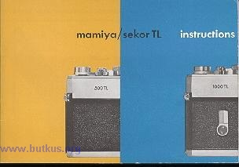
You are now the proud owner of one of the world’s finest cameras, the Mamiya/Sekor TL Single Lens Reflex Camera. In order to get excellent results with your first roll of film, we suggest that you familiarize yourself with the camera and its working parts. Read this instruction book before you load the camera.
CONTENTS
Nomenclature of Functional Parts
Construction Features and Specifications
How to Insert the Silver Battery 3
Loading the film 4
Set the film speed 5
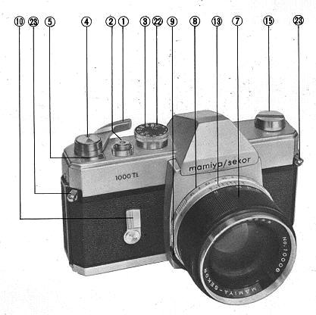 | 1. Rapid Film Advance  2. Shutter Release With cable release socket  3. Shutter Speed Dial  4. Meter Off Button  5. Automatic Reset Exposure Counter  6. Viewfinder  7. Focusing Ring  8. Diaphragm Ring  9. Preview Lever  10. Self-Timer Winding Lever (only on 1000 TL)

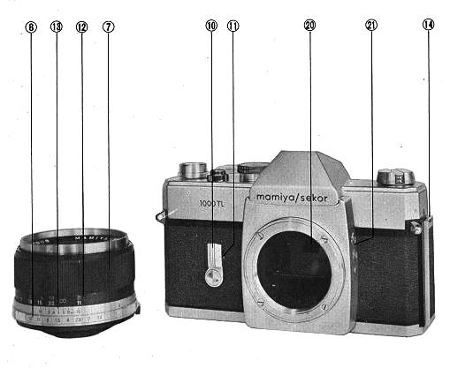 | 11. Self-Timer Actuating Button  12. Distance Scale  13. Depth of Field Scale  14. Back Cover Lock  15. Rewind Crank  16. Film Chamber  17. Film Sprockets  18. Film Take-up Spool  19. Film Rewind Release Button

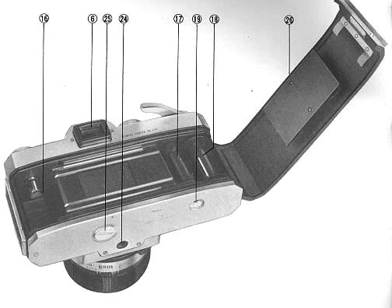 | 20. Mirror-Matic Spot Meter  21. FP & X Flash Terminals  22. ASA Film Speed Setting  23. Neck Strap Eyelets  24. Tripod Socket  25. Battery Cover  26. Back Cover

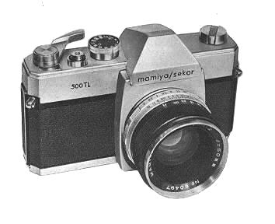
SPECIFICATIONS
TYPE: | 35mm Single Lens Reflex with Built-in behind the lens Light Meter
FILM & THREADING SIZE: | 35mm (20 or 36 exposures); 24x36mm.
STANDARD LENS----1000 TL | Mamiya/Sekor : f/l.4 - 55mm, 7 elements in 5 groups, angle 43 degrees  Mamiya/Sekor : f/1.8--55mm, 6 elements in 4 groups, angle 43 degrees
STANDARD LENS----500 TL | Mamiya/Sekor : f/2.0----5Omm, 6 elements in 4 groups, angle 47 degrees
LENS MOUNT | Threaded Praktica/Pentax type mount, 42mm
SHUTTER | Focal plane shutter
SPEEDS | 1000 TL- B to 1--1/1000th second, with Self-timer 500TL- B to 1 1/500th second, without Self-timer
EXPOSURE CONTROL | Highly sensitive CdS Meter positioned on the back of the mirror. Internally coupled to both shutter speed and lens diaphragm of all Mamiya/Sekor Lenses and Praktica-Pentax type lenses. Needle point indicator visible in viewfinder. Operating range EV-2 to EV-18, with an ASA 100 film, and f/1.4 lens; EV-2.7 to EV-18, with an ASA 100 film, and f 1.8 lens; EV.3 to EV-17, with an ASA 100 film, and f/2.0 lens.
ASA RANGE | 25 to 800 : DIN 15 to 30
FINDER | Penta-Prism finder with micro diaprism fresnel lens for instant focusing. Finder ratio: 0.95 magnification for f/1.4 and f/1.8 lens at infinity. 0.86 magnification for f/2.O at infinity. Brackets visible in the viewfinder indicate location of meter and facilitate use as a true spot meter.
REFLEX MIRROR | Instant return type.
FILM ADVANCE: | 160 degrees, single-stroke, advances film, winds shutter mechanism as well as advancing exposure counter. Built-in On/Off switch for the exposure meter.
EXPOSURE COUNTER | Automatically returns to pre-zero position when camera back cover is opened.
DIMENSIONS | Width: 5.8 inches (148mm)  Height: 3.7 inches (95mm)  Thickness: 2 inches (51mm) (without lens)
WEIGHT | Body only: 1 lb. .5 ozs. (600 grams)  Lens: 1000 TL with f/b.8 lens: 2 lbs.-2-1/2 ozs. (980 grams)

Before using the camera, be sure that the silver battery is installed in compartment on the bottom of the camera.
1. HOW TO INSERT THE SILVER BATTERY  To open the battery cover 25) use a coin in slot on base of camera body, turning the cover counter-clockwise. Then insert the battery, with its negative ( -- ) side down. The battery will last approximately one year, depending upon the frequency of use. For replacement, use one of the following: Eveready 76, Mallory MS-675, Ray-O-Vac RS-76.  You need a Wein Air Battery as a replacement. Get a few, they only last 3 -6 months. Recovering the air holes will make them last longer when not used. | 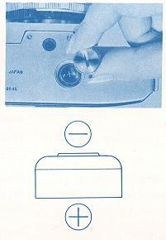

2. FILM LOADING  Do not load in bright light. Open back cover of camera by pulling out the slide lock (14). Pull up the rewind crank knob (15) and place the film cassette into the cassette chamber (16). Return the rewind crank to its former position. Draw out the film leader and insert it in the slit of the take-up spool. If the slit is not in the proper position to insert the film leader, turn the take-up spool.  Turn the rapid wind lever and make sure that both sprockets have properly engaged the film perforations. Close and lock the back cover.  The letter "S" appears opposite the triangle mark in the exposure counter window (5). Advance film a single stroke and depress shutter button after each stroke. Continue this until the figure "1" appears opposite the triangle mark. The camera is now ready for the first picture.  Each time the film is advanced the rewind crank (15) will turn. This assures proper film action in the camera.  The shutter is automatically wound when film is advanced next frame can only be advanced after shutter is released. | 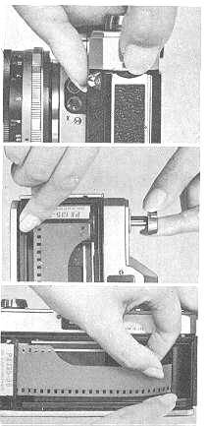

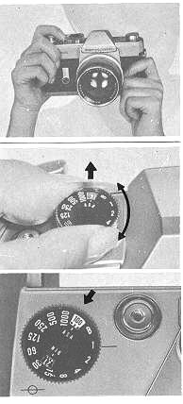 | 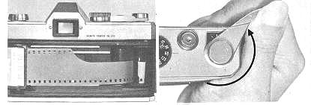
3. SET FILM SPEED
Lift the outer ring of the shutter speed dial, and set the ASA number of the film to correspond to the small white index which appears above the letter "S" on the ASA window (22). Dots in-between stipulated numbers represent the following ASA Speeds:

4. SELECT THE SHUTTER SPEED  At shutter speeds slower than 1/30th of a second support your camera rigidly or use a tripod to prevent movement.  With the shutter speed dial set on B (bulb), the shutter will stay open as long as you depress the shutter button. When you release the shutter button, the shutter closes. When a long exposure is desired use the "B" setting and attach a shutter release cable with a locking device to the shutter button. This will permit a time exposure.  To protect the shutter mechanism, trip the shutter release before storing the camera for an extended period.  5. ADJUST EXPOSURE METER  When the film advance lever (1) is pushed toward the camera body to its full stop, the exposure meter switch is 'on", and at the same time, the lens diaphragm closes down to its preselected aperture. (The shutter button may be operated while the film advance lever is in this position).  Correct exposure can be determined by turning the aperture ring (8), until the needle, visible at the right side in the viewfinder is positioned between the exposure index mark. If the f/stop was first determined, then the shutter speed has to be adjusted. In the event the needle does not center properly, adjust the lens aperture as mentioned above. | 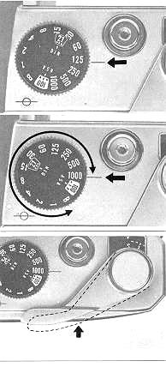

6. THE EXPOSURE METER  One of the most advanced features of your mamiya/sekor TL Camera is the Mirror-Matic behind the lens meter system. With the CdS cell (positioned on the back of the mirror) you may take a spot meter reading (covering about 10% of your picture area). The meter is clearly outlined by the two engraved brackets located in the bottom of the viewfinder. Meter readings can be taken from the camera position and will work with any lens. In using the Mirror-Matic system, it is not necessary to figure exposure factors, regardless of lenses or filters used.  When using extension tubes, bellows units, and/or microscope attachments, take the exposure reading after focusing, as in macro photography the exposure varies as the lens barrel rotates. | 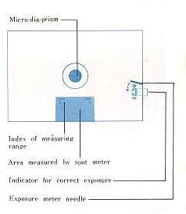

7. FOCUSING AND VIEWING  The Mamiya/Sekor TL Camera is a Single Lens Reflex. You view and take the picture through the same lens.  What you see in the viewfinder you will see on the film. Parallax problems are completely eliminated. And you may check the depth of field at any time before releasing the shutter. | 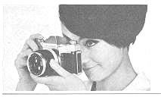

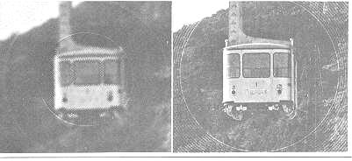
8. FOCUSING
The Focusing Ring (7) is turned in either direction until the image in the small circle of the viewfinder becomes sharp. The microdiaprism then disappears, indicating the sharpest point of focus. It reappears when out of focus.

9. DEPTH OF FIELD  The Depth of field of a lens is the area between the farthest and nearest point in focus. The shorter the focusing length of the lens and the smaller the lens opening, the more depth of field. To see the depth of field push the lens preview lever (9 to the right. Due to the unique Mirror Matic behind the lens meter system, you can even more conveniently check Depth of field by pushing in fully the film advance lever. This action automatically closes down the lens aperture to the pre-selected setting.  When using a pre-set lens, close pre-set ring manually down to the pre-selected aperture to see the effect of the depth of field.  Depth of field can also be determined by consulting the scale on the ring (13). This is helpful when the lens is stopped down, admitting less light. For example, with the standard lens aperture set at f/11 and focused at 30 feet, the f 11 on the depth of field ring (13) will indicate a depth of field from 15 feet to infinity. This indicates the area within which all will be in focus. | 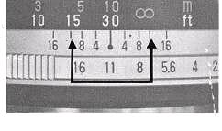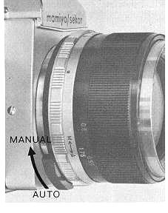

10. HOLDING THE CAMERA  Lightly support the bottom of the camera with the palm of the left hand; adjust the position of the camera so that the thumb and forefinger of the left hand can reach the focusing ring (7). Place the palm of the right hand against the end of the camera body. Then the forefinger of the right hand will automatically be near the shutter release button (2) and the thumb will be on the film advance lever (1). Bring the finder window (6) to the level of the eyes and rest against the forehead. This will help steady the camera.  For vertical pictures, the camera should be held with the film advance lever up. Procedure is the same as for horizontal pictures. Hold the camera with the left elbow as close to the body as possible.  The above camera positions are the same when other lenses are used. When taking pictures with speeds slower than 1/30th of a second, or when using the self-timer. Use a tripod, or rest the camera on a steady supporting base to prevent movement when the shutter is released.  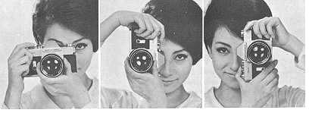 | 11. CHANGING LENSES  To remove the lens, turn the barrel counter clock-wise.  To insert the lens, turn the barrel clock-wise until it stops firmly. When pressure is necessary to remove the lens or to screw in the lens tightly, grasp the lens as near to the camera body as possible to avoid accidents. Do not touch the mirror after removing the lens. If there are any dust particles on the mirror, brush them away with a camels hair brush.  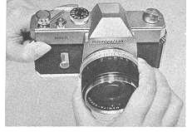

12. SELF--TIMER  Mamiya/Sekor 1000 TL Cameras have a built-in adjustable self-timer (10). This feature makes it possible for the photographer to be in his own picture. It is also good practice 'to use the self-timer for slow speed shutter release to avoid vibration even if the camera is mounted on a tripod.  When the self-timer lever is turned clock-wise approximately 180 degrees, the timer allows about ten seconds before it releases the shutter. Time allowance is adjustable freely by turning the lever within a range of 90 degrees to 180 degrees.  To operate the self-timer, just depress the 'self-timer actuating button (11). Even after the self-timer has been set, you can release the shutter release button without affecting self-timer operation.  Before actuating the self-timer, the shutter must first be wound. When releasing the shutter with the self-timer, the automatic aperture control mechanism works in the same way as when the shutter is released by depressing the shutter release button. | 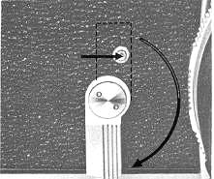

13. FLASH PHOTOGRAPHY  The Mamiya/Sekor TL has two sets of terminals FP and X (21). The table below shows flash contact, shutter speed, and flash bulb to be combined for maximum lamp efficiency. Unless these combinations are rigidly followed, there will be a failure in flash synchronization. Note that 160th of a second is marked in red on the shutter speed dial. This indicates the highest shutter speed at which electronic flash units may be used. | 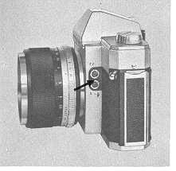

14. INFRA RED PHOTOGRAPHY  When infra-red film is used, a red dot on the depth of field scale ring(13) should be used as an index for the distance. Adjust the distance indicator to match the red dot by turning the distance scale ring (12 after focusing through the viewfinder. This is necessary because the film is only sensitive to infra-red rays which focus slightly behind the film plane for ordinary light rays.  15. REWIND THE FILM  After you shoot 20 or 36 exposures, rewind the film into its original cartridge as follows:  Push the film rewind release button (19) of the camera. Then turn the film rewind crank (15) in the direction of the arrow. You will feel the tension on the rewind crank lessen as the leader end of the film slips off the take-up spool. Stop rewinding when you feel this happen.  AVOID DIRECT SUNLIGHT WHEN UNLOADING YOUR FILM. | 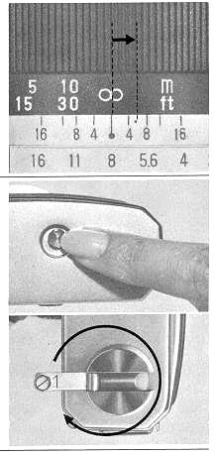

16. PLACING THE CAMERA INTO CASE
When placing the camera into the leather case or when you are through using the camera, push the film advance housing button (4) so that the rapid film advance lever returns automatically to its original position flush to the camera body.
The button (4) pops up when the rapid film advance lever is pulled out approximately 15 degrees.
Be sure the film advance housing button (4) is pushed down if the camera is to be stored for a long period of time.
17. HELPFUL HINTS
Storage (When camera will not be used for a long period of time
· Store without winding the shutter. This relieves spring tension.
·Push the film advance housing button 4).
·Remove silver battery. This is very important.
18. CARE AND CLEANING
· Never expose the camera to direct sunlight for an extended period of time.
· When any abnormality is found in the camera, do not attempt to disassemble or lubricate. Contact the camera shop where you purchased the camera, or a service division of this company.
· CAUTION ! High temperatures of over 100 degrees F and low temperatures of less than freezing, moisture and salty atmosphere are injurious to ANY camera.

1. SET FILM SPEED.  Lift the outer ring of the shutter speed dial, turn it around and set the same number as the ASA number of the loaded film to the small white index which appears alongside the ASA window. Then advance the rapid wind lever.  2. SET SHUTTER SPEED.  Turn the shutter speed dial and set the speed you wish to use to the index. When outdoors, set the speed at 1/125 sec. or faster, depending upon the lighting. When outdoors, set it at 1/30, or in its neighborhood. Change the shutter speed later, when necessary. (Refer to item 5, page 16.)  3. COMPOSE AND FOCUS.  While viewing through the viewfinder, turn the distance scale ring with your thumb and index finger until you get the sharpest image of your subject at the micro prism centre of the finder. | 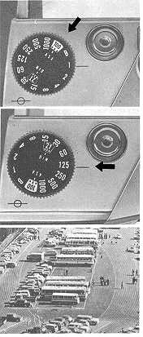
4. TURN ON LIGHT METER SWITCH.  Push the rapid film advance lever (1) toward the camera body with your thumb. Thought the viewfinder, you will observe the movement of the right side of the ground.  5. ROTATE DIAPHRAGM RING.  The needle moves up and down with the turn of the diaphragm ring. When the needle rests at the centre, you will get correct exposure. If the needle does not come to the centre no matter how far you turn the diaphragm ring, change the shutter speed When the needle is off centre and close to the (+) mark, you will get over-exposure: change the shutter speed to a faster setting. If the needle is closer to the (--) mark, you will get under-exposure change the shutter speed to a slower setting.  6. RELEASE SHUTTER.  Hold your camera firmly and trip the shutter. Wind the rapid wind lever for the next picture. (When taking a series of pictures under the same lighting conditions, it is not necessary to repeat instructions 4 and 5). | 